Oxidative dehydrogenation of n-octane using vanadium-based hydrotalcite-like compounds

By
Mayashree Bux
(MSc)

Submitted in the fulfillment of the academic requirements for the degree of Doctor of Philosophy in the School of Chemistry University of KwaZulu-Natal Durban South Africa
July 2010

As the candidates supervisor I have / have not approved this thesis / dissertion for submission.

Signed: Name: Date:

ABSTRACT

The oxidative dehydrogenation of alkanes provides a potential route to higher value products such as olefins and aromatic compounds. Alkanes are of low environmental impact and their increasing availability has prompted extensive research in the field of alkane activation. The use of hydrotalcite-type compounds (HTlc), to achieve such reactions, has received much attention over recent years. Specifically, hydrotalcites and hydrotalcite-like compounds are promising catalysts because they provide a route to mixed-metal oxides with variable composition and significantly high metal-oxide distribution.

Vanadium containing hydrotalcite-like catalysts were synthesized via the co-precipitation route and doped with either barium, cesium or boron using the wet impregnation method. These catalysts were characterized using electron microscopy, inductively coupled plasma - optical emission spectroscopy, X-Ray diffraction, differential thermal analysis, BET surface area measurements and infrared spectroscopy. The catalysts were then tested in a fixed bed reactor using n-octane as the feed and air as the oxidant. The effect of fuel-air ratios and contact time was studied on the unpromoted Mg-V-HTlc. The conversion of n-octane and the selectivity and yields to the products were quantified using gas chromatography and used to determine optimum reaction conditions. The effect of promoters on the conversion of n-octane and the selectivity of the catalyst in terms of products was determined under the optimum reaction conditions.

PREFACE

The experimental work described in this thesis was carried out in the School of Chemistry, University of KwaZulu-Natal, Howard College and Westville, Durban, from June 2004 to December 2009 under the supervision of Prof. H.B. Friedrich.

These studies represent original work by the author and have not been otherwise submitted in any form for any degree or diploma to any tertiary institution. Where use has been made of the work of others it is duly acknowledged in the text.

DECLARATION 1 – PLAGIARISM

I,…………………………………………………………………………..., declare that
- The research reported in this thesis, except where otherwise indicated, is my original research.

- This thesis has not been submitted for any degree or examination at any other university.

- This thesis does not contain other persons’ data, pictures, graphs or other information, unless specifically acknowledged as being sourced from other persons.

- This thesis does not contain other persons’ writing unless specifically acknowledged as being sourced from other researchers. Where other written sources have been quoted, then:
- Their words have been re-written but the general information attributed to them has been referenced
- Where their exact words have been used, then their writing has been placed in italics and inside quotation marks, and referenced.

- This thesis does not contain text, graphics or tables copied and pasted from the Internet, unless specifically acknowledged, and the source being detailed in the thesis and in the References sections.

Signed

……………………………………………………………………………………….

Declaration Plagiarism 22/05/08 FHDR Approved

DECLARATION 2 – CONFERENCE CONTRIBUTIONS

Part of the work reflected in the following thesis has been presented at the following conferences as poster presentations:

CATSA Conference 2005, Eskom Convention Centre, ODH of n-octane using hydrotalcite-type catalysts

CATSA Conference 2006, Mossel Bay, Oxidation of n-octane using vanadium containing catalysts

CATSA Conference 2007, Richards Bay, Activation of n-Octane using hydrotalcite-type catalysts

CATSA Conference 2008, Parys, Activation of n-Octane using hydrotalcite-type catalysts

DEDICATION

For my family…

Contents

ABSTRACT ii
PREFACE iii
DECLARATION 1 – PLAGIARISM iv
DECLARATION 2 – CONFERENCE CONTRIBUTIONS v
LIST OF ABBREVIATIONS xii
LIST OF FIGURES xv
LIST OF SCHEMES xix
LIST OF TABLES xx
ACKNOWLEDGMENTS xxii

CHAPTER ONE - INTRODUCTION 1
1.1. Introduction to oxidation catalysis 1
1.2. Dehydrogenation versus oxidative dehydrogenation 2
1.3. Role of the oxygen species 4
1.3.1. Electrophilic oxidation 5
1.3.2. Nucleophilic oxidation 6
1.4. Vanadium in catalysis 7
1.5. Promoters 8
1.6. Oxidation of n-octane 9
1.6.1. Industrial production of aromatic compounds 9
1.6.2. Industrial production of C8 olefins 11
1.6.3. Research efforts for the oxidation of n-octane 12
References 16

2. CHAPTER TWO - HYDROTALCITES 18
2.1. Introduction to hydrotalcites (HT) 18
2.2. Structure of hydrotalcite-like compounds (HTlc) 19
2.3. Hydrotalcite-like compounds: [M(II)_{1-x}M(III)_{x}(OH)₂]^{x+} (A^{n-}_{x/n}).mH₂O 22
2.3.1. The nature of M(II) and M(III) 23
2.3.2. Nature of the anion 25
2.3.3. Values of x 26
2.3.4. Values of m 27
2.4. Preparative methods 27
2.4.1. Precipitation methods 28
2.4.1.1. Titration methods 28
2.4.1.2. Precipitation at low supersaturation 28
2.4.1.3. Precipitation at high supersaturation 29
2.4.2. Hydrothermal treatments 29
2.4.3. Anionic exchange methods 30
2.4.4. Calcination 30
2.5. Physico-chemical characterization of HTlc’s 31
2.5.1. X-Ray diffraction 31
2.5.2. Infrared spectroscopy 32
2.5.3. Thermal methods 33
2.5.4. Other methods 34
2.6. Hydrotalcite-like compounds in catalysis 35
2.6.1. HTlc’s as catalyst supports 35
2.6.2. HTlc’s in air decontamination reactions 36
2.6.3. Advances in natural gas conversion 36
2.6.4. HTlc’s as redox catalysts 37
2.6.4.1. Oxidation of alcohols 37
2.6.4.2. Oxidation of aromatic compounds 37
2.6.4.3. HTlc’s in dehydrogenation reactions 37
References: 39

3. CHAPTER THREE - EXPERIMENTAL 43
3.1. Introduction 43
3.2. Reactor configuration 43
3.3. Analytical system 45
3.3.1. TCD sampling 45
3.3.2. FID sampling 45
3.4. Non-catalytic experiments 46
3.5. Catalytic experiments 46
3.6. Interpretation of reaction data 46
3.6.1. Quantification of TCD results 47
3.6.2. Quantification of FID results 48
3.6.2.1. Identified components 48
3.6.2.2. Unidentified components 51
3.6.3. Carbon balance, conversion, yield and selectivity 53
3.7. Catalyst preparation 54
3.7.1. Preparation of Mg-V-CO₃ HTlc 54
3.7.2. Synthesis of promoted Mg-V-CO₃ HTlc’s 54
3.8. Catalyst treatment conditions 55
3.8.1. In-situ treated catalysts 55
3.8.2. Calcination 56
3.9. Catalyst characterisation 56
3.9.1. XRD 57
3.9.2. ICP-OES 57
3.9.3. BET surface area measurements 57
3.9.4. TGA / DSC analysis 58
3.9.5. Electron microscopy 58
3.9.6. Infrared spectroscopy (IR) 58
3.9.7. Temperature programmed analysis 58
3.10. Chemicals and reagents 59
References 60

4. CHAPTER FOUR - CHARACTERISATION 61
4.1. Characterisation of the Mg-V-HTlc 61
4.2. Characterisation of barium promoted catalysts 74
4.3. Characterisation of cesium promoted catalysts 85
4.4. Characterisation of the boron promoted catalysts 93
References 101

5. CHAPTER FIVE – RESULTS AND DISCUSSION 102
5.1. Non-catalytic experiments 102
5.2 Effect of treatment conditions on the Mg-V-HTlc 104
5.3. Effect of contact time 108
5.4. Effect of fuel-air ratio 116
5.5. Catalytic results for barium promoted catalysts 121
5.6. Catalytic results for the cesium promoted catalysts 127
5.7. Catalytic results for the boron promoted catalysts 132
References 137

6. CHAPTER SIX - CONCLUSION 138

APPENDIX A 141
APPENDIX B 156

LIST OF ABBREVIATIONS

% - percent
°C - degrees Celsius
Å - angstrom
ACP - acetophenone
BET - Brunner Teller Emmett
CT - contact time
cm - centimeter
CPO - catalytic partial oxidation
DSC - differential scanning calorimetry
DTA - differential thermal analysis
DTG - differential thermal gravimetry
EBHP - ethylbenzene hydroperoxide
EDX - energy dispersive X-ray spectroscopy
EM - electron microscopy
FID - flame ionization detector
g - gram
GC - gas chromatography
GHSV - gas hourly space velocity
HDPE - high density polyethylene
HPLC - high performance liquid chromatography
HTlc - hydrotalcite-like compound
HTlc’s - hydrotalcite-like compounds
ICP-OES - inductively coupled plasma – optical emission spectroscopy
IR - Infrared
JCPDS - joint committee on powder diffraction standards
KF - Karl Fischer
LDH - layered double hydroxides
LLDPE - linear low density polyethylene
m²/g - square meter per gram
MBA - methylbenzyl alcohol
mg/g - milligram per gram
ml - milliliter
ml/min - milliliter per min
mmol - microliter
mPa - milli-Pascal
ODH - oxidative dehydrogenation
PO - propylene oxide
PXRD - powder X-Ray Diffraction
RF - response factor
s - second
SEM - scanning electron microscopy
SGE - Scientific Glass Engineering
TCD - thermal conductivity detector
TEM - transmission electron microscopy
TGA - thermogravimetric analysis
Tmax - maximum temperature
TPD - temperature programmed desorption
TPR - temperature programmed reduction
µmol - micro mole
viz. - namely
XRD - X-Ray diffraction

LIST OF FIGURES

Figure 1.1: Mars van Krevelen Mechanism [20] 7

Figure 2.1: Sheet-like layer of Mg(OH)₆ octahedra [53] 19
Figure 2.2: Schematic top view of a brucite-like layer [20] (reprinted with permission from Nova Science Publishers) 20
Figure 2.3: Idealised structure of a HTlc showing the location of interlayer species [26] (reprinted with permission) 20
Figure 2.4: Lowering of symmetry for a ZnAl-HTlc [54] (reprinted with permission from Nova Science Publishers) 22
Figure 2.5: Diffractograms of MgAl-HTlc (a) and CoCuAl-HTlc (b) showing characteristic HT peaks [1] (reprinted with permission) 32
Figure 2.6: IR spectrum showing peaks attributed to water for various metal-containing HTlc’s [54] (reprinted with permission from Nova Science Publishers) 33

Figure 3.1: Schematic of the reactor set-up 44

Figure 4.1: Powder X-Ray diffractogram of uncalcined Mg-V-HTlc 62
Figure 4.2: PXRD of the in-situ treated Mg-V-HTlc 63
Figure 4.3: PXRD pattern of the calcined Mg-V-HTlc 64
Figure 4.4: In-situ XRD of the Mg-V-HTlc 64
Figure 4.5: Infrared Spectra of uncalcined, calcined and in-situ treated Mg-V-HTlc’s 65
Figure 4.6: SEM image of Mg-V-HTlc 67
Figure 4.7: a) Composite scan showing Mg and V b) Mg distribution c) V distribution 67
Figure 4.8.: TEM image of the uncalcined Mg-V-HT 68
Figure 4.9: Selected area electron diffraction TEM image of uncalcined Mg-V-HTlc 68
Figure 4.10: The TG and DTG curves for Mg-V-HTlc 69
Figure 4.11: DTA profile for the uncalcined Mg-V-HTlc 70
Figure 4.12: TG and DTG curves for the in-situ treated Mg-V-HTlc 71
Figure 4.13: TPR curve for the Mg-V-HTlc 72
Figure 4.14: XRD of the TPR sample for Mg-V-HTlc 72
Figure 4.15: TPD curve for the Mg-V-HTlc 73
Figure 4.16: XRD of 0.2% BaMg-V-HTlc 76
Figure 4.17: XRD of 0.7% BaMg-V-HTlc 76
Figure 4.18: XRD of 1.4% BaMg-V-HTlc 77
Figure 4.19: XRD of 6% BaMg-V-HTlc 77
Figure 4.20: TPR curves for the barium promoted catalysts 78
Figure 4.21: TPD curves for the Ba promoted catalysts 79
Figure 4.22: IR spectra for Ba promoted catalysts 80
Figure 4.23: SEM images of a) 0.2% BaMg-V-HTlc b) 0.7% BaMg-V-HTlc c) 1.4% BaMg-V-HTlc d) 6% BaMg-V-HTlc 82
Figure 4.24: TG and DTG curves for 0.25 BaMg-V-HTlc 83
Figure 4.25:TG and DTG curves for 0.7% BaMg-V-HTlc 83
Figure 4.26: TG and DTG curves for 1.4% BaMg-V-HTlc 84
Figure 4.27: TG and DTG curves for 6% BaMg-V-HTlc 84
Figure 4.28: Diffractorgram of 0.4% CsMg-V-HTlc 85
Figure 4.29: Diffractogram of 0.9 % CsMg-V-HTlc 86
Figure 4.30: Diffractogram of 1.9 % CsMg-V-HTlc 86
Figure 4.31: IR spectra of Cs promoted catalysts 88
Figure 4.32: TPR curves for Cs promoted catalysts 89
Figure 4.33: TPD curves for the Cs promoted catalysts 89
Figure 4.34: SEM images ofa) 0.4% CsMg-V-HTlc b) 0.9% CsMg-V-HTlc and c) 1.9% CsMg-V-HTlc 90
Figure 4.35: TG and DTG curves for the 0.4% CsMg-V-HTlc 91
Figure 4.36: TG and DTG curves for the 0.9% CsMg-V-HTlc 92
Figure 4.37: TG and DTG curves for the 1.9% CsMg-V-HTlc 92
Figure 4.38: X-Ray diffractogram for the 0.1% BMg-V-HTlc 94
Figure 4.39: Diffractogram of the 0.3% BMg-V-HTlc 95
Figure 4.40: Diffractogram of 0.6% BMg-V-HTlc 95
Figure 4.41: IR spectra of boron promoted catalysts 96
Figure 4.42: TPR curves for the boron promoted catalysts 97
Figure 4.43: TPD curves for the various B-HTlc’s 98
Figure 4.44: TG and DTG curve for 0.1% BMg-V-HTlc 99
Figure 4.45: TG and DTG curves for the 0.3% BMg-V-HTlc 100
Figure 4.46: TG and DTG curves for the 0.6% BMg-V-HTlc 100

Figure 5.1: Conversion of n-octane as a function of temperature for the blank reactor experiment 102
Figure 5.2: Selectivity to organic products obtained 103
Figure 5.3: Selectivity to CO and CO₂ for the blank reactor experiment 104
Figure 5.4.: Comparison of conversions of n-octane for the Mg-V-HTlc under different treatment conditions 105
Figure 5.5: Total selectivity to C8 aromatics 105
Figure 5.6: Total yield and selectivity to C8 olefins 107
Figure 5.7: Total Selectivity to carbon oxides 107
Figure 5.8: Effect of contact time on conversion of n-octane as a function of temperature 109
Figure 5.9: Selectivity to total C8 olefins for various contact time experiments 110
Figure 5.10: 1-octene selectivity for various contact times 110
Figure 5.11: Effect of contact time on yield to total C8 olefins 111
Figure 5.12: Effect of contact time on total C8 aromatic selectivity 112
Figure 5.13: Selectivity to carbon oxides for different contact times 113
Figure 5.14: Selectivity to the total cracked products for various contact times 114
Figure 5.15: Total diene selectivity for different CT experiments 115
Figure 5.16: Comparison of yields to various groups of products at 500 °C 116
Figure 5.17: Effect of fuel-air ratio on conversion of n-octane 117
Figure 5.18: Total selectivity to C8 aromatic compounds for different fuel-air ratios 118
Figure 5.19: Effect of fuel-air ratios on total selectivity to CO_{x} 118
Figure 5.20: Effect of fuel-air ratio on total selectivity to C8 olefins 119
Figure 5.21: Effect of fuel-air ratios on yields at 500 °C for n-octane conversion 120
Figure 5.22: Conversion of n-octane as a function of temperature for Ba promoted catalysts 121
Figure 5.23: Selectivity to total C8 olefins for Ba promoted catalysts 122
Figure 5.24: Total selectivity to C8 aromatic compounds for Ba promoted catalysts 123
Figure 5.25: Total CO_{x} selectivity for barium promoted catalysts 124
Figure 5.26: Selectivity to the aromatic products for the 1.4% BaMg-V-HTlc 124
Figure 5.27: Selectivity to total “cracked” products for barium promoted catalysts 125
Figure 5.28: Comparison of results at ~ 16% conversion and 450 °C 126
Figure 5.29: Comparison of conversion of n-octane for the cesium promoted catalysts 127
Figure 5.30: Total C8 olefin selectivity for Cs promoted catalysts 128
Figure 5.31: Total CO_{x} selectivity for cesium promoted catalysts 129
Figure 5.32: Total selectivity to C8 aromatic compounds for cesium promoted catalysts 130
Figure 5.33: Selectivity to the total cracked products for Cs promoted catalysts 131
Figure 5.34: Comparison of selectivity at 450 °C and ~ 16% conversion 131
Figure 5.35: Effect of boron loading on conversion of n-octane 132
Figure 5.36: Selectivity to total C8 olefinic species for boron promoted catalysts 133
Figure 5.37: Total selectivity to C8 aromatic compounds for n-octane conversion 134
Figure 5.38: Total carbon oxide selectivity for n-octane conversion 135
Figure 5.39: Comparison of data at 450 °C and ~ 19% conversion of n-octane 136

LIST OF SCHEMES

Scheme 1: Schematic showing the dehydrogenation of an alkane molecule 3
Scheme 2: Oxidative dehydrogenation of an alkane molecule 3
Scheme 3: Nonselective oxidation of an alkane with oxygen 4
Scheme 4: Gradual enrichment of adsorbed oxygen species [13] (reprinted with permission) 5
Scheme 5: Formation of styrene from ethylbenzene 10
Scheme 6: Degradation of ethylbenzene to benzene and ethane 10
Scheme 7: Degradation of ethylbenzene to carbon and hydrogen 10
Scheme 8: Representation for anionic exchange 30

LIST OF TABLES

Table 2.1: Structural data about the layers of a Zn-Al and Zn-Cr based LDH [54] (reprinted with permission from Nova Science Publishers) 22
Table 2.2: Ionic radii of some M(II) and M(III) cations [1] (reprinted with permission) 23
Table 2.3: Chemical composition range of various LDH [54] (reprinted with permission from Nova Science Publishers) 25
Table 2.4: Examples of different types of anions for HTlc [54] (reprinted with permission) 26

Table 4.1.: Experimental and literature comparison of lattice parameters 62
Table 4.2: ICP results for Mg-V-HTlc 66
Table 4.3.: BET surface areas of Mg-V-HTlc’s 66
Table 4.4: Peak assignments for the Reduced Mg-V-HTlc from TPR 73
Table 4.5: Barium loadings on each catalyst as determined from ICP-OES 74
Table 4.6: Catalyst naming system for Ba promoted Mg-V-HTlc’s 74
Table 4.7: Lattice parameters and Mg/V ratio of barium promoted catalysts 75
Table 4.8: Vanadium oxidation state and % reducibility of Ba promoted catalysts 78
Table 4.9: Total acidity of Ba promoted catalysts 79
Table 4.10: Surface area measurements for the Ba promoted catalysts 81
Table 4.11: Lattice parameters for Cs promoted catalysts 87
Table 4.12: Effect of Cs loading on surface area 87
Table 4.13: TPR results for the Cs containing Mg-V-HTlc’s 88
Table 4.14: Total acidity of the Cs promoted catalysts 90
Table 4.15: ICP results for the boron promoted catalysts 93
Table 4.16: Calculated lattice parameters for boron promoted catalysts 94
Table 4.17: Surface areas of the boron promoted catalysts 97
Table 4.18: TPR results for the boron promoted catalysts 98
Table 4.19: Total acidity of the boron promoted catalysts 99

Table 5.1: Yield to the total C8 aromatic products 106
Table 5.2: Surface area of the used catalysts for various contact time experiments 113
Table 5.3: Surface areas of the used catalysts 119
Table 5.4: Surface areas of the used catalysts 125
Table 5.5: Surface areas of the used Cs promoted catalysts 129
Table 5.6: Surface areas of the used boron promoted catalysts 134

ACKNOWLEDGMENTS

Most importantly I would like to thank God for his blessings and guidance. My sincere thanks go to my family – I could not have done this without their love, patience and understanding.

I would like to thank SASOL for their academic and financial contributions to this project as well as THRIP for financial support.

I extend a special thank you to my supervisor, Prof. Friedrich, for his constant encouragement and advice and for giving me the opportunity to carry out this research. I would also like to thank the technical staff at the University of KwaZulu-Natal, with specific mention to Mrs. Thiloshnee Naidoo for assistance with instrumentation, Mr. Rickey Parasaram for assistance with electrical matters, Mr. Gregory Moodley for the handling of chemicals and Mrs. Jayambal Govender for assistance with administrative and financial issues. I also extend a thank you to Mr. Gregory Loubser for assistance with the reactor block and to the staff at the EM unit at the University of KwaZulu-Natal for electron microscopy data. My gratitude also goes to Mr. Louis Titshall and Dr. Jeffrey Hughes of the Soil Science Departments, PMB, for the efficient XRD analyses. I also extend a sincere thank you to Miss Alisa Govender for the numerous TGA analyses.

Finally, I wish to extend my deepest gratitude to my friends Miss Thirusha Naicker, for her support and advice and Miss Letitia Pillay for her encouragement and invaluable assistance with ICP.

CHAPTER ONE - INTRODUCTION

Introduction to oxidation catalysis

Catalytic selective oxidation processes continue to be an important technology in the chemical industry with more than 60% of chemicals and intermediates being products of oxidation reactions [1]. The functionalisation of hydrocarbons represents an important industrial application of selective oxidation catalysis. Monomers and modifiers for example, which are used in the production of fibers, plastics, paints and adhesives among others, are synthesized via catalytic oxidation routes [1,2]. In this context, modifiers are essentially additives which can affect the performance of the catalyst either positively, in which case it would be termed a promoter, or in an undesirable manner.

Alkenes and, sometimes, aromatics are readily available traditional raw materials in the petrochemical industry and their conversion to higher value products such as oxygenated compounds and certain olefins has been extensively researched [1,3-7]. In addition, they are relatively reactive and therefore easily functionalized, which makes them versatile raw materials. However, as the focus of the chemical industry shifts towards more environmentally friendly processes and with the incremental demand for olefins, it is necessary to explore the use of alkanes as alternative feed stocks for functionalisation [8-13].

The motivation for the implementation of alkane functionalisation on an industrial scale stems from various factors such as the ease with which they can be obtained from both petroleum and natural gas [1,8-11]. This implementation may lead to the development of more economical routes to higher value products due to reduced capital costs brought about by process simplicity and energy savings [1]. In addition, alkanes offer the added advantage of having a lower toxicity than the traditionally used raw materials – benzene, for example, is a carcinogen [14], and this alone is a strong driving force from an environmental point of view [1, 8].

As is the case with various processes in the field of chemistry, the selective oxidation of alkanes to desirable products is associated with certain challenges. The activation of the paraffin itself is one such challenge. This challenge is associated with the absence of reactive sites such as acidic hydrogen atoms as well as electron rich double bonds [1, 2, 12]. Furthermore, the products of partial oxidation reactions are usually more reactive than the starting material and this, coupled with the exothermicity of oxidation reactions, can result in both the over-oxidation of desirable products to invaluable ones such as the combustion products, as well as catalyst damage or reduced catalyst lifetime due to potential temperature runaways [2, 11]. The overall implication from this on an industrial scale implies lower selectivities and therefore higher operating costs associated with separation of the valuable products, recycling of the unused reactants and regeneration of the catalyst, if possible [12].

The challenge, therefore, lies in the development of a catalytic system, in combination with technological and reactor engineering solutions, that can strictly control the reactivity of the alkane, to yield a process with high selectivities to desirable products at a minimum cost [1]. The successful and efficient functionalisation of alkanes therefore provides a potential route for the production of valuable chemicals and intermediates via less costly processes and from more environmentally acceptable raw materials.

Dehydrogenation versus oxidative dehydrogenation

Pure dehydrogenation processes (Scheme 1) represent an important route used industrially for the synthesis of various compounds such as propene, butane, butadiene and styrene [2, 11]. One of the limitations faced with dehydrogenation processes is operation at high pressures, which is favoured in industry but which shifts the equilibrium of the reaction in the unfavourable direction for dehydrogenation reactions. Furthermore, the reaction proceeds endothermically and is thermodynamically limited. The need to work at higher temperatures (500 °C – 650 °C) makes it difficult to control side reactions, such as cracking, which lower the selectivity of the process [2,9,12,13]. In addition, coke deposition on the surface of the catalyst also poses a problem, as this reduces the activity and lifetime of the catalyst. The need to provide heat at high pressures for the reaction makes the process energy and capital intensive [4, 11, 15].

Scheme 1: Schematic showing the dehydrogenation of an alkane molecule

These challenges have led to increasing research into the field of oxidative dehydrogenation (ODH) as a viable alternative for the synthesis of industrially important chemicals and intermediates from alkane feedstocks. Oxidative dehydrogenation takes place in the presence of a hydrogen acceptor such as molecular oxygen in the reaction medium (Scheme 2) [2, 8-10]. These processes proceed exothermically and the production of water makes it thermodynamically favourable. It can therefore operate at low temperatures which is advantageous from an economic and process engineering perspective [13]. Deactivation of the catalyst is also reduced as the use of oxygen can possibly remove coke and its precursors [16].

C_{n}H_{2n+2} + 0.5 O₂ C_{n}H_{2n} + H₂O

Scheme 2: Oxidative dehydrogenation of an alkane molecule

Notwithstanding all of the advantages associated with oxidative processes versus pure dehydrogenation processes, ODH routes do have some drawbacks. The exothermicity of the reaction necessitates careful reactor design for removal of heat so as to avoid potentially explosive feed compositions [13]. In addition, various parallel side reactions are possible with the use of oxygen such as the formation of carbon oxides (Scheme 3) and this can lower potential yields and selectivities in an otherwise favourable process [17].
C_{n}H_{2n + 2} + 0.5 (3n + 1) O₂ n CO₂ + (n + 1) H₂O

Scheme 3: Non-selective oxidation of an alkane with oxygen

Thus, the oxidative dehydrogenation of alkanes has the potential to establish industrial processes of significant economical and environmental advantages over classical dehydrogenation routes. The focus therefore lies in the development of an industrially viable procedure incorporating the use of a catalyst that targets the efficient production of desirable products with the highest possible yields and selectivities. In addition, the properties of the catalyst should ideally ensure desorption of these reactive target products prior to the occurrence of subsequent non-selective reactions, which could reduce the yields obtained, as well as jeopardize the lifetime and performance of the catalyst (catalyst deactivation).

Role of the oxygen species

The identity and role of the reactive oxygen species is an important concept in oxidation catalysis. When gaseous oxygen is absorbed by the surface of the catalyst, it is possible for different adsorbed-oxygen species to be formed, namely, adsorbed oxygen (O⁻, O₂⁻ and O₂²⁻) and lattice oxygen (O²⁻). This occurs through a series of equilibria whereby the gaseous oxygen is gradually enriched in electrons until the final lattice oxygen is formed (Scheme 4) and can exist in either the terminal or bridged form [13].

These adsorbed oxygen species have different electron density and their availability on the surface of the catalyst gives rise to two possible categories for catalytic oxidation reactions viz. electrophilic oxidation and nucleophilic oxidation [2, 13, 18, 19].

Scheme 4: Gradual enrichment of adsorbed oxygen species [13] (reprinted with permission)

Electrophilic oxidation

When oxygen is adsorbed at solid surfaces it can be present as superoxide or peroxide ions, but these decompose at high temperatures into radical species [2]. This decomposition produces three activated forms of oxygen which are strongly electrophilic i.e. the neutral singlet O₂ and the ionic O₂⁻ and O⁻ species. The superoxide (O₂⁻), oxide (O⁻) and peroxide (O₂²⁻) are electron deficient species and can therefore attack electron rich regions such as π bonds of a hydrocarbon. This type of reaction can lead to a breakdown in the carbon skeleton and the overall formation of degradation products [13]. The electrophilic oxygen species is therefore thought to be responsible for deep oxidation reactions, which for the purpose of this research refer to oxidation of the alkane to CO₂.

Nucleophilic oxidation

The nucleophilic oxidative route involves the lattice oxygen ions (O²⁻) which are nucleophilic reactants which have a high electron density but no oxidizing properties [2, 13]. The initial step is the activation of the hydrocarbon, which occurs by the cations of the catalyst, followed by nucleophilic attack of the lattice oxygen on the activated hydrocarbon [2, 13]. Lattice oxygen is therefore responsible for oxygen insertion reactions, or for the production of water as is observed in ODH reactions [19]. These products then desorb from the surface of the catalyst and gaseous oxygen replaces the oxygen in the vacancies created on the surface of the catalyst whilst simultaneously reoxidising the reduced catalyst [2]. This type of redox mechanism was first postulated by Mars and van Krevelen in 1951 and has since become known as the Mars van Krevelen mechanism (Figure 1), which is generally argued as the mechanism for oxidation reactions in heterogeneous catalysis [19, 20].

This type of mechanism requires a catalyst that contains a suitable redox couple at the operating temperatures and which exhibits a high electrical conductivity to favour the transfer of electrons, since lattice oxygen has a 2- oxidation state and its replacement by oxygen demands the transfer of 4 electrons. In addition, it needs to display a high lattice oxygen anion mobility within the material to ensure reoxidation of the reduced catalyst, thus maintaining the redox mechanism [19]. Since this mechanism clearly requires two different types of active sites – one for oxidizing the substrate and one for reduction of oxygen, the catalyst should be able to facilitate both electron and oxygen species transfer [19].

Gaseous Phase Solid Catalyst Gaseous Phase

Hydrocarbon O ²⁻ 1/2 O₂

M ^{m+} M ^{n+}

Oxygenate 2e⁻

M = Metal ion

Figure 1.1: Mars van Krevelen Mechanism [20]

Vanadium in catalysis

Albonetti et al. report that vanadium is one of the main elements present in catalysts that are used for the selective oxidation of alkanes [8]. It is thought that the vanadium is involved in the activation of the C-H bond in paraffins and possible plays a role in the insertion of oxygen in the activated molecule [8].

Comprehensive literature on the oxidative dehydrogenation of lower alkanes, i.e. < C5, confirms the use of vanadium-containing catalysts at temperatures between 300 – 400 ºC [15]. It was shown that the ability to oxidize the alkane decreases with increasing carbon chain length using vanadium-based catalysts [15]. Vanadium containing catalysts have also been successfully employed in the oxidative dehydrogenation of n-butane [13, 21].

Vanadium was therefore chosen as the element to be used in this study. However, while the literature on the oxidative dehydrogenation of lower alkanes may be useful, it cannot be directly applied to the ODH of higher alkanes, as it is suggested that both the alkane and the nature of the catalyst determine the product profile [15].

Promoters

The addition of promoters to a catalyst is aimed at improving the activity of the catalyst, as well as the selectivity towards desirable products.

Alkali promoters are thought to improve the efficiency of a catalyst [22]. Ammonia synthesis has, for example, shown improved activity when Ru supported on hydrotalcite was promoted with alkali and alkali earth metals [23]. The promotional effect was found to be inversely proportional to the electronegativity of the metal i.e. Cs > Ba > K > Na [24]. Seetharamulu et al. thus investigated the use of Cs and Ba, as well as a combination of both in double promoter studies, over a Mg-Al hydrotalcite supported Ru catalyst. Their results showed increased basicity of the promoted catalysts [25]. A similar promotional effect of Ba and Cs on cobalt-cerium composite oxide catalysts was also observed in the catalytic decomposition of N₂O [26].

Cesium itself has also been used as a promoter on silica-supported vanadium oxide catalysts, as well as nickel molybdate, catalysts in butane oxidation [27,28].

Boron-oxide catalysts have been used in the oxidation of ethane and propane, but the catalyst is associated with a high volatility [29]. In practical terms, this implies a reduced catalyst lifetime due to loss of the active component. Cavani and Trifiro infer that boron-oxide can be stabilized by “interaction within a support or by formation of stable compounds” [29]. Patent literature suggests that boron and barium can easily be deposited on a new polytype anionic clay and these can be used in SO_{x} and NO_{x} removal [30].
It was therefore decided that the project would focus on the investigation of boron, cesium and barium as promoters in a vanadium-containing catalyst.

Oxidation of n-octane

A specific example of alkane oxidation would be the functionalisation of n-octane. This higher linear alkane has potential to produce valuable types of products such as aromatic compounds as well as the C8 olefins, more specifically, the α-olefin 1-octene. Various catalytic systems and synthetic routes to these types of products exist on both industrial and research scales and these will be briefly discussed in the sections that follow.

Industrial production of aromatic compounds

One very important C8 aromatic compound is styrene and its production is being intensely researched as this is an important aromatic monomer used in the synthesis of polystyrene [31]. Currently, styrene is produced by the dehydrogenation of ethylbenzene in the vapor phase with steam over an iron oxide based catalyst – the catalyst having been improved in the 1960’s by the incorporation of promoters such as vanadium and molybdenum [2, 11, 31]. The raw material alone accounts for ~ 80 % of the cost of producing the final product. The reaction is highly endothermic (Δ H = 124.9 kJmol⁻¹) (Scheme 5) and, in addition, thermal reactions can cause the degradation of ethylbenzene to benzene, which lowers the potential yields (Scheme 6), or carbon, which acts as a catalyst poison (Scheme 7) [2,31]. Thermal or catalytic ethylbenzene dealkylation can also result in the formation of benzene as a by-product [2].

Scheme 5: Formation of styrene from ethylbenzene

Scheme 6: Degradation of ethylbenzene to benzene and ethane

Scheme 7: Degradation of ethylbenzene to carbon and hydrogen

A variation for the production of styrene was developed by Arco Chemicals in the USA and involves the peroxidation of ethylbenzene [11]. The hydroperoxide is treated with small amounts of propene and the products, propylene oxide and 2-phenylethanol are successively dehydrated to styrene [11]. The process, however, displays a fair degree of complexity.

Another route for the synthesis of styrene is from the styrene-propylene oxide process which accounts for ~ 15 % of the worlds production, as well as the butane-butadiene process – a route that has not as yet been commercially implemented, but shows promise due to the availability and cost associated with butane as compared to ethylbenzene as a feedstock [31]. The styrene-propylene oxide process occurs in 4 steps the first of which involves the direct air oxidation of ethylbenzene (130 ° C, 0.2 mPA and ~ 13% conversion) to produce ethylbenzene hydroperoxide (EBHP) in ~90% selectivity, as well as smaller quantities of α-methylbenzyl alcohol (MBA) and acetophenone (ACP). The BHP is then reacted with propylene in the presence of a metallic catalyst to form propylene oxide (PO) and more MBA. To improve yields, ACP is then hydrogenated to form more MBA in the liquid phase. Finally, MBA is dehydrated to styrene at 150 °C and low pressure over a metal oxide catalyst, usually Al₂O₃ [31]. The butane-butadiene route involves the Diels-Alder dimerisaion of 1,3-butadiene to 4-vinylcyclohexene-1 (yields ~90%). This is then dehydrogenated to ethylbenzene or under more severe conditions, oxidatively dehydrogenated to styrene [31]. The economics alone for both these routes, therefore, provide significant incentive into the use of alternative synthesis procedures.

Industrial production of C8 olefins

The production of higher linear α-olefins (C₆ – C₁₈) is of industrial importance since these olefins can be used in a variety of reactions, such as hydration to produce alcohols, which are then used in the synthesis of plasticisers, and ozonolysis to produce aldehydes and ketones [31]. A more specific example is 1-octene which is used as a comonomer in the production of high density polyethylene (HDPE) and linear low density polyethylene (LLDPE) [31].

Linear α-olefins can be produced via paraffin cracking processes followed by thermolysis (500 °C – 600 °C) in the presence of steam. However, a substantial amount (> 10 %) of by-products such as non-terminal olefins, dienes, as well as traces of aromatic compounds are also produced and as such, olefins derived via this synthetic route are unsuitable for use as comonomers for example [31]. Expansion of this production route is therefore unlikely and the development of a more efficient competitive production route such as the ODH of hydrocarbons, specifically n-octane, would be more favourable.
Olefins can also be produced via catalytic dehydrogenation of alkanes, however, the location of the double bond cannot be controlled. In addition, the reaction requires a substantial amount of energy to be supplied, making it an uneconomical process to implement on large scales. The thermodynamics of this route makes cracking of longer chain paraffins a more viable process. It is however important to note that catalytic dehydrogenation of alkanes leads to the production of H₂, which is valuable in the chemical industry [31].

The motivation to develop an ODH process using n-octane as the feedstock, for the production of both aromatic compounds as well as higher linear olefins with emphasis on the α-olefin, stems from their current importance in the chemical industry, as implementation of this route has potential to be more economically feasible as well as being more environmentally friendly [31].

Research efforts for the oxidation of n-octane

Oxidation reactions using n-octane as the feed have been researched in the liquid and gas phase systems using varying experimental set-ups [32 - 37]. As a result, the product profiles for each of these cases often differed. Literature pertaining to the oxidation of n-octane is scarce since this is a relatively “new” field of research with much of the earlier work on ODH focusing on the lower alkanes [15, 38]. Some of the various catalytic systems presented in the literature for the oxidation of n-octane are discussed in the section that follows.

Liquid phase oxidation of n-octane, for example, has been carried out in Parr autoclaves using Ti-MMM-1 which is a mixed-phase material containing both micro and mesopores [32]. Conversions of up to 19.8% were reported with the main products being the C8 ketones (14.5% selectivity) and C8 alcohols (80.8% selectivity). Of the alcohols produced, the catalyst was found to be significantly more selective to the formation of 2-octanol. This catalytic result was compared to data obtained under identical conditions using TS-1 which is a titanium-substituted zeolite. TS-1 was found to be equally selective to 2-, 3-, and 4-octanol [32]. The high selectivities to these products and not towards the C8 olefins or C8 aromatic compounds, for example, was rationalized by the microporous nature of the catalyst, which was thought to impart a size and shape selective character towards the reaction products [32].

The use of zeolites with n-octane has also been studied [33 -36]. In 2003, Brillis and Manos studied the cracking of n-octane over zeolite Y in a fixed bed reactor [33]. Their 20 min time-on-stream experiments between 523K – 623K showed that isobutene, propane, isopentane and n-butane were the major cracking products. Heavy coking was found to occur from 0 – 3 min, following which catalyst deactivation occurs. No C8 products were found in this study. Similarly, a study using a variety of 8-ring small pore zeolites in a fixed bed reactor by Altwasser et al. showed only C1-C4 paraffins and C2-C4 olefins and no C8 olefins or aromatics [34]. A slight variation in zeolite work was done in 2005 by Jung and co-workers in a conventional flow reactor where the extent of alkali treatment on the zeolite was studied [35]. Conversions varied between 3% and 78%. Apart from the range of cracking products reported, a small selectivity (<1.4%) to xylene was observed. No other C8 compounds were seen.

Research efforts for the study of the aromatization of n-octane were reported in 2006 by Széchenyi and Solymosi [36]. The catalysts used included unsupported Mo₂C as well as Mo₂C supported on alumina, silica and ZSM-5. Temperatures studied varied between 573K and 873K with up to 10 hours reaction times. Aromatic products that were reported include ethylbenzene, toluene, xylene, benzene, but no styrene. The production of octenes is also observed, however, the paper acknowledges poor separation of the octene isomers.

Catalytic partial oxidation (CPO) involves the use of hydrocarbon feedstocks and millisecond contact times for the autothermal generation of valuable products [37]. n-Octane, among other feeds, has been studied under these conditions using Rh-coated α-alumina ceramic foam monolith catalysts as well as Pt-coated catalysts [37, 39]. The main products reported are H₂, H₂O, CO, CO₂, ethylene, propylene and butylenes. The effect of the size of the catalyst, as well as the addition of H₂ and methane to the system was also discussed. As a further study, species and temperature profiles were measured in a differential sphere bed reactor where the catalysts used were low surface area 1.3mm diameter α-alumina spheres [40]. None of these reports show any C8 products.

Another class of compounds, known to catalyse oxidation reactions using hydrogen peroxide as the oxygen source, is the titanium-substituted molecular sieves [41-46]. These catalysts include titanium-containing pure-silica ZSM-5 (TS-1), ZSM-11(TS-2) and Ti-Al-beta (zeolite beta). According to the literature, the oxidation of alkanes using TS-1 occurs on the secondary and tertiary carbon atoms with no primary C-H bond activation [42]. Dartt et al. reported the use of TS-1 and Ti-β for the hydroxylation of n-octane using aqueous hydrogen peroxide [41]. For the conditions used in their study, Ti-β was found to be inactive for the hydrocarbon oxidation reaction while TS-1 resulted in ~21 % conversion of n-octane to alcohols and ketones substituted at positions two and three. No selectivity and yield data was presented in this report [41]. In a related report, it was suggested that the mechanism occurs through radical intermediates and the active species was tentatively assigned to Ti(III) [42].

In 2005, Krasnobaeva et al. reported the use of vanadium-containing hydrotalcite-like catalysts for the oxidative dehydrogenation of octane to octene [47]. Their study was aimed at determining the effect of the particle size composition of the catalyst relative to the synthesis parameters. The oxides derived from these precursors were the compared in terms of catalytic efficiency. Reactions were carried out in a fused silica flow-through reactor using 10 – 15ml of catalyst while varying parameters such as temperature, hydrocarbon flowrates etc. [47]. Higher yields and selectivities to octene were reportedly obtained with coarse-grained hydroxo salts (particle sizes of 10 – 12 µm) than those with particle sizes of 3 – 4 µm. The paper, however, does not distinguish between octene isomers, if any, nor does it account for all of the oxidation products obtained during the oxidative dehydrogenation reaction [47].

The use of hydrotalcite-type catalysts, specifically a Mg-V-HTlc, for the ODH of n-octane was reported by Friedrich and Mahomed in 2008 [48]. Catalytic testing was carried out in a fixed bed reactor and fuel-air ratios of 2% - 7% octane in air were studied. Styrene was found to be the main organic product reaching an optimum selectivity of 19% under reaction conditions of 4% octane in air and GHSV of 6039 hr⁻¹ . The effect of Mg/V ratio showed that Mg/V = 2.29 produced the best catalytic results. Emphasis was not placed on the optimization of the C8 olefin selectivity. The effect of temperature on the fuel-air ratios was not discussed. Fuel-air ratios higher than 7% octane in air were not reported.

The literature study showed that few reports exist for the ODH of higher alkanes, specifically n-octane, using hydrotalcite-like catalysts (HTlc’s). In addition, previous published work on hydrotalcite-like compounds has led to some competency within the group regarding these types of catalysts [5, 6, 47].

It was therefore decided that the focus of this research would be aimed at investigating the effect of the following parameters using hydrotalcite-like catalysts viz.
- Effect of the reactor heating block length on conversions yields and selectivity i.e. to what extent does the length of the heating block affect the free radical reactions occurring within the reactor?
- Effect of temperature on various contact times i.e. what is the optimum contact time for the production of valuable products?
- Effect of temperature on various fuel-air ratios not reported in literature i.e. based on the optimum contact time, which fuel air ratio gives good yields and selectivities to the C8 aromatics and C8 olefins?
- Effect of dopants i.e. what is the effect of different promoters on the performance and characteristic properties of the catalyst?
To the best of our knowledge, such work is unreported in the literature.

References

- G. Centi, F. Cavani and F. Trifirò, Selective Oxidation by Heterogeneous Catalysis, Kluwer Academic / Plenum Publishers, New York, 2001
- Handbook of Heterogeneous Catalysis, Ed. G. Ertl, H. Knözinger and J. Weitkamp, Vol. 5, Weinheim: VCH, 1997
- J-S Chang, M.S. Park, V.P. Vislovskiy, S-E. Park and J.S. Yoo, Fuel Chem. Div. Reprints, 47, 2002, 309
- F.E. Kühn, A. Schebaum and W.A. Herrman, J. Organomet. Chem., 689, 2004, 4149
- H.B. Friedrich, M. Govender, X. Makhoba, T.D. Ngcobo and M.O. Onani, Chem. Commun., 2003, 2922
- H.B. Friedrich, F. Khan, N. Singh and M. van Staden, Synlett, 6, 2001, 869
- A. Brückner and M. Baerns, Appl. Catal. A: Gen., 157, 1997, 311
- S. Albonetti, F. Cavani and F. Trifirò, Key Aspects of Catalyst Design for the Selective Oxidation of Paraffins, Marcel Dekker inc., 1996, 413
- F. Cavani and F. Trifirò, Catal. Today, 24, 1995, 307
- G. Busca, E. Finocchio, G. Ramis and G. Ricchiardi, Catal. Today, 32, 1996, 133
- F. Cavani and F. Trifirò, Appl. Catal. A : Gen., 88, 1992, 115
- F. Cavani and F. Trifirò, Catal. Today, 36, 1997, 431
- L.M. Madeira and M.F. Portela, Catal. Rev., 44, 2002, 247
- P.J. Nyman, G.W. Diachenko, G.A. Perfetti, T.P. McNeal, M.H. Hiatt and K.M. Mprehouse, J. Agric. Food Chem., 56, 2008, 571
- E.A. Mamedov and V.C. Corberán, Appl. Catal. A: Gen., 127, 1995, 1
- M.A. Chaar, D. Patel and H.H. Kung, J. Catal., 109, 1988, 463
- H.H. Kung and M.C. Kung, Appl. Catal. A: Gen., 157, 1997, 105
- J.C. Vedrine, J.M.M. Millet and J-C. Volta, Catal. Today, 32, 1996, 115
- J.C. Vedrine, G. Coudurier and J-M.M. Millet, Catal. Today, 33, 1997, 3
- P. Mars and D.W. van Krevelen, Chem. Eng. Sci. Spec. Suppl., 3, 1951, 41
- N. Govender, H.B. Friedrich and M. Janse van Vuuren, Catal. Today, 97, 2004, 315
- W.D. Mross, Catal. Rev.-Sci. Eng., 25, 1983, 637
- P. Seetharamulu, V.S. Kumar, A.H. Padmasri, B.D. Raju and K.S.R. Rao, J. Mol. Catal. A: Chem., 263, 2007, 253
- K. Aika, M. Kumasaka, T. Oma, O. Kato, H. Matsuda, N. Watanabe, K. Yamazaki, A. Ozaki and T. Onishi, Appl. Catal. A, 28, 1986, 57
- P. Seetharamulu, K.H.P. Reddy, A.H. Padmasri, K.S.R. Rao and B.D. Raju, Catal. Today, 141, 2009, 94
- L. Xue, H. He, C. Liu, C. Zhang and B. Zhang, Environ. Sci. Technol., 43, 2009, 890
- F.J. Maldonado-Hodar, L.M. Madeira, M.F. Portela, R.M. Martin-Aranda and F. Freire, J. Mol. Catal. A: Chem., 111, 1996, 313
- L.M. Madeira, J.M. Herrmann, F.G. Freire, M.F. Portela and F.J. Maldonado, Appl. Catal. A:Gen., 158, 1997, 243
- F. Cavani and F. Trifiro, Catal. Today, 51, 1999, 561
- D. Stamires, P. O’Conner and W. Jones. Pat. WO 2001012550 A1 20010222, 2001
- Ullman’s Encycl. Ind. Chem., 7th Ed., 2005, Chapter : Styrene, pg. 7
- Raja H.P.R. Poladi and C. C. Landry, Micropor. Mesopor. Mater.,52, 2002, 11
- A. A. Brillis and G Manos, Catal. Lett., 91, 2003, 185
- S. Altwasser, C.Welker, Y. Traa and J. Weitkamp, Micropor. Mesopor. Mater., 83. 2005, 345
- J.S.Jung, J.W.Park and G. Seo, Appl. Catal. A: Gen., 288, 2005, 149
- A. Széchenyi and F. Solymosi, Appl. Catal. A: Gen., 306, 2006, 149
- G.J. Panuccio, K.A. Williams and L.D. Schmidt, Chem. Eng. Sci., 61, 2006, 4207
- M.M. Bhasin, J.H. McCain, B.V. Vora, T. Imai and P.R. Pujado, Appl. Catal. A: Gen., 221, 2001, 397
- G.J. Panuccio and L.D. Schmidt, Appl. Catal. A: Gen., 313, 2006, 63
- G.J. Panuccio and L.D. Schmidt, Appl. Catal. A: Gen., 332, 2007, 171
- C.B. Dartt, C.B. Khouw, H-X. Li and M.E. Davis, Micropor. Mater., 2, 1994, 425
- C.B. Khouw, C.B. Dartt, J.A. Labinger and M.E. Davis, J. Catal., 149, 1994, 195
- J.S. Reddy and R. Kumar, J. Catal., 130, 1991, 440
- A. Tuel and Y.B. Taarit, Appl. Catal. A: Gen., 102, 1993, 69
- M.G. Clerici, Appl. Catal., 68, 1991, 249
- C.B. Khouw and M.E. Davis, J. Catal., 151, 1995, 77
- O.N. Krasnobaeva, V.P. Danilov, I.P. Belomestnykh, G.V. Isagulyants, T.A. Nosova, T.A. Elizarova, A.V. Orlov and V.N. Kornyshev, Russ. J. Inorg. Chem., 50, 2005, 1397
- H.B. Friedrich and A.S. Mahomed, Appl. Catal. A: Gen., 347, 2008, 11

2. CHAPTER TWO - HYDROTALCITES

2.1. Introduction to hydrotalcites (HT)

Hydrotalcite (HT) is a naturally occurring hydroxycarbonate of magnesium and aluminum first discovered in Sweden in 1842 and belongs to the anionic clay family [1]. The term hydrotalcite-like compound (HTlc) or layered double hydroxides (LDH) has been adopted in literature to describe synthetic compounds based on the hydrotalcite structure.

The first structural formula for hydrotalcite was proposed in 1915 by Manasse who acknowledged that carbonate ions are an important part of the structure of these compounds [2]. It was thought that these minerals were mixed hydroxides [1].

Literature concerning synthetic hydrotalcites was published by Feitknecht in the 1940’s. He suggested that the hydrotalcite-like structure constituted of a layer of hydroxide of one cation intercalated with a layer of hydroxide of the second cation [3,4]. It was much later that X-Ray analysis work by Allman [5] and Taylor [6] concluded that the cations are located in the same layer and only the water molecules and anions are located in the interlayer.

Research into the use of hydrotalcite-type compounds in the field of catalysis dates back to the 1970’s, when the first patent appeared referring to the use of compounds with the HT-like structure in the preparation of hydrogenation catalysts [7].

Interest in these types of compounds has grown significantly since then and is reflected by the extensive amount of open literature, both papers and review articles, in the fields of, for example, catalyst characterization, preparation methods and applications of hydrotalcite-like compounds in various types of chemical reactions [8-52].
A more detailed discussion of the structural properties, physico-chemical characterization, preparative methods and applications of hydrotaclite-like compounds is presented in the sections that follow.

2.2. Structure of hydrotalcite-like compounds (HTlc)

In order to understand the structure of layered double hydroxides, it is helpful to start from the structure of brucite, Mg(OH)₂ (Figure 2.1). Here, the Mg(OH)₆ octahedral units share edges in order to build the sheet like brucite layers as shown in Figure 2.2 and Figure 2.3.

These sheets can stack on top of each other and are held together by hydrogen bonding (Figure 2.3). Hydrotalcite-like compounds, given the general formula [M(II)_{1-x}M(III)_{x}(OH)₂]^{x+} (A^{n-}_{x/n}).mH₂O, therefore contain both the divalent and trivalent metal ions in these octahedral units, while the anions (usually carbonate) and waters of crystallization are located in the interlayer as displayed in Figure 2.3 [1, 34, 54].
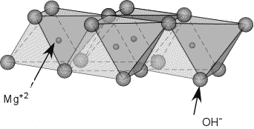

Figure 2.1: Sheet-like layer of Mg(OH)₆ octahedra [53]

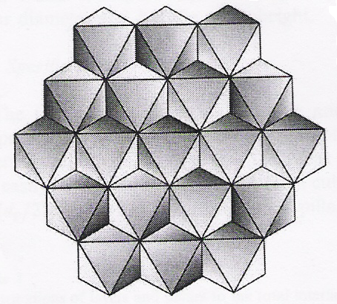

Figure 2.2: Schematic top view of a brucite-like layer [20] (reprinted with permission from Nova Science Publishers)
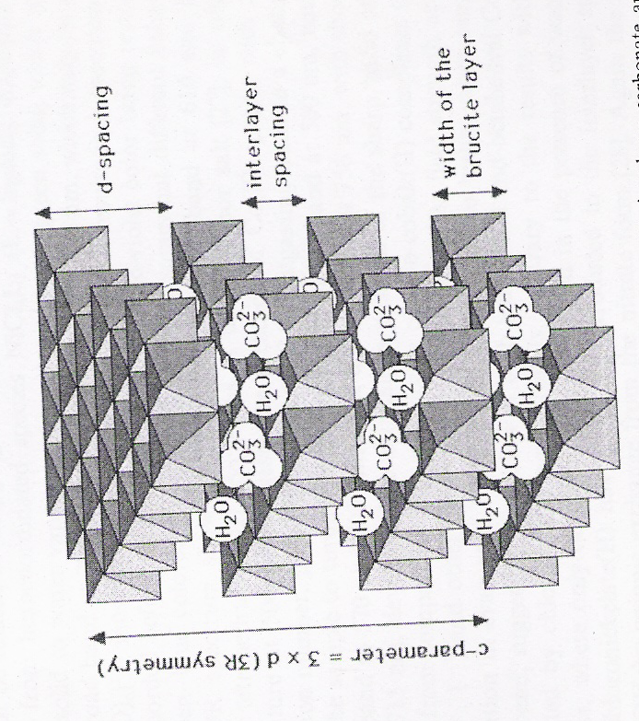

Figure 2.3: Idealised structure of a HTlc showing the location of interlayer species [26] (reprinted with permission)

The Mg²⁺ and Al³⁺ cations found in hydrotalcite can be substituted with M(II) and M(III) cations of similar ionic radius respectively. When the Mg²⁺ cations are substituted by M(III) (of similar radius) a partial positive charge will be generated on the octahedral layers. This charge density is compensated for by the anions located in the interlayer. HTlc can therefore be formed using a variety of combinations of M(II) and M(III) cations which consequently determines some of the characteristics of the LDH product [1, 54].

The anions and water molecules are randomly located in the interlayer (Figure 2.3) and are free to move by breaking bonds and forming new ones [1]. The bonding between the carbonate anions and hydroxyl groups can either be direct: OH-CO₃-HO or indirect via intermediate water molecules through hydrogen bridges: OH-H₂O-CO₃-HO [1]. The loosely bound water and the carbonate anions which are situated flat in the interlayer can be removed without destroying the hydrotalcite-like structure [1].

In addition to accommodating varying M(II) and M(III) cations, the stacking of the brucite-like sheets can lead to two polytypes of hydrotalcites: rhombohedral or hexagonal and this was recognised in the 1930’s [1, 54]. The structure displayed in Figure 2.3 corresponds to type 3R where c’ is defined as the spacing between two consecutive layers and the lattice parameter c corresponds to 3c’ [1, 34, 54]. The value of the a parameter (not displayed in Figure 2.3) corresponds to the average cation-cation distance in the brucite-like layer. The precise determination of these lattice parameters can be obtained from powder X-Ray diffractograms and is discussed in section 2.4.1.

In these compounds, the octahedra of the metallic cations are not regular polyhedra [54]. They are in fact, flattened along the stacking direction which lowers the symmetry from O_{h} to D₃ as is illustrated in Figure 2.4 for the Zn-Al-LDH [54]. This flattening effect and lowering of the layer thickness becomes more pronounced with an increase in the average metal ionic radius, while the distance between the metals themselves increases. To appreciate this, data for the Zn-Al and Zn-Cr based HTlc is presented in Table 2.1 [54].

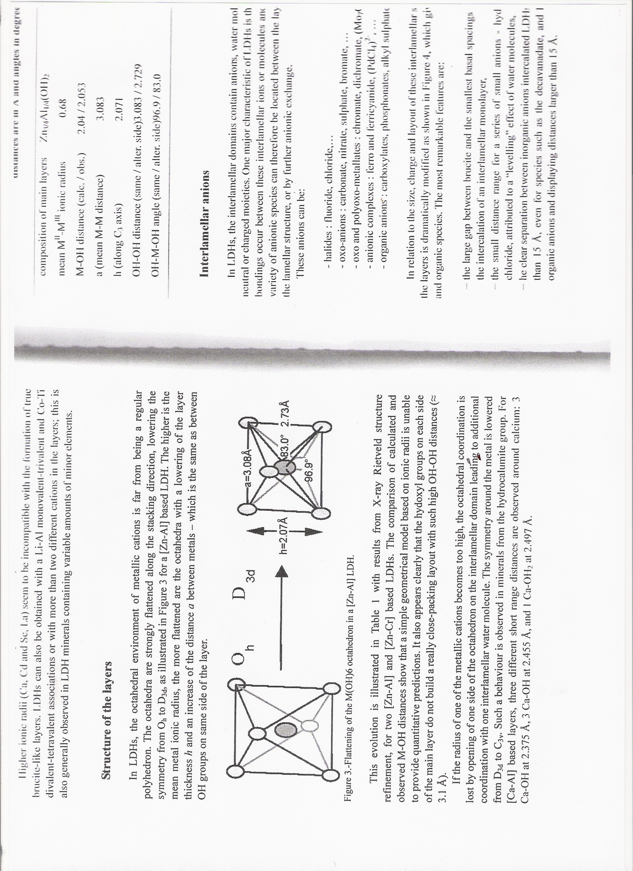

Figure 2.4: Lowering of symmetry for a ZnAl-HTlc [54] (reprinted with permission from Nova Science Publishers)

Table 2.1: Structural data about the layers of a Zn-Al and Zn-Cr based LDH [54] (reprinted with permission from Nova Science Publishers)
Composition of main layers | Zn_{3/4}Al_{1/4}(OH)₂ | Zn_{2/3}Cr_{1/3}(OH)₂
Mean M^{II} – M^{III} ionic radius | 0.68 | 0.72
M – OH distance (calc / obs.) | 2.04 / 2.053 | 2.08 / 2.053
a (mean M-M distance) | 3.083 | 3.120
h (along C₃ axis) | 2.071 | 2.020
OH-OH distance (same / alter. side) | 3.083 / 2.729 | 3.120 / 2.707
OH-M-OH angle (same / alter. side) | 96.9 / 83.0 | 98.1 / 81.9

2.3. Hydrotalcite-like compounds: [M(II)_{1-x}M(III)_{x}(OH)₂]^{x+} (A^{n-}_{x/n}).mH₂O

The actual composition of HTlc determines their characteristics and consequently shapes their applications. The nature of M(II) and M(III) and the anion as well as the values of x, n and m will therefore be discussed in the sections that follow.

2.3.1. The nature of M(II) and M(III)

HTlc can be formed using M²⁺ and M³⁺ cations having an ionic radius not too different from that of magnesium as these can be accommodated in the octahedral sites of the close-packed configuration of the hydroxide ions [1, 54]. Table 2.2 reports the ionic radii for some M(II) and M(III) cations [1].

Table 2.2: Ionic radii of some M(II) and M(III) cations [1] (reprinted with permission)
M(II)  Radii /Å | Be  0.30 | Mg  0.65 | Cu  0.69 | Ni  0.72 | Co  0.74 | Zn  0.74 | Fe  0.76 | Mn  0.80 | Cd  0.97 | Ca  0.98
M(III)  Radii /Å | Al  0.50 | Ga  0.62 | Ni  0.62 | Co  0.63 | Fe  0.64 | Mn  0.66 | Cr  0.69 | V  0.74 | Ti  0.76 | In  0.81

It has been reported that Ca²⁺ and Ba²⁺ (1.49 Å) are too big for the octahedral coordination in the holes of the brucite-like layers and can form other structures, while Be²⁺ is too small [4, 55]. However, work carried out by Allman, does report small amounts of Ca²⁺ within the brucite-like sheet and this has been confirmed by Drits et al. [56, 57].

Copper 2+ cations display a slightly different behavior when used in the synthesis of HTlc. This metal, along with Cr²⁺, Mn²⁺ and Ni³⁺, forms compounds which display a cooperative Jahn-Teller Effect i.e. the distortion in the octahedral coordination structure leads to a gain in energy due to the arrangement of OH groups around the copper ion [1]. Copper therefore only forms HTlc when a second bivalent cation is introduced such that the Cu²⁺ / M(II) ratio is < 1 [1]. This ratio ensures that the coppers cations are separate from each other in the brucite-like sheet and thus form the required undistorted octahedral coordination [1]. All trivalent metal cations with ionic radius 0.5 Å - 0.8 Å can form HTlc. Vanadium(III), however, is reported to be unstable in air and Cavani et al. suggest that V³⁺ cannot form hydrotalcites [1, 54]. This argument has been challenged in work by Kooli et al., who suggest that V(III) ions were indeed incorporated into the interlayer of magnesium aluminium vanadates, supporting their claim by comparing the differences in the a parameter in HTlc’s with and without V(III) in the brucite-like layers [58]. Rives et al. also report the synthesis of V(III) HTlc’s and use X-Ray Absorption Spectroscopy to assess the oxidation state and local coordination of the vanadium ions [59]. Reports describing layered double hydroxides containing V(III) was also published by Labajos et al. using Ni(II) and Mg(II) as the divalent metal respectively [45, 11]. The most recent report in 2008 concludes that V(III) ions are indeed present in the layers of the brucite-like sheets of Mg-V-HTlc’s [52]. There are, however, no reports for the use of titanium(III) in hydrotalcite-like materials, although literature for the incorporation of Ti(IV) into hydrotalcite-like compounds is evident [60, 61].

Most of the LDH can be prepared with a varying M(II) / M(III) ratio as shown in Table 2.3 [54]. However, in order to ensure that the initial M(II) / M(III) ratio is maintained, a suitable pH of precipitation must be used as both the pH and ratio can affect the final phases formed [54]. Using the Zn-Al-CO₃ LDH as an example, only the LDH phase exists at Zn²⁺ / Al³⁺ ~3. At pH 10 for M²⁺ / M³⁺ ≥ 3, Zn-Al-Cl coexists with Zn(OH)₂, while at the ratio ≤ 1, excess Al³⁺ crystallizes as Al(OH)₃ [54].

Table 2.3: Chemical composition range of various LDH [54] (reprinted with permission from Nova Science Publishers)
M^{II}-M^{III}-X | pH_{formation} | M^{II}/M^{III} (R) range
Zn-Al-Cl | 7.0 | 1.0 ≤ R ≤ 5.0
Zn-Al-Cl | 10.0 | 1.0 ≤ R ≤ 3.0
Ni-Cr-Cl | 1.5 | 1.0 ≤ R ≤ 3.0
Ni-Cr-CO₃ | 13.0 | 1.0 ≤ R ≤ 2.0
Cu-Cr-Cl | 5.5 | 1.6 ≤ R ≤ 2.3
Zn-Al-CO₃ | 9.0 | 1.7 ≤ R ≤ 2.3
Mg-Al-CO₃ | 8.0 | 1.0 ≤ R ≤ 3.0
Zn-Cr-Cl | 4.5 | R ~ 2.0
Zn-Cr-Cl | 10.0 | 2.0 ≤ R ≤ 3.0
Mg-Fe-CO₃ | - | 2.7 ≤ R ≤ 5.6
Ni-Al-ClO₄ | 10.0 | 1.0 ≤ R ≤ 3.0
Co-Fe-Cl | 9.0 | 1.8 ≤ R ≤ 4.0
Co-Fe-CO₃ | 9.0 | 1.0 ≤ R ≤ 3.0

2.3.2. Nature of the anion

HTlc’s are extremely versatile regarding the incorporation of anions into their structure as there is almost no limit. Table 2.4 displays examples of the various types of anions that can be used in the synthesis of HTlc [54].

Table 2.4: Examples of different types of anions for HTlc [54] (reprinted with permission)
Inorganic anions | F⁻, (NO₃)²⁻, (SO₄)²⁻, [SiO(OH)₃]⁻
Isopolyanions | V₁₀O₂₈⁶⁻, Mo₇O₂₄⁶⁻
Heteropolyanions | PMo₁₂O₄₀³⁻, PW₁₂O₄₀³⁻
Complex anions and organometallic complexes | [Fe(CN)₆]³⁻
Organic anions | Carboxylates and dicarboxylates
Layered compounds | Mineral chlorite, (Mg,Fe,Al)₆[(Si,Al)₄O₁₀](OH)₈

The major problem incurred when introducing anions other than carbonate, stems from contamination by these easily intercalated species which might be present in the aqueous solution [1, 54]. In addition, the pH range where the anion is stable must coincide approximately with the pH of precipitation for the HTlc in question. For example, the Keggin anions PW₁₂O₄₀³⁻ and SiW₁₂O₄₀⁴⁻are not stable at pH > 5, preventing the direct precipitation of Zn-Al which is usually carried out at pH ~ 9 [54].

Different anions bond differently to the OH groups in the brucite-like layer and this, together with the number, size and orientation of the anions, determines the thickness of the interlayer.

2.3.3. Values of x

The parameter x may be defined as $x= {M\text{2+}}/{M^{2+}+ M^{3+}}$ where x is the molar ratio of ${M\text{2+}}/{M^{2+}+ M^{3+}}$ in the HTlc.

The values of x for which HTlc can exist lies between 0.1 – 0.5 although it has also been argued that HTlc’s can only be produced for 0.2 ≤ x ≤ 0.33 [1]. Paush et al., for example, reported the formation of MgAlOH-HTlc with x values of 0.25 – 0.44 as optimal [62]. The same compound was also reported by Mascolo and Marino which suggests that the range of x is 0.23 – 0.33 [63].
It is reported that for values of x outside of 0.2 – 0.33, other compounds and / or pure hydroxides are obtained [63, 64]. The upper limit of x is usually attributed to the electrostatic repulsion between the trivalent metal ions which is unavoidable when x > $1/3$ [1, 54]. In this instance, using Al³⁺ as an example, the increased number of aluminium octahedra can lead to the formation of Al(OH)₃, not detectable by X-Ray measurements [1, 54]. Conversely, the lower limit of x could correspond to a high density of the magnesium octahedral, for example, leading to Mg(OH)₂ formation or leading to a too high a main distance between these interlamellar species and this results in a collapse of the interlamellar domains [1, 54].

2.3.4. Values of m

This value is attributed to the amount of water molecules located in the interlayer and can be determined by observing the thermogravimetric weight loss pattern [1, 54]. Alternatively, various formulas have been deduced based on the assumption of a close-packed configuration of O₂ atoms [1]. Some of these formulae are discussed below:
- Miyata et al. [63, 64] defined $m=1-N x/n$ where:
N = number of sites occupied by the anion
n = charge of the anions
$$x= {M\text{3+}}/{M^{2+}+ M^{3+}}$$
and for (CO₃)²⁻ m = 1 – 3 $x/2$
- Taylor suggests that m = 1 – d + 3 $x/{2 }$ where d = 0.125 [67]
- Mascolo and Marino suggest that m = 0.81 – x for MgAlOH-HT [63]

2.4. Preparative methods

Hydrotalcites and hydrotalcite-like compounds can be produced by different methods:
- Precipitation which includes co-precipitation at a high or low supersaturation and the increasing pH method
- Ageing as well as hydrothermal treatments and synthesis
- Exchange methods
Of these, co-precipitation is seen to be the most favourable and is a popular method in the literature [1, 11, 45, 52, 59].

2.4.1. Precipitation methods

Co-precipitation of two cations usually occurs under supersaturation conditions and these can be achieved chemically e.g. pH variation or physically e.g. evaporation [1]. The method of pH variation has been reported to work well for the production of HTlc [1, 54]. The mechanism is based on condensation of hexa-aquo complexes in solution in order to build the brucite-like layers resulting in the distribution of the metallic cations and with solvated interlamellar anions [54].

2.4.1.1. Titration methods

This usually involves titration with NaOH and/or NaHCO₃, also referred to as sequential precipitation or the increasing pH method. In this method, co-precipitation also occurs to a small extent. Interestingly, the first synthetic hydrotalcite was prepared by titration of very dilute solutions of Mg and Al with a dilute caustic solution up to pH 10 [1].

2.4.1.2. Precipitation at low supersaturation

This usually occurs at a constant pH in the range 7 – 10 and at temperatures between 333K and 353K. Two solutions of known low reagent concentrations are prepared i.e. the metal solution containing the source of the M²⁺ and M³⁺ for the HTlc and a base solution used to maintain the desired pH. These are added drop-wise i.e. with a low flow, to the reaction vessel. This is followed by extensive washing of the precipitate, some ageing and drying at temperatures not greater than 393 K [1]. Compounds produced via this synthetic route are usually more crystalline than those produced using high supersaturation conditions. The product usually consists of a large number of particles that are small in size [1].

2.4.1.3. Precipitation at high supersaturation

Preparation of compounds using this method results in materials that are usually less crystalline due to a high number of crystallization nuclei i.e. the rate of nucleation is higher than the rate of crystal growth. It is worth noting, however, that the first patent on HTlc’s as catalyst precursors used high supersaturation conditions, so that MgAlCO₃-HTlc, NiAlCO₃-HTlc, CoMnAlCO₃-HTlc, NiAlCO₃-HTlc were among the many catalysts synthesized by adding to a solution containing the respective metal salts to a NaHCO₃ solution [68].

2.4.2. Hydrothermal treatments

The hydrothermal treatment of freshly precipitated mixed hydroxides or mechanical mixtures of the oxides with water can be used to synthesise HTlc’s, to improve the crystallinity of an amorphous or poorly crystalline compound or to transform small crystallites into larger ones [1].
What is referred to as high temperature treatments involves temperatures higher than 373K. To achieve this, pressure is essential and synthesis usually takes place in an autoclave [1]. Roy et al. were the first to report the preparation of a MgAlCO₃ HTlc from a mechanical mixture of MgO and Al₂O₃ [69].

2.4.3. Anionic exchange methods

Layered double hydroxides are a good class of ion exchangers as their lamellar structure (based on positive layers encompassing anions in the interlayer) is highly favourable to anion diffusion [70]. This is useful for the preparation of new HTlc’s and can be represented by Scheme 8.

[M^{II} – M^{III} – X] + Y [M^{II} – M^{III} – Y] + X

Scheme 8: Representation for anionic exchange

Work carried out by Miyata in 1983 reported ion-exchange isotherms of [Mg-Al-X/Y] for a series of monovalent and divalent anions [71]. Thermodynamically, exchange in LDH depends on the interaction of brucite-like sheets and the exchanging anion and, to a smaller extent, the free energy involved in the hydration changes [72]. It was also suggested that exchange is favoured for in-going anions with a high charge density. Kinetically, the rate determining step of the reaction is the diffusion of the in-going anions within the interlayer, provided that the basal spacing of the existing catalyst can accommodate the size of the anion it is to be exchanged with [54]. Synthesis can be relatively simple where an aqueous solution of the LDH precursor is mixed with a large excess of the salt of the anion to be intercalated [54]. The pH of the synthesis is important and this can determine whether or not certain anions are exchanged e.g. a pH of 4.5 – 6.0 is required in order to remove either the carbonate or carboxylate anions from a LDH precursor [54].

2.4.4. Calcination

Hydrotalcite-like compounds are known to display a property called retro-topotactical transformation, also known as the “memory effect” [54, 73]. This effect essentially implies that the layered structure of the hydrotalcite-like compound can be reconstructed after calcination. Successful reconstruction occurs when the calcined material is in contact with water and the appropriate anions and depends strongly on the calcination temperature. A high calcination temperature, which results in the formation of mixed metal oxides, reduces or eliminates the memory effect. It is worth noting that the reconstructed layered structure is not identical to that of the original hydrotalcite-like compound [73].

2.5. Physico-chemical characterization of HTlc’s

2.5.1. X-Ray diffraction

XRD studies are a strong diagnostic tool for proving that the hydrotalcite-like structure has been obtained [1, 54]. The diffractograms of these types of compounds are characterized by sharp and intense peaks at lower 2θ values and less intense and generally asymmetric lines at higher angular values [1]. As an example of this, Figure 2.5 displays the diffractograms of Mg-AlCl-HTlc and CuCoAl-HTlc.

The successive orders of the basal spacing parameter c’ corresponds to the basal [00l] reflections. The true c parameter, as defined in Section 2.2, depends on the layer stacking sequence and c’ itself depends on the anion size, the x value and for some anions, on the degree of hydration [1, 62, 72, 74]. The c’ value is actually the d-spacing of the (003) reflection and can therefore be directly obtained from the diffractogram.

In Figure 2.5, the doublet at the higher angular value has been indexed as the [110] plane [1] and is used to calculate the a parameter (defined in section 2.2): a = 2d_{[110]}. Unlike the c parameter, this value is independent of the layer stacking sequence and is influenced by the nature and ionic radius of the cation as well as the value of x [1].
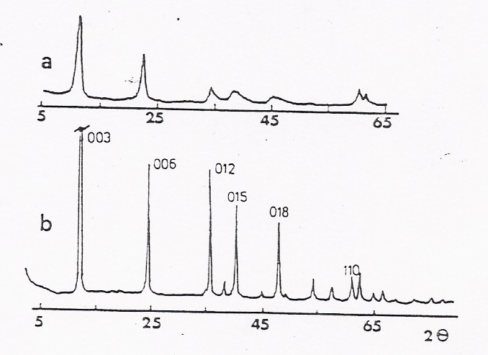

Figure 2.5: Diffractograms of MgAl-HTlc (a) and CoCuAl-HTlc (b) showing characteristic HT peaks [1] (reprinted with permission)

2.5.2. Infrared spectroscopy

Although not a diagnostic tool, this technique can provide information about the types of bonds formed in the HTlc and about their orientation. In addition, it can be used to identify the presence of foreign anions in the interlayer [1].

The carbonate anions in CO₃²⁻ containing LDH’s undergo interactions with the water molecules and / or hydroxyl groups in the LDH layers. This interaction results in a shift of the characteristic vibrations to lower wavenumbers when compared to those observed for free carbonate moieties [54]. Generally, CO₃²⁻ bands are expected around 1360 – 1400 cm⁻¹, 875 cm⁻¹ and 670 cm⁻¹, while those due to interaction with interlayer water molecules is observed in the OH⁻ stretching region of the spectrum around 3000 – 3100 cm⁻¹ (Figure 2.6) [1,54]. It is also not uncommon to observe a band around 1400 cm⁻¹, also due to the carbonate ion but attributed to a lowering of the symmetry of the ion due to the disordered nature of the interlayer [1].
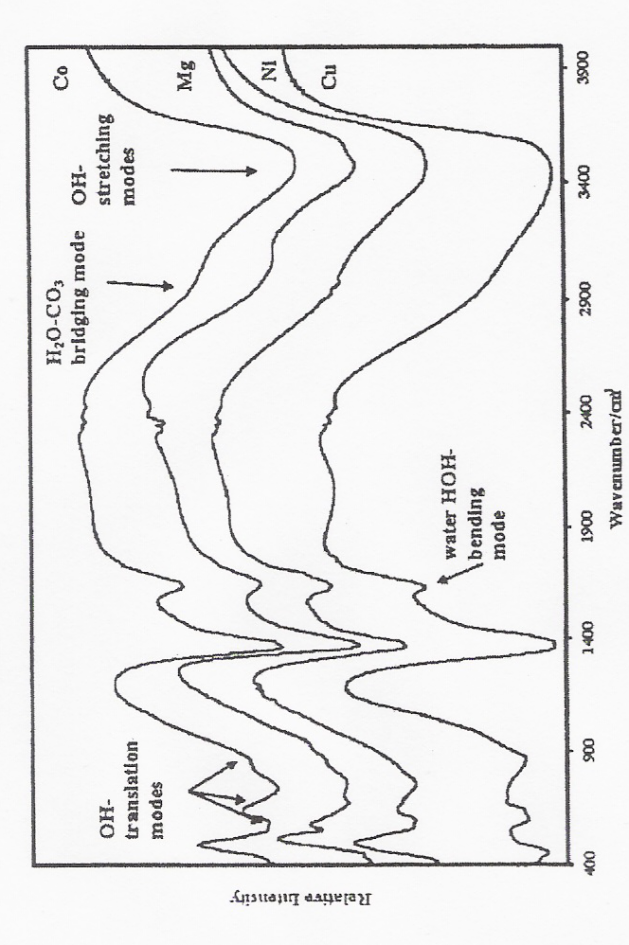

Figure 2.6: IR spectrum showing peaks attributed to water for various metal-containing HTlc’s [54] (reprinted with permission from Nova Science Publishers)

Water bending modes can be recognized in the IR spectrum between ca. 1500 – 1700 cm⁻¹ accompanied by OH-stretching vibrations in the 3000 – 4000 cm⁻¹ region (Figure 2.6) [1, 54].

2.5.3. Thermal methods

HTlc’s usually give two transitions when subjected to thermal treatment [1]:
- At low temperature due to a loss of interlayer water. There is no collapse of the hydrotalcite-like structure and this step is reversible
- At high temperatures due to the removal of hydroxyl groups from the brucite-like layer, as well as removal of the anions such as the carbonate ions.
It is, however, possible to have the first and second transition in 2 stages, as these depend on factors such as the ratio of the divalent and trivalent metal ion, the type of anions, the low temperature treatment etc. [1]. In a pioneering paper on a MgAl-HTlc for example, Miyata reported three thermal transitions at 280 °C, 400 °C and 450 °C due to the loss of interlayer water, of structural hydroxide groups and water and of interlayer carbonate ions respectively [76]. These results were confirmed in later studies [77, 78].

2.5.4. Other methods

Both scanning electron microscopy (SEM) and transmission electron microscopy (TEM) can be applied to HTlc’s. In general LDH’s present a hexagonal platelet morphology [1, 16, 54]. Ageing of the precipitated layered double hydroxides gives rise to an increase in the crystallites as shown by Basile and co-workers, while Reichle showed that crystallite size increases with increasing ageing temperature [79, 80].

BET surface area measurements available in the literature for HTlc’s range from a few m²/g to over 100 m²/g [54]. This technique is useful to follow the surface area development of the catalyst with different treatments e.g. calcinations, ageing, hydrothermal treatments etc. Literature suggests that calcination of the catalyst at moderate temperatures leads to an increase in surface area [54].
An elemental analysis of the catalyst can be obtained by both inductively coupled plasma-optical Emission Spectroscopy (ICP-OES) and EDX. While the former gives a good representation of the ratio of metals in the bulk of the catalyst, EDX provides a near surface representation of the metal content.

2.6. Hydrotalcite-like compounds in catalysis

Synthetic hydrotalcite-type compounds, as such or after thermal decomposition, have been found to be useful catalysts for various types of reactions such as polymerization of alkene oxides, hydrogenation reactions, oxidation reactions etc. [54]. They have therefore been well researched and often exploited with environmental and economic concerns being a priority when designing the system.

The specific features of HTlc’s and their decomposition products such as their high surface area (100 – 300 m²/g) and the homogeneous and thermally stable interdispersion of the elements makes them ideal for use in the catalysis industry [54]. Furthermore, these compounds can be tailored to suit their specific application as will be seen by the examples discussed below.

2.6.1. HTlc’s as catalyst supports

Hydrotalcite-like compounds have found application as catalyst supports. The purpose of the material in this case is to provide a high surface area, to be inert and thermally stable for the active phase [1]. These catalysts often show improved catalytic activity than conventional catalysts. Gold supported on Mg_{x}AlO hydrotalcite-type catalysts was reported by Ching-Tu Chang et al. and used for CO oxidation [15]. The calcination temperature of the support and the final catalyst determined the ratio of the gold oxidation states in the catalyst and hence the catalytic activity. The oxidative dehydrogenation of n-butane has also been studied using vanadium oxides supported on Mg-Al hydrotalcites [43]. In this study, the specific activity of the catalyst was found to increase with increasing vanadium loading, while the conversion of n-butane was found to be relatively similar. Further, a novel heterogenised palladium supported on hydrotalcite of formula Mg₆Al₂(OH)₁₆CO₃.4H₂O was reported by Kaikuchi et al. for the selective oxidation of alcohols using molecular oxygen [82]. They found the catalyst to be efficient for a wide range of alcohols and that the reactions proceed with good yields.

2.6.2. HTlc’s in air decontamination reactions

Reactions of high environmental interest such as SO_{x} and NO_{x} removal, have found use for calcined HTlc’s [54]. A Cu/Mg/Al HTlc, for example, was reported to catalyse both NO decomposition and NO reduction by propane [81]. The catalyst contained ca. 9 wt% of CuO, was calcined at 1023 K and activated under H₂ at 773 K for 3 min [81]. In the NO decomposition, the initial conversion of ca. 95% decreased rapidly with time-on-stream, whereas total conversion was reported for the reduction of propane. The observed difference in conversion for the two reactions was attributed to thermodynamic limitations [81]. In comparison, a MgFe-HTlc has been reported to decompose NO at 673 K, showing conversions of < 27 % and impractical experimental conditions [54, 83].

2.6.3. Advances in natural gas conversion

Natural gas is of high availability and of low cost and activation of its principal component CH₄ to form CO and H₂ (synthesis gas) is an important industrial reaction as various chemical processes require syngas in various H₂ / CO ratios [54]. Current syngas technologies are capital and energy intensive and the process is therefore being continually researched in order to improve this [54]. Nickel containing catalysts prepared via HT precursors have been used to catalyse such reactions, as these catalysts are thought to slow down the growth of nickel particles and hence reduce coke formation as compared to catalysts prepared by other methods [54]. The use of NiAl or NiMgAl HTlc’s has been well established with Bhattacharyya et al. suggesting that nickel catalysts prepared from hydrotalcite precursors are superior in terms of stability and show higher activity than commercial Ni-supported catalysts [84, 85]. They attribute this to the crystallites with a spinel-like phase that surrounds the Ni particles.

2.6.4. HTlc’s as redox catalysts

Hydrotalcite type catalysts have been used in oxidation reactions such as those for aromatic compounds and alcohols, as well as reduction and dehydrogenation reactions. Specific examples are discussed in the following section.

2.6.4.1. Oxidation of alcohols

Velu et al. investigated a series of CuZnAl ternary oxide catalysts derived from CuZnAl hydrotalcite-like precursors for the partial oxidation of methanol to hydrogen [40]. The catalysts were reported to have good catalytic activity reaching methanol conversions of 40 % – 60% with high selectivities to H₂ and CO₂ [40]. The oxidation of allylic and benzylic alcohols with molecular oxygen was achieved using ruthenium containing HTlc’s [86, 87]. The study showed that primary allylic and benzylic alcohol groups are converted into the corresponding aldehydes.

2.6.4.2. Oxidation of aromatic compounds

The liquid phase hydroxylation of phenol using H₂O₂ as the source of oxygen was tested using a copper containing HTlc [88]. The reaction yielded hydroquinone and catechol in almost equal amounts. Literature has also shown that p-hydroxybenzaldehyde, which is an important chemical for the pharmaceutical and perfume industry, may be produced by the liquid phase oxidation of p- cresol using oxygen as the oxidant and various cobalt containing HTlc’s [89].

2.6.4.3. HTlc’s in dehydrogenation reactions

Styrene has multiple applications as a monomer for synthetic polymers and as such its synthesis is of industrial importance. The use of HTlc’s in the dehydrogenation of ethylbenzene to styrene is reported using natural and aluminium pillared clays as well as those HTlc’s with mesoporous properties [25, 28]. The use of vanadium containing layered double hydroxides under a carbon dioxide flow showed that styrene yield and selectivity increases with increasing vanadium content [25]. The use of Mg-Fe-Al HTlc’s produced ethylbenzene conversions of 60 % and styrene selectivity of 95% for 3hrs at 550 °C [28]. Further, there exists a patent describing the use of HTlc’s for the dehydrogenation of C₆ – C₂₀ aliphatic hydrocarbons to aromatics in a fixed or fluidized bed reactor [89]. The findings suggest that the catalyst works better than conventional catalysts.
Hydrotalcite-like catalysts are evidently a complex class of materials that has been well researched and finds many different applications. Their versatility, as well as past experience with these types of compounds, has therefore led to this family of clays being the catalytic system of choice in this research [91].

References:
- F. Cavani, F. Trifiró and A. Vaccari, Catal. Today, 11, 1991, 173
- E. Manasse, Am. Soc. Toscana Sci. Nat. Pisa PV, 24, 1915, 92
- W. Feitknecht, Helv. Chim. Acta.,25, 1942, 131
- W. Feitknecht, Helv. Chim. Acta.,25, 1942, 555
- R. Allman, Acta Cryst., B24, 1968, 972
- H.F.W. Taylor, Miner. Mag., 37, 1969, 338
- F.J. Brocker and L. Kainer, German Patent 2,024,282, 1970, to BASF and UK Patent, 1,342,020, 1971, to BASF AG
- A. Vaccari, Appl. Clay Sci., 14, 1999, 161
- B. F. Sels, D.E. Vos and P.A. Jacobs, Catal. Rev., 43, 2001, 443
- S.Albertazzi, F. Basile and A. Vaccari, Clay Surface: Fundamentals and Applications, Elsevier Ltd., 2004, 496
- F. M. Labajos, V. Rives, P. Malet, M.A. Centeno and M.A. Ulibarri, Inorg. Chem., 35, 1996, 1154
- D. Meloni, R. Monaci, V. Solinas, A. Auroux and E. Dumitriu, Appl. Catal. A: Gen., 350, 2008, 86
- S. Hamada and M. Machida, Sol. State Ionics., 172, 2004, 81
- F.R. de Castro, Y.L. Lam, M.H. Herbst, F.M. Santos and M.M.Pereira, Catal. Today., 133-135, 2008, 210
- C-T. Chang, B-J. Liaw, C-T. Huang and Y-Z. Chen, Appl. Catal. A: Gen., 332, 2007, 216
- W.T. Reichle, Sol. State Ionics., 22, 1986, 135
- S. Blanco, S.R.G. Carrazán and V. Rives, Appl. Catal. A: Gen., 342, 2008, 93
- H.S. Panda, R. Srivastava and D. Bahadur, Mater. Res. Bul., 43, 2008, 1448
- G.Carja, Y. Kameshima, K. Okada, Micropor. Mesopor. Mater., 115, 2008, 541
- J.J. Bavo-Suárez, E.A. Páez-Mozo and S.T Oyama, Micropor. Mesopor. Mater., 67, 2004, 1
- S. Kannan, Catal. Surv. Asia, 10, 2006, 117
- W.T. Reichle, S.Y. Kang and D.S. Everhardt, J. Catal., 101, 1986, 352
- M.J. Holgado, F.M. Labajos, M.J.S. Montero and V. Rives, Mater. Res. Bul., 38, 2003, 1879
- F. Malherbe, C. Forano, B. Sharma, M.P. Atkins and J.P. Besse, Appl. Clay Sci., 13, 1998, 381
- G. Carja, R. Nakamura, T. Aida and H. Niiyama, J. Catal., 218, 2003, 104
- V. Rives, M. A. Ulibarri, Coord. Chem. Rev., 181, 1999, 61
- O. Bergadà, I. Vicente, P. Salagre, Y. Cesteros, F. Medina and J.E. Sueiras, Micropor. Mesopor. Mater., 101, 2007, 363
- Y. Ohishi, T. Kawabata, T. Shishido, K. Takaki, Q. Hang, Y.Wang, K. Nomura and K. Takehira, Appl. Catal. A: Gen., 288, 2005, 220
- G. Mascolo, Appl. Clay Sci., 10, 1995, 21
- J. Don Wang, G. Serrette, Y. .Tian, A. Clearfield, Appl. Clay Sci., 10, 1995, 103
- P. Arpentinier, f. Basile, P. Del Gallo, G. Fornasari, D. Gary, V. Rosetti and A. Vaccari, Catal. Today, 99, 2005, 99
- E.M. Serwicka and K. Bahranowski, Catal. Today,90, 2004, 85
- K. Schulze, W. Makowski, R. Chyży, R. Dziembaj, G. Geismar, Appl. Clay Sci., 18, 2001, 59
- V. Rives, Mater. Chem. Phys., 75, 2002, 19
- M.J. Holgado, S. San Román, P. Malet and V. Rives, Mater. Chem. Phys., 89, 2005, 49
- F. Kovanda, D. Koloušek, Z. Cílová, V. Hulínský, Appl. Clay Sci., 28, 2005, 101
- M.A. Ulibarri, I. Pavlovic, C. Barringa, M.C. Hermosín and J. Cornejo, Appl. Clay Sci., 18, 2001, 17
- A. Vaccari, Catal. Tod., 41, 1998, 53
- K.M. Lee and W.Y. Lee, Catal. Lett., 83, 2002, 65
- S. Velu, K. Suzuki and T. Osaki, Catal. Lett., 62, 1999, 159
- K. Takehira, T. Shishido, D. Shouro, K. Murakami, M. Honda, T. Kawabata and K. Takaki, Appl. Catal. A: Gen., 279, 2005, 41
- V. Rives, Inorg. Chem., 38, 1999, 406
- J.M. López Nieto, A. Dejoz and M.I. Vazquez, Appl. Catal. A: Gen., 132, 1995, 41
- J. Rocha, M. del Arco, V. Rives and M.A. Ulibarri, J. Mater. Chem., 9, 1999, 2499
- F.M. Labajos, M.D. Sastre, R.Trujillano and V. Rives, J. Mater. Chem., 9, 1999, 1033
- Y. Lwin, A.B. Mohamad, Z. Yaakob and W.R. W. Daud, React. Kinet. Catal. Lett., 70. 2000, 303
- K. Kaneda, K. Yamaguchi, K. Mori, T. Mizugaki and K. Ebitani, Catal. Surv. Jap., 4, 2000, 31
- L. Hickey, J.T. Kloprogge, R.L. Frost, J. Mater. Sci., 35, 2000, 4347
- F.M. Labajos, M.J. Sánchez-Montero, M.J. Holgado and V. Rives, Thermo. Acta, 370, 2001, 99
- T. Hibino and A. Tsunashima, J. Mater. Sci. Lett., 19, 2000, 1403
- T.S. Stanimirova and G. Kirov, J. Mater. Sci. Lett., 20, 2001, 453
- H. B. Friedrich and A. S. Mahomed, Appl. Catal. A: Gen., 347, 2008, 11
- www.tulane.edu/~sanelson/eens211/phyllosilicates, Phyllosilicates (micas, Chlorite, Talc and Serpentine, 12 November 2008, accessed 13 September 2010
- V. Rives, Layered Double Hydroxides: Present and Future, Nova Science Publishers Inc., 2001
- S. Miyata and T. Kumura, Chem. Lett., 1973, 843
- R. Allman, N. Jhb. Miner. Mh., 3, 1977, 136
- A. Drits, T.N. Sokolova, G.V. Sokolova and V.I. Cherkashin, Clays and Clay Miner., 35, 1987, 401
- F. Kooli, I. Crespo, C. Barriga, M.A. Ulibarri, V. Rives, J. Mater. Chem., 6, 1996, 1199
- V. Rives, F.M.Labajos, M.A. Ulibarri and P. Malet, Inorg. Chem., 32, 1993, 5000
- W.H. Zhang, X.D. Guo, J. He and Z.Y. Qian, J. Eur. Cer. Soc., 28, 2008, 1623
- N. Das and A. Samal, Micropor. Mesopor. Mater., 72, 2004, 219
- I. Pausch, H.H. Lohse, K. Schürmann and R. Allman, Clays and Clay Miner., 34, 1986, 507
- G. Mascolo and O. Marino, Miner. Mag., 43, 1980, 619
- M.C. Gastuche, G. Brown and M. Mortland, Clay Miner., 7, 1967, 177
- S. Miyata, Clays and Clay Miner., 23, 1975, 369
- R. Allman, Chimia, 24, 1970, 99
- H.F.W. Taylor, Miner. Mag., 39, 1973, 377
- French Patent 2,091,785, 1971, to BASF AG
- D.M. Roy, R. Roy and E.F. Osborn, Amer. J. Sci., 251, 1953, 337
- A. Clearfield, Chem. Rev., 88, 1988, 125
- S. Miyata, Clays and Clay Miner., 31, 1983, 305
- Y. Israeli, C. Taviot-Gueho, J.P. Besse, J.P. Morel and N. Morel-Desrosiers, J. Chem. Soc. Dalton Trans., 5, 2000, 791
- D.P. Dececker, E.M. Gaigneaux and G. Busca, Chem. Eur. J., 15, 2009, 3920
- A. De Roy, J.P. Besse and P. Bondot, Mat. Res. Bull., 20, 1985, 1091
- G.W. Brindley and S. Kikkawa, Clays and Clay Miner., 28, 1980, 50
- S. Miyata, Clays and Clay Miner., 28, 1980, 50
- S.K. Yun and T.J. Pinnavaia, Chem. Mater., 7, 1995, 348
- W. Yang, Y. Kim, P.K.T. Liu, M. Sahimi and T.T. Tsotsis, Chem. Eng. Sci., 57, 2002, 2945
- F. Basile, G. Fornasari, M. Gazzano and A. Vaccari, Appl. Clay Sci., 16, 2000, 185
- W.T. Reichle, Solid State Ion., 22, 1986, 135
- I.J. Shannon, F. Rey, G. Sankar, J.M. Thomas, T. Maschmeyer, A.M. Waller. A.E. Palomares, A. Corma, A.J. Dent and G.N. Greaves, J. Chem. Soc., Faraday Trans., 92, 1996, 4331
- N. Kaikuchi, T. Nishimura. M. Inoue and S. Uemura, Bull. Chem. Soc. Jpn., 74, 2001, 165
- R.S. Mulukula and C. Detellier, J. Mater. Sci. Lett., 15, 1996, 797
- A. Bhattacharyya, M.S. Kleefisch and C.A. Udovich, US Pat. 5,439,861 A 19950808, 1995 to Amoco Co.
- A. Bhattacharyya, W.D. Chang, M.S. Kleefisch and C.A. Udovich, US Pat. 5,399,537 A 19950321, 1995 to Amoco Co.
- T. Matsushita, K. Ebitani and K. Kaneda, Chem. Commun., 1999, 265
- K. Kaneda, T. Yamashita, T. Matsushita and K. Ebitani, J. Org. Chem., 63, 1998, 1750
- K. Zhu, C. Liu, X. Ye and Y. Wu, Appl. Catal. A: Gen., 168, 1998, 365
- L. Yumin, L. Shetian, Z. Kaizheng, Y. Xingkai and W. Yue, Appl. Catal. A: Gen., 169, 1998, 127
- N.J. Blom and E.G. Derouane, EP. 0475357A1, 1991
- H.B. Friedrich, M. Govender, X. Makhoba, T.D. Ngcobo and M.O. Onani, Chem. Commun., 2003, 2922

3. CHAPTER THREE - EXPERIMENTAL

3.1. Introduction

Oxidation catalysis is a complex field of chemistry and, as such, the design of the experimental set-up is crucial for the understanding of the relationship that exists, if any, between the catalyst and the reactant feed. In addition, characterization of the catalyst as well as the reaction products, is vital in providing possible mechanistic information which could help justify the type of reaction pathways adopted by the system.

The following chapter describes the experimental and analytical set-up that was constructed to study the oxidative dehydrogenation of n-octane over hydrotalcite-type catalysts. The synthesis of the various catalysts studied, as well as the techniques used to characterize them, is also discussed.

3.2. Reactor configuration

For the purpose of this research, the reactants (excluding the catalysts) were used in a gaseous form and it was decided that a fixed-bed reactor set-up would be appropriate for this type of work, as opposed to a fluidized-bed reactor. The former is cheaper and easier to construct on a lab scale. A schematic design of the reactor is shown in Figure 3.1. This design is based on previous research but has been modified and reconstructed to suit the scope of this project [1].

The system was designed such that air was used as an oxidant, while nitrogen was introduced in appropriate amounts to achieve the desired reaction condition, such as contact time (C.T.). These gases entered the system through ¼ ″ copper tubing and was regulated to 100 kPa using mini-regulators installed on the reactor control panel as shown in Figure A1 in Appendix A, while their individual flowrates was carefully controlled using calibrated rotameters (refer to Figure A2 Appendix A).
Figure 3.1: Schematic of the reactor set-up

The feed delivery lines post rotameters composed of 316-grade ¼ ″ stainless steel tubing connected using Swagelok fittings of the appropriate size. The feed, n-octane, was introduced via a previously calibrated High Performance Liquid Chromatography (HPLC) pump and was allowed to stand on a 3 decimal place balance. The purpose of this was to be able to continuously monitor the mass of liquid entering the system during any particular time frame. In order to completely vapourise the feed, the feed line after the introduction of n-octane was heated to 180 °C using a CB-100 temperature controller with internal relay output.

The reactor itself was a ½ ″ (internal diameter) stainless steel tube (316-grade), 28 cm in length. This was placed in a copper block (11cm length) and was heated using cylindrical heating elements as shown in Figure A3 in Appendix A. This was insulated using glass wool and covered in a stainless steel jacket. The heating of the reactor block was controlled by a CB-100 temperature controller equipped with a solid state relay. The product line from the reactor was connected to a 150 ml sample cylinder containing a needle valve. This was cooled to ~ 0°C to assist the condensation of the gaseous products. All gaseous products that did not condense were vented via a Ritter wet gas flow meter which monitored the volume of gas produced over a given time frame.

3.3. Analytical system

All products that were obtained from the reaction were quantified using gas chromatography (GC). To this end, a Perkin Elmer Clarus 500 instrument was used and was equipped with both a thermal conductivity detector (TCD) and a flame ionization detector (FID) for the sequential analysis of carbon oxides using a Carboxen 106 PLOT column and all other organic products (using a 50m PONA column), respectively. The GC methods used to achieve this are presented in Appendix A Figure A4.1 and Figure A4.2, respectively.

3.3.1. TCD sampling

Both carbon monoxide and carbon dioxide were produced during the various reactions. These were analysed by withdrawing a 100 μl gas sample using a 500 μl gas tight syringe supplied by Scientific Glass Engineering Pty. Ltd. (SGE). The column was able to clearly separate CO and CO₂ and this data was translated to yield and selectivity as discussed in section 3.4.1.

3.3.2. FID sampling

Gaseous organic products were analysed on the FID by injecting a 0.2 ml gas sample withdrawn at the specific analysis time.
Liquid organic products that condensed in the sample cylinder were drained via the needle valve and accurately weighed. In some cases, two distinct layers were observed i.e. an organic layer and an aqueous layer. These were then carefully separated and re-weighed to obtain their individual contributions to the total mass of liquid products. Chromatograms were then obtained for each of the layers separated.

3.4. Non-catalytic experiments

These experiments were carried out using the reactor set-up described in Section 3.2. The reactor tube was packed with carborundum and the products were quantified by methods previously discussed (refer to Section 3.3).

3.5. Catalytic experiments

All catalytic experiments were carried out in the same reactor tube as that for the non-catalytic experiments. The catalyst (1.5ml) was packed in the reactor tube between carborundum and separated by a thin layer of glasswool, such that it is located within the hottest zone of the copper block.

3.6. Interpretation of reaction data

In order to quantify the data obtained from the chromatograms during one analysis to usable data, such as yield and conversion, parameters including run time, mass of feed used, mass of products collected and gas flow rates were recorded. In addition, the water content of the individual layers in the liquid products was determined by Karl Fischer Analysis using a Metrohm 870 KF Titrino Plus instrument. The values obtained were used to correct the mass of the organic and aqueous layers as shown in the example below. These corrected masses were used in further calculations as discussed in section 3.4.2.1.

Example 3.1: KF calculation
$\text{Mass of organic layer} = 59.5160 \text{g}$
$\text{Average water content as determined by KF} = 1.26 \%$
$\text{Actual Mass of organics in the organic layer} = 59.5160 –\{\left({1.26}/{100}\right)x 59.5160\}$
$= 58.8 \text{g}$
An example of the spreadsheet used to record the parameters discussed thus far and to reflect their subsequent manipulation is shown in Figure A5.1 in Appendix A.

3.6.1. Quantification of TCD results

Both CO and CO₂ were calibrated on the TCD using various volumes of gas from a cylinder of known CO_{x} make-up. The equations thus obtained were used to determine the molar amounts of the gases produced in one particular analysis, as shown in the example below for carbon monoxide. Figure A5.2 in Appendix A shows a simplified example for the quantification of carbon oxides for a reaction carried out.
Example 3.2: Determination of moles carbon oxide
$\text{CO mole calibration: y} = {2.90 x 10}^{ 10}$
$\text{Actual Peak Area} = 922.34$
$Moles in 0.1ml (injection volume) = {922.34}/{{2.90 x 10}^{10}}$
$$= {3.18x 10}^{-08}$$
$Volume gas out for analysis = 14600 ml$
$Moles CO out = moles carbon out =$ ${3.2 x 10}^{-08}$ $×$ ${14600 ml}/{0.1 ml}$
$= 0.005 moles$

3.6.2. Quantification of FID results

3.6.2.1. Identified components

Quantification of the organic and aqueous products was achieved by using both calibration graphs, as well as response factors (RF) for the different products (refer to example 3.3 and Figure A5.3 in Appendix A). For any particular component of the liquid samples, the percent peak area (from the chromatogram) and its RF relative to octane (calculated) were used to calculate the moles of that specific product in a given analysis. These response factors were determined experimentally by injecting a known mass of a component into the GC to obtain the relevant peak area, the results of which were then further translated (Example 3.4 for 1-octene). The actual peak area and equations of calibration graphs were used to quantify gaseous organic products (Example 3.5 for butane). Figure A5.4 in Appendix A shows a simplified example of this type of calculation for the liquid organic products obtained. The aqueous layer is calculated in the identical way. A simplified spreadsheet for the gaseous sample in presented in Figure A5.5 Appendix A.

Example 3.3: Calculation of RF
Assign n-octane a RF of 1 and calculate all other RF’s relative to this.
$Mass octane in standard solution=0.3679 g$
$Mass 1-octene in standard=0.1086 g$
$Injection volume=0.5 μl$
$Volume \% octane=37.48 \%$
$Volume \% 1-octene=10.88 \%$
$Actual volume octane \left(ml\right)= {37.48}/{100} × 0.5 μl =$ 0.2 μl= 0.0002 ml
$Actual volume 1-octene \left(ml\right)= {10.88}/{100} × 0.5 μl =$ 0.05 μl = 0.00005 ml
$Actual Mass octane injected \left(μg\right)= density octane ×0.0002 ml$
$=0.703\frac{g}{ml} ×$ 0.0002 ml = 0.0001 g
$Actual Mass 1-octene injected=density ×0.000054 ml=0.00039 g$
$Average peak area octane=x$
$Average peak area 1-octene=y$
${Area}/{Mass octane= x/{0.000137 = p }}$
${Area}/{Mass 1-octene= y/{0.000386}} = q$
$$RF octene= p/q$$

Example 3.4: Determination of moles of 1-octene from a liquid organic sample
$\% peak area (P.A.) of component = 0.67$
$Calculated R.F. = 1$
$Corrected Area =\% P.A. ×calc.R.F. = 0.67 × 1 =0.67$
$Normalised Area (\%)$ = ${0.67}/{sum of corrected areas of all products in sample × 100}$
$=67$

$Mass component out (g)$ = $\left({normalised area}/{100}\right)$ $×$ $actual mass of organic layer$
$= {67}/{100 ×4.2109 g}$
= $0.0282 g$
$Moles component out (mol) =$ ${Mass component out}/{Molar Mass Component}$
$={0.0282 g}/{112.22 g/mol}$
$= {2.52 x 10}^{-04 } mol$
$Moles Carbon of Component =Moles component ×carbon number$
$= {2.52 x 10}^{-04}$ $×8$
$= {2.02 x 10}^{-03}$ $mol carbon$

Example 3.5 : Determination of moles of butane from a gaseous organic sample
$Actual peak area=1950.58$
$Butane calibration: y= {1.19 x 10}^{12}$
$Moles in 0.2 ml injected= {1950.58}/{{1.19 x 10}^{12}}$
= ${1.64 x 10}^{-09}$

$Volume of gas out for run=15560 ml$

$Moles butane in volume gas out = {1.639 x 10}^{-09 } × {15560 ml}/{0.2 ml}$
= ${1 x 10}^{-04}$ mol
$Moles carbon of butane out={1.275 x 10}^{-04} ×4$
= ${5.100 x 10}^{-04}$ mol carbon

3.6.2.2. Unidentified components

The contribution of unidentified components in each chromatogram, albeit minimal, was quantified based on the percent peak area of the component relative to the equation of an octane mass calibration graph. Example 3.6 below discusses the calculation for unknown cracked products i.e. products with a carbon number < 8. All such products were grouped together for calculations (refer to Figure A5.6 Appendix A for spreadsheet).

Example 3.6 : Calculation of moles of unidentified cracked components

$\% Peak Area of total Cracked products=0.64$
A response factor of 1 is assumed for the cracked and other unidentified products.
$Corrected Area=total \% peak Area ×R.F.$
$=0.64 ×1$
$=0.64$
$Normalised Area = {corrected area}/{total corrected area of components in run ×100}$
$={0.64}/{98.993 ×100}$
$=0.65$
$octane mass calibration \left(g\right):y= {1.59 x 10}^{10}$
$Peak Area of Octane for that run =73383.25$ (obtained directly from chromatogram)
$Normalised Area of octane for that run=87.20$%
$Mass of octane \left(in 0.2 ml\right) based on calibration (g)= {1.24 x 10}^{-05}$ g
$Mass cracked prod.in 0.2 ml ={ \left({1.24 x 10}^{-05 }g×0.6465 \%\right)}/{87.20 \%}$
$= {9.22 x 10}^{-08} g$

$Volume of gas out in the run=208770 ml$

$$Mass cracked products in gas out= {mass cracked prod. ×vol.gas out}/{0.2 ml}$$
$= {{9.22 x 10}^{-08} ×208770}/{0.2}$
$= {9 x 10}^{-02} g$

A molar mass of 75 g/mol and a carbon number of 6 is assumed for the cracked products.
$Moles cracked products= {{9.626 x 10}^{-02}}/{75 g/mol}$
$= {1.3 x 10}^{-03} mol$

$Moles carbon of cracked products= {1.283 x 10}^{-03} ×6$
$= {7.698 x 10}^{-03 }mol$

3.6.3. Carbon balance, conversion, yield and selectivity

The results obtained for the calculations discussed in Section 3.4.1. and 3.4.2. were translated to an easily comparable format viz. conversion, yield and selectivity (Example 3.7 and 3.8). A carbon balance between 95 – 105 was deemed acceptable, thus validating the use of that particular data set (refer to Example 3.9). The numeric values for conversion, yield and selectivity expressed in the sections that follow have a standard deviation of + 1%.

Example 3.7.: Conversion of octane
${moles octane in-moles octane out}/{moles octane in} × 100$

Example 3.8: Selectivity and Yield
$Selectivity= {total moles carbon of component}/{total moles carbon of all products} ×100$
$Yield to component=selectivity to component ×conversion for that run$

Example 3.9.: Carbon balance calculation
$Balance= {moles carbon in}/{moles carbon out }×100$

3.7. Catalyst preparation

3.7.1. Preparation of Mg-V-CO₃ HTlc

These catalysts were prepared via co-precipitation (Chapter 2, section 2.3.1) as discussed in literature [2].
A base solution containing NaOH (0.1 mol) and NaCl (0.1 mol) was prepared by dissolving 40 g NaOH and 11 g NaCl in 100 ml H₂O. A second solution containing the metals was prepared by dissolving 30.33 g MgCl₂.6H₂O (0.1 mol) and 7.87 g VCl₃ (0.05 mol) in 125 ml H₂O. These solutions were added drop-wise over a period of 2 hours to a reaction vessel containing 20 ml H₂O to facilitate mixing. The precipitation of the product was done while maintaining a pH 8 – 10. The resulting slurry was then stirred at 65°C for 12 hours. This was followed by filtration and extensive washing with deionised water until the filtrate was pH neutral to litmus paper. The catalyst was then dried at 110 °C overnight to yield the HTlc.

3.7.2. Synthesis of promoted Mg-V-CO₃ HTlc’s

The Mg-V-CO₃ catalysts were doped with different promoters viz. barium, cesium and boron, each of various loadings. A literature survey for promoted hydrotalcite-like catalysts using various promoters ranging from the alkali metals and noble metals to rare earth metals has shown that a fair amount of work has been done while maintain low loadings of the promoter. Thus, low loadings were investigated for the dopants used in this research [3 – 6]. This was achieved using the incipient wetness technique as outlined in literature [7]. The fraction of the metal loaded was calculated as a function of the molar concentration of Mg²⁺ in the sample, as determined by ICP-OES. Example 3.10 outlines a sample calculation to determine the mass of the barium source needed for a 0.5% barium promoted catalyst. A 0.1M solution of the required dopant was then added to 1 g of the catalyst. The resulting mixture was evaporated to remove excess water (if present) and then dried at 110 °C overnight to yield the promoted Mg-V-HTlc.

Example 3.10.: 0.5% promotion of Mg-V-CO₃ with barium
ICP data shows that the catalyst contains (for example) 0.0107 mol Mg / g catalyst
To promote 1 g of catalyst:
$mol Ba required=0.0107 mol ×0.5\%={5.35 x 10}^{-05 }mol Ba$
$Mass of Ba=mol ×molar mass= {5.35 x 10}^{-05 }mol ×137.33\frac{g}{mol} ={7.35 x 10}^{-03 }g$
$ratio of {\text{BaCl}\text{2}}/{\text{Ba = }{\text{244.26}}/{\text{137.33 =1.778}}}$
∴ $Mass \text{BaCl}\text{2}=Mass Ba ×ratio= {7.35 x 10}^{-05 }×1.778 = {1.31 x 10}^{-02 }g$

All other barium promoted catalysts were synthesized using the method outlined above and the method was adapted based on the desired loading of the promoter. The source of cesium for the Cs promoted catalysts was CsCl, while boric acid (H₃BO₃) was used for the boron promoted catalysts.

3.8. Catalyst treatment conditions

The precipitated HTlc was tested as is, after calcination in a furnace, as well as after in-situ treatment in the reactor. The following section describes the different methods adopted for the treatment of the catalysts.

3.8.1. In-situ treated catalysts

The precursor LDH was packed in the reactor and heated such that the catalyst bed temperature reached and remained stable at 300 °C under a nitrogen flow of 110ml / min. Air was then introduced (75 ml / min) and the catalyst bed temperature was allowed to stabilize at 350 °C. A low flow rate of octane (0.01 ml / min) was allowed to pass through the system while maintaining the temperature for 1 hour. This was followed by a temperature ramp to 450 °C which was maintained for a further hour. In the final step, the bed temperature was raised to 550 °C and maintained for 3 hours. The catalyst was allowed to then cool to 300 °C under an air flow only (75 ml / min) at which point catalytic runs were initiated. The conditions used correspond to ~ 2% octane in air, a contact time of 0.65s and a HC: O₂ ratio of 0.09.

3.8.2. Calcination

Calcination of the HTlc’s was carried out in a PyroTherm Furnace under an air atmosphere. The sample was heated to 200 °C and maintained for 2 hours at this temperature. The temperature was then ramped at 10 °C / min to 550 °C, maintained for 3 hours and then cooled to room temperature. The calcination temperature program was chosen based on the planned experimental testing conditions i.e. the catalyst would be tested until 550 °C in the reactor and it was envisioned that calcining up to this temperature would reduce the possibility of phase changes in the catalyst during the reaction. Whether or not phase changes did occur, cannot be said for certain as the reaction generates CO₂ and water which are conditions that may lead to the “memory effect”. In addition, previous work has employed similar calcination temperature programs [1, 8].

3.9. Catalyst characterisation

Various techniques were used to characterize the catalysts and the sections that follow briefly describe some of the parameters used for each of the characterization techniques, as well as succinct descriptions of the instruments used.

3.9.1. XRD

Powder XRD analyses were carried out on finely ground samples using a Philips PW1050 diffractometer containing a monochromated Co Kα radiation source. The samples were scanned from 3° to 75 ° 2θ using a scanning step of 0.02 ° and a counting interval of 1 °/min. The data was captured using a Sietronics 122D automated micro-processor and the results were quantified using JCPDS files to determine the phases present in the sample.

In-situ XRD analyses were carried out on a Bruker D8 Advance instrument. This was equipped with a XRK 900 reaction chamber, a TCU 750 temperature control unit and a Cu radiation source. Diffractograms were obtained at 50 °C intervals from room temperature to 600 °C.

3.9.2. ICP-OES

The concentrations of the elements present in both the promoted and unpromoted catalyst samples were obtained by ICP-OES using a Perkin Elmer, Optima 5300 DV ICP-OES. Samples were prepared by digesting 0.1 g of material with 6 ml HCl using a hotplate.

3.9.3. BET surface area measurements

Surface area measurements (10 point average analysis) and total pore volume determination was obtained using a Micromeritics Gemini 2375 instrument. Prior to analysis, the powdered samples (~ 0.03 g) were degassed overnight at 200 °C using a Micromeritics FlowPrep 060 instrument.

3.9.4. TGA / DSC analysis

Characterisation by thermal methods was obtained using a SDT Q600 TA Instrument. Samples were analysed from 0 °C to 700 °C using a ramp rate of 10 °C / min and a nitrogen flow of 5.0 ml / min.

3.9.5. Electron microscopy

The samples were coated with carbon using a JEOL JEE 1C vacuum evaporator and Scanning Electron Microscopy was carried out using a JEOL JSM 6100 microscope. Elemental analyses on these samples were obtained using a Bruker detector and Esprit 1.8 software.
TEM images were taken on a JEOL JEM 1010 Microscope operated at a voltage of 100 kV. Sample preparation involved deposition of a small amount of the catalyst between two formvar coated copper grids and the images were captured with a MegaView III Soft Imaging System.

3.9.6. Infrared spectroscopy (IR)

A Perkin Elmer Spectrum 100 was used to obtain infrared spectra by Attenuated Total Reflectance (ATR). The samples were finely ground prior to analysis.

3.9.7. Temperature programmed analysis

Temperature Programmed Desorption (TPD) and Temperature Programmed Reduction (TPR) were carried out using a Micromeritics Autochem II Chemisorption Analyser. Desorption studies were carried out from 80 °C to 600 °C at a ramp rate of 10 °C / min with 1 measurement every 1.0 s, whereas reduction studies were carried out from 80 °C to 950 °C using the same ramp rate and measurement parameters as the desorption studies.

3.10. Chemicals and reagents

All chemicals used for synthetic procedures were obtained from Aldrich. ICP standards (1000 ppm) were purchased from Polychem Supplies.

References

- H. B. Friedrich and A. S. Mahomed, Appl. Catal. A: Gen., 347, 2008, 11
- V. Rives, F.M. Labajos, M.A. Ulibarri, P. Malet, Inorg. Chem., 32, 1993, 5000
- A. R. Pillai and E. Sahle-Demessie, Appl. Catal. A: Gen., 281, 2005, 31
- K. Karaskova, L. Obalova, K. Jiratova and F. Kovanda, Chem. Eng. J., 160, 2010, 480
- T. Miyata, D. Li, M. Shiraga, T. Shishido, Y. Oumi, T. Sano and K. Takehira, Appl. Catal. A: Gen., 310, 2006, 97
- A.F. Lucredio, G. Jerkiewickz and E.M. Assaf, Appl. Catal. A: Gen., 333, 2007, 90
- N. Barrabes, D. Cornado, K. Foettinger, A. Dafinov, J. Llorca, F. Medina and G. Rupprechter, J. Catal., 263, 2009, 239
- H.B. Friedrich, M. Govender, X. Makhoba, T.D. Ngcobo and M.O. Onani, Chem. Commun., 2003, 2922

4. CHAPTER FOUR - CHARACTERISATION

The physicochemical charactersation of the active phases in a catalyst is imperative in the understanding and rationalization of the reaction mechanisms that exist in a particular catalytic system. For the purpose of this research, a combination of in-situ X-Ray diffraction, Powder X-Ray Diffraction (PXRD), Infrared Spectrocopy (IR), Electron Microscopy (EM), Inductively-Coupled Plasma – Optical Emission Spectroscopy (ICP-OES), Thermogravimetric Analysis (TGA) coupled with Differential Scanning Calorimetry (DSC), as well as Temperature Programmed Desorption (TPD) and Temperature Programmed Reduction (TPR) were used to obtain a structural and morphological description of the various catalysts studied.

4.1. Characterisation of the Mg-V-HTlc

The powder X-Ray diffractogram of the uncalcined Mg-V-HTlc (Figure 4.1) shows generally broad peaks of relatively low intensity which is indicative of small particle size. This may be described as being quasi-amorphous such that the structure of the material has no definite order in the stacking of the interlayers due to the distortion of the polyhedra of the vanadium ions [1,2]. Ascription of the peaks was done assuming a 3R packing of the layers [1]. The c parameter was calculated as an average of the (003) and (006) planes according to equation 4.1., due to the broad nature of the first and second harmonic [1]. If, however, these peaks were sharp and intense, as was observed for pure hydrotalcite for example, then the c parameter can be derived directly from the position of either the first or second harmonic [1]. The average cation-cation distance was derived from the (110) plane. Table 4.1 presents the calculated lattice parameters and compares them to literature [2].

$$c= 3/2 \left\lfloor \left(d\left(003\right)+ 2d\left(006\right)\right)\right\rfloor$$
Equation 4.1: Determination of the c parameter

Figure 4.1: Powder X-Ray diffractogram of uncalcined Mg-V-HTlc

Table 4.1: Experimental and literature comparison of lattice parameters
Catalyst | Mg/V ratio | a (Å) | c (Å)
Mg-V-HTlc | 1.90 | 2.91 | 21.05
Literature Mg-V-HTlc [2] | 2.29 | 3.12 | 19.26

Both the a and c parameters were different from those reported in literature and this may be attributed to the difference in metal ratios of the catalysts. The value of the a parameter was found to be lower due to a slight decrease in the content of the Mg(II) which has a greater crystal radius than the V(III); 0.86 Å compared to 0.78 Å [3]. The slightly higher c parameter is due to an increase in the formal positive charge of the brucite-like layers as a result of the increased V(III) content [1].

The powder diffractogram of the in-situ treated Mg-V-HTlc (Figure 4.2) shows a loss of the original HT-like phase, while the MgO (JCPDS 4-0829) showing characteristic peaks at 2θ equal 51 ° (d-spacing of 2.09 Å) and 74 ° (d-spacing of 1.49 Å) is present. The mixed magnesium vanadium oxide phases are also observed viz. magnesium ortho vanadate (Mg₃V₂O₈ JCPDS 12-405) showing characteristic peaks at 2θ equal 34.3 ° (d-spacing of 3.04 Å), 2 θ equal 36.5 ° ( d-spacing of 2.86 Å) and 42 ° (d-spacing of 2.5 Å) are dominant. The peak at 2 θ equal 35.8 ° (d-spacing of 2.9 Å) is tentatively assigned to the presence of magnesium pyro vanadate [4]. The material is also slightly more crystalline and is likely to have a smaller particle size distribution than the uncalcined sample, inferred from the intensity of the diffractogram [5].

Figure 4.2: PXRD of the in-situ treated Mg-V-HTlc

The diffractogram of the calcined sample (Figure 4.3) also shows a loss in the hydrotalcite-like phase with the concomitant formation of the MgO and magnesium vanadium mixed oxide phases (as observed for the in-situ treated catalysts discussed previously). The diffractogram displays peaks that are generally sharp and intense, suggesting a very crystalline material compared to the uncalcined and in-situ treated samples.

The in-situ XRD of the Mg-V-HTlc under a nitrogen atmosphere from room temperature to 550 °C is presented in Figure 4.4. The initial room temperature scan shows the presence of the hydrotalcite-like peaks which decrease progressively with an increase in temperature. At ~ 300 °C, the hydrotalcite-like phase is lost with a concomitant formation of the MgO and mixed Mg_{x}V_{y}O_{z} phases. The peaks associated with these phases are relatively sharp and intense and may be attributed to a more crystalline material than the precursor [5].
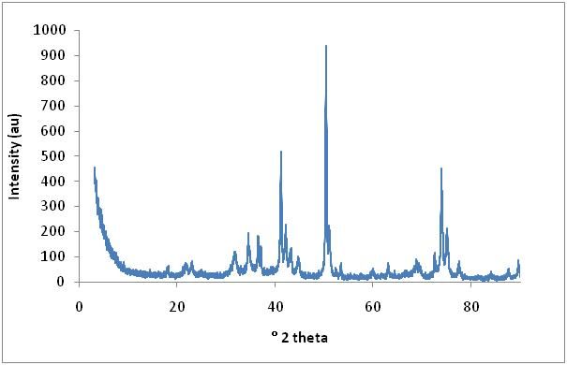

Figure 4.3: PXRD pattern of the calcined Mg-V-HTlc

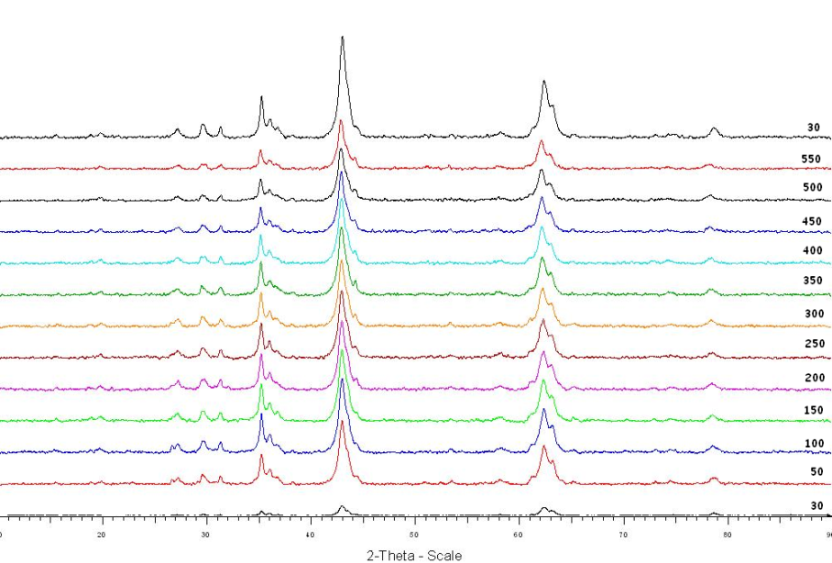

counts

Figure 4.4: In-situ XRD of the Mg-V-HTlc
The IR spectrum for the Mg-V-HTlc (Figure 4.5), shows a broad peak at 3421 cm⁻¹ which is attributed to OH⁻ stretching vibrations. The carbonate bands were observed at 1481 cm⁻¹ , 1421 cm⁻¹ , 880 cm⁻¹ and 667 cm⁻¹ respectively, while the smaller band observed at ~ 1650 cm⁻¹ is attributed to water bending vibrations [6, 7]. The spectra of the in-situ treated catalyst as well as the calcined sample (Figure 4.5), showed a smaller peak due to OH⁻ stretching vibrations (~3360 cm⁻¹). This observation is expected as the catalyst is subjected to heat during treatment and subsequent loss of water molecules from the catalyst layers, accompanied by structural changes from HTlc to mixed oxide, occurs. The calcined and in-situ treated samples also show only one CO₂ band at 1438 cm⁻¹, unlike the uncalcined sample. It is reported that the splitting of the υ₃ band into 2 bands at 1400 – 1383 cm⁻¹ and 1369 – 1364 cm⁻¹ is due to water molecules being hydrogen bonded to interlayer carbonate ions [6]. During calcinations and in-situ treatment, these bonds are broken due to the evolution of both water molecules and CO₂ and is confirmed by thervogravimetric analysis on the Mg-V-HTlc.

Figure 4.5: Infrared Spectra of uncalcined, calcined and in-situ treated Mg-V-HTlc’s

The data obtained from ICP analysis for the concentrations of magnesium and vanadium in the catalyst is presented in Table 4.2. The catalyst was therefore found to show good incorporation of both the metals.

Table 4.2: ICP results for Mg-V-HTlc
Theoretical Mg/V ratio | Actual Mg/V ratio
2 | 1.9

Surface area measurements were obtained for the uncalcined, calcined and in-situ treated samples and are presented in Table 4.3. The uncalcined sample shows the highest surface area, while the calcined sample shows the lowest. According to literature, calcination at moderate temperatures leads to an increase in surface area [6]. The Mg-V-HT was, however, calcined at 550 °C and treated in-situ to 550°C, a relatively high temperature at which the MgO and mixed oxide phases are dominant. The XRD of the calcined catalyst shows a much more crystalline material than the in-situ treated sample which therefore accounts for the lowest surface area obtained for the calcined sample.

Table 4.3.: BET surface areas of Mg-V-HTlc’s
CATALYST | SURFACE AREA (m²/g)
Uncalcined Mg-V-HTlc | 65.4
Calcined Mg-V-HTlc | 26.2
In-situ treated Mg-V-HTlc | 32.5

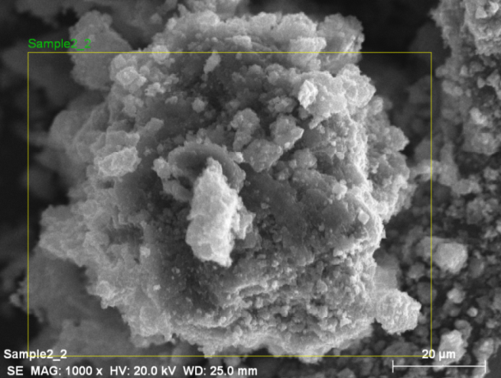
Scanning Electron Microscopy images of the uncalcined Mg-V-HTlc, showed a very irregular surface morphology (Figure 4.6). Elemental mapping to determine the distribution of magnesium and vanadium across the surface, using the area shown in Figure 4.6, suggest that no surface agglomeration of either metal exists (Figure 4.7 a-d). The SEM image of the calcined catalyst (Appendix B, Figure B1) and its related elemental mapping (Appendix B, Figure B2 a-c), as well as those for the in-situ treated sample (Appendix B, Figure B3 and B4 a-c), suggests that thermal treatment by either method does not significantly affect the surface morphology or the distribution of the metal ions.

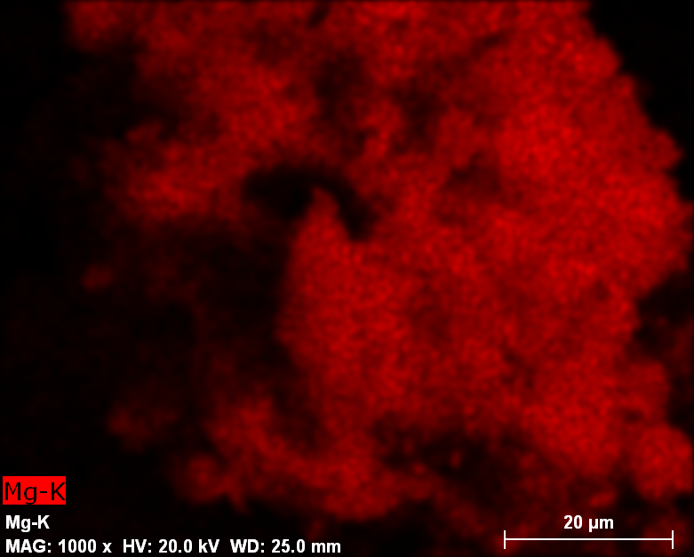
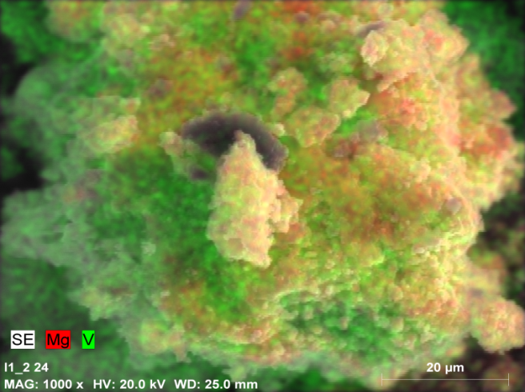
Figure 4.6: SEM image of Mg-V-HTlc
b
a
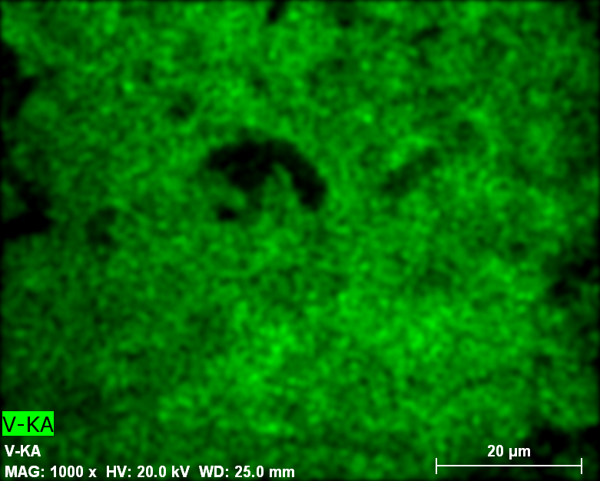
c

Figure 4.7: a) Composite scan showing Mg and V b) Mg distribution c) V distribution
Micrographs obtained from TEM on the uncalcined sample (Figure 4.8), clearly showed the hexagonal platelet morphology of the material. The presence of darker regions in the image may be due to overlapping of the HT-like layers and is consistent with literature reports for these lamellar type compounds [7]. The selected area electron diffraction image shows the presence of a spotty ring pattern which suggests that the size of the particles in the material is small. The presence of spots themselves suggests that the material contains some degree of crystallinity.
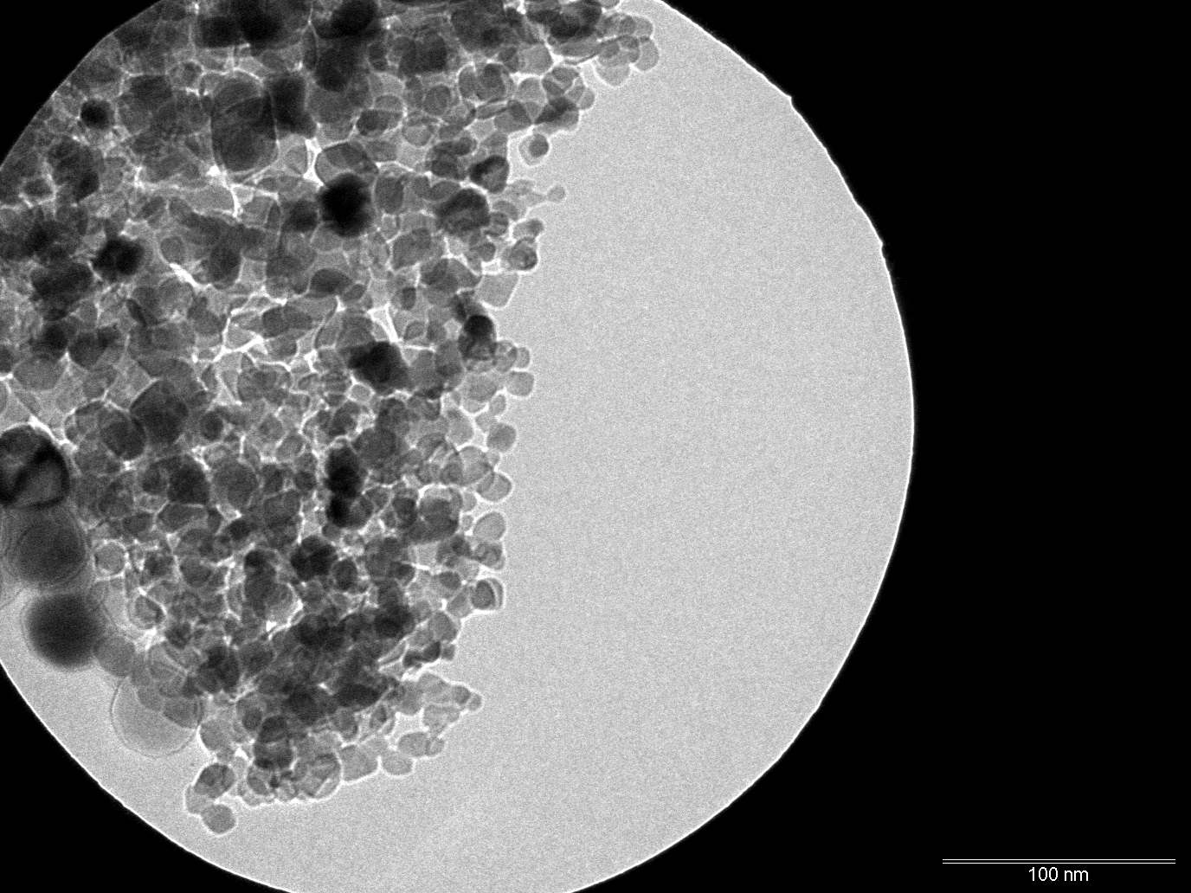

Figure 4.8.: TEM image of the uncalcined Mg-V-HT
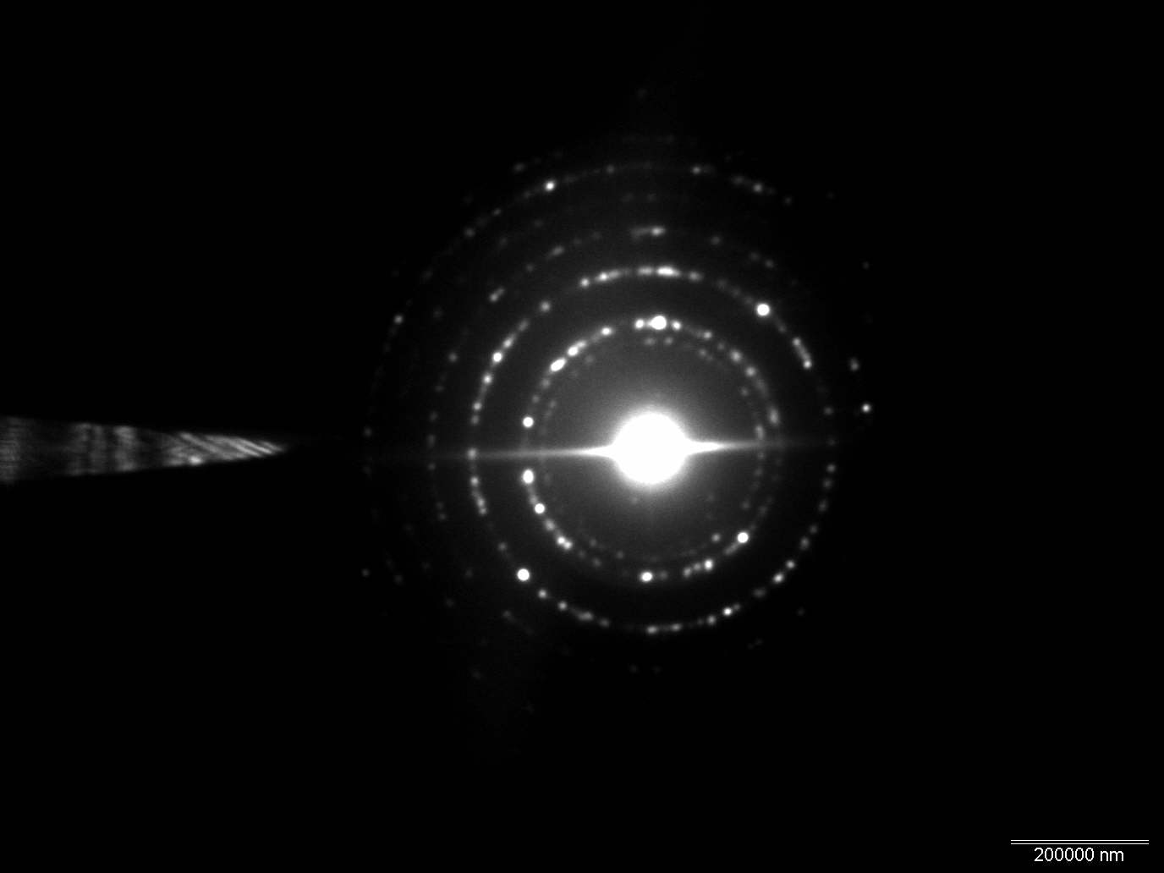

Figure 4.9: Selected area electron diffraction TEM image of uncalcined Mg-V-HTlc
The thermogravimetric analysis and differential thermogravimetric analysis on the uncalcined Mg-V-HT is presented in Figure 4.10. Three weight loss steps are clearly identified accounting for a total weight loss of ~ 40 weight %. The first transition which shows a derivative peak at ~ 75°C and corresponds to a weight loss of ~ 12.9% (0.549mg), is due to a loss of adsorbed water and is comparable to literature reports for a sample containing both Mg(II) and V(III) [6, 8]. Drying of the catalyst after synthesis removes most of this water; however, it is possible for re-adsorption to occur during handling of the sample and subsequent exposure to ambient conditions. This can therefore result in partial rehydration of the catalyst giving rise to a peak between room temperature and 100 °C [6]. Early work by Miyata suggests that the second weight loss (4.47% , 0.190mg) occurs at ~230 °C and is attributed to the removal of interlayer water, while Stanimirova et al. suggest that this loss can occur in two consecutive stages (140-180 °C and 240 – 260 °C) [9 - 11]. The final transition observed shows a derivative peak at ~ 400°C and accounts for a weight loss of ~ 18.6% (0.79 mg). This has been attributed to a combination of decarboxylation and dehydroxylation which is thought to occur up to ca. 450-500 °C [6]. The DTA profile recorded (Figure 4.11) shows the presence of three endothermic peaks, which coincide with the weight losses observed in the DTG curve. This suggests that the dehydroxylation and decarboxylation are endothermic processes.

Figure 4.10: The TG and DTG curves for Mg-V-HTlc

Figure 4.11: DTA profile for the uncalcined Mg-V-HTlc

The TG and DTG curves for the in-situ treated sample (Figure 4.12) showed a smaller total weight loss of ~ 12% as compared to the uncalcined sample. This observation is due to the heat treatment of the catalyst, which results in a loss of water and possibly CO₂ and is accompanied by structural changes as seen by XRD. Similar to the uncalcined catalyst, three weight loss steps are observed, however, these occur at higher temperatures than the corresponding peaks for the uncalcined Mg-V-HTlc (Appendix B Figure B5 for TGA comparison) i.e. at 121 °C, 398 °C and 583 °C respectively. The second peak that was observed in the uncalcined sample is lost upon in-situ treatment, suggesting that there is no interlayer water present in the material. The loss of the peak can be confirmed by XRD on the in-situ treated catalyst which shows a loss of the hydrotalcite-like structure, thereby implying that interlayer water may no longer be present.

Figure 4.12: TG and DTG curves for the in-situ treated Mg-V-HTlc

TPR analysis on the Mg-V-HTlc after calcination showed the presence of a single deep reduction peak, although slightly asymmetric, with a maximum at ca. 730 °C (Figure 4.13). This peak can be attributed to the reduction of vanadium ions present in the catalyst. Literature reports, using similar experimental conditions for TPR studies on a Mg-Al-HTlc, showed no reduction peaks and therefore infer that Mg and Al cannot be reduced under the conditions used [12]. It can therefore be said that the reduction peak observed for the Mg-V-HTlc is likely due to the reducible vanadium ions in the sample. The total amount of hydrogen consumed during the study was found to be 0.054 μmol and using the vanadium content of the sample (188mg V / g catalyst) the percent reducibility of the catalyst was found to be 65%. This corresponds to an average vanadium oxidation state of 3.7 in the reduced catalyst [12]. This, together with the shape of the peak, suggests that vanadium was reduced predominantly to V⁴⁺ and that minor further reduction to V³⁺ also occurred [13]. XRD analysis obtained for the TPR sample (Figure 4.14) and the assignment of the d-spacings (Table 4.4) indicate that the two main phases that are formed after reduction are the MgO (JCPDS 4-0829) and Mg₂VO₄ in which vanadium exists as the V^{IV} species [14]. It should be noted that due to the small amount of sample available after TPR, a background scan of the sample holder was done and the peaks used as an “internal standard” [13]. It therefore follows that the minor peak at ca. 89.7 ° 2 theta is assigned to the XRD of the sample holder (Appendix B Figure B6 for diffractogram).

Figure 4.13: TPR curve for the Mg-V-HTlc

Figure 4.14: XRD of the TPR sample for Mg-V-HTlc
Table 4.4: Peak assignments for the Reduced Mg-V-HTlc from TPR
d-spacing (Å) | Peak Assignment
4.86 | Mg₂VO₄ ª
2.97 | Mg₂VO₄ ª
2.53 | Mg₂VO₄ ª
2.43 | Mg₂VO₄ ª
2.10 | MgO
1.62 | Mg₂VO₄ ª
1.49 | MgO
1.29 | XRD sample holder ^{b}
ª [12]
^{b} Appendix B Figure B1
^{c} JCPDS 4-0829

Temperature Programmed Desorption studies on the Mg-V-HTlc showed the presence of two types of acid sites (Figure 4.15). The first, a weak acid site, occurs between 100°C - 200°C, while the medium acid site occurs between 300°C - 550°C. In order to determine the total acidity of the catalyst, the amount of NH₃ consumed was calculated by applying the NH₃ calibration curve to the results and using the Autochem (II) software to derive the optimized peaks. The Mg-V-HTlc was found to have a total acidity of 904.5 μmol NH₃ / g catalyst.

Figure 4.15: TPD curve for the Mg-V-HTlc

4.2. Characterisation of barium promoted catalysts

Barium promoted catalysts were synthesized and ICP-OES analysis was used to determine the barium loading (weight percent) of each catalyst (Table 4.5). The Mg/V ratios in each of the catalyst were found to be similar to the unpromoted catalyst i.e. 2.
Table 4.5: Barium loadings on each catalyst as determined from ICP-OES
CATALYST | % BARIUM | Mg/V RATIO
Catalyst 1 | 0.2 | 1.8
Catalyst 2 | 0.7 | 1.9
Catalyst 3 | 1.4 | 1.9
Catalyst 4 | 6 | 1.8

In order to maintain simplicity in terms of the catalyst naming, it was decided that barium promoted Mg-V-HTlc’s will be named according to the weight percent of barium in the sample as presented in Table 4.6 below.

Table 4.6: Catalyst naming system for Ba promoted Mg-V-HTlc’s
% BARIUM | CATALYST NAME
0.2 | 0.2% BaMg-V-HTlc
0.7 | 0.7% BaMg-V-HTlc
1.4 | 1.9% BaMg-V-HTlc
6 | 6% BaMg-V-HTlc

The XRD patterns of the 0.2% and 0.7% barium promoted catalysts (Figure 4.16 and Figure 4.17 respectively) shows the presence of the hydrotalcite-like peaks observed for the Mg-V-HTlc (at ~ 17 °2θ, ~ 27 °2θ, ~ 43 °2θ and ~ 70 °2θ). No additional phases were detected; here too the spike at ~ 30 °2θ is due to the XRD sample holder. The 1.4% barium promoted catalyst does, however, show the formation of phases (between 30 - 40 °2 theta) other than those attributed to the hydrotalcite-like structure (Figure 4.18). These peaks have been tentatively (as the hydrotalcite-like peaks are possibly overlapping the peaks associated with the mixed metal phases) assigned to the formation of BaMg₂ (JCPDS 6-0368), BaO₂.8H₂O (JCPDS 3-0306) and BaCO₄ (JCPDS 3-0659). As the barium loading was increased to 6%, these phases were more crystalline in nature, as inferred from the intensity of the peaks in Figure 4.19, and were coupled with the appearance of new peaks in the diffratogram not present in the XRD data of the other barium promoted compounds. The peaks associated with the hydrotalcite-like phase can still be discerned in the XRD diffractogram for the 6% barium promoted catalyst. In addition to the barium phases identified above, other phases that possibly co-exist with the hydrotalcite-like phase in the 6% BaMg-V-HTlc are Ba(OH)₂ (JCPDS 1-0630), Ba(OH)₂.8H₂O (JCPDS 3-0306) and BaCO₃ (JCPDS 5-0378). The distinct production of the additional phases was confirmed by literature, which suggests that barium is too big for octahedral coordination and can form other structures [5]. The values of the lattice parameters presented in Table 4.7. show that, with the exception of the 6% BaMg-V-HTlc, there are marginal increases in the a and c parameter as the barium loading increases. The increase in the a parameter is likely due to the increase in the barium content; Ba(II) has a crystal radius of 1.49 Å, much larger than that for Mg quoted earlier. The formal positive charge of the brucite-like layers is also likely to increase, albeit minimally, as the Ba(II) loading increases and this accounts for the small differences in the c parameter observed. The decreases in both the lattice parameters for the 6% BaMg-V-HTlc is likely due to the presence of additional phases in the material.

Table 4.7: Lattice parameters and Mg/V ratio of barium promoted catalysts
CATALYST | c (Å) | a (Å) | Mg/V
0.2% BaMg-V-HTlc | 23.48 | 3.10 | 1.8
0.7% BaMg-V-HTlc | 23.54 | 3.11 | 1.9
1.4% BaMg-V-HTlc | 23.96 | 3.12 | 1.9
6% BaMg-V-HTlc | 23.50 | 3.07 | 1.8

Figure 4.16: XRD of 0.2% BaMg-V-HTlc

Figure 4.17: XRD of 0.7% BaMg-V-HTlc

Figure 4.18: XRD of 1.4% BaMg-V-HTlc

Figure 4.19: XRD of 6% BaMg-V-HTlc

TPR experiments showed a single, slightly asymmetric reduction peak for each of the catalysts (Figure 4.20) and these results suggest that it becomes increasingly difficult to reduce the catalyst as the barium loading increases. The maxima of the reduction peaks increased with increasing barium loading and were higher than that obtained for Mg-V-HTlc (Section 4.1). The oxidation state of vanadium in the reduced catalyst was found to change marginally with increasing barium loading viz. 0.2% < 0.7%, 0.7% = 1.4% and 1.4% < 6% (Table 4.8). The results suggest that the vanadium in the catalyst was not completely reduced to the +3 state, as also observed for the unpromoted catalyst. The peak shape of the 6% Ba promoted catalyst was found to be flatter than the shape observed in all other catalysts, possibly due to the overlapping of peaks.
Table 4.8: Vanadium oxidation state and % reducibility of Ba promoted catalysts
CATALYST | V OXIDATION STATE (REDUCED CATALYST) | % REDUCIBILITY | Peak T_{max}  (°C)
0.2% BaMg-V-HTlc | 3.1 | 95 | 733
0.7% BaMg-V-HTlc | 3.2 | 87 | 743
1.4% BaMg-V-HTlc | 3.2 | 92 | 754
6% BaMg-V-HTlc | 3.3 | 86 | 787

Figure 4.20: TPR curves for the barium promoted catalysts
TPD results (Figure 4.21 and Table 4.9) show that the acidity of the catalyst decreased with increasing Ba loading. All of the barium promoted samples had a lower total acidity than the Mg-V-HTlc discussed previously (Section 4.1) and showed the presence of weak and medium acid sites. Barium is a basic promoter and an increased concentration in the sample is likely to increase basicity.

Figure 4.21: TPD curves for the Ba promoted catalysts

Table 4.9: Total acidity of Ba promoted catalysts
CATALYST | TOTAL ACIDITY (µmol NH₃/g catalyst)
0.2% BaMg-V-HTlc | 622.8
0.7% BaMg-V-HTlc | 397.7
1.4% BaMg-V-HTlc | 277.2
6% BaMg-V-HTlc | 270.7

The IR spectra for each of the barium promoted catalysts clearly showed the presence of OH⁻ stretching vibrations ( ~ 3350 cm⁻¹ – 3400 cm⁻¹), while the water bending vibrations were observed at ~ 1635 cm⁻¹ (Figure 4.22). Bands attributed to the presence of carbonate ions at ~ 1480 cm⁻¹, 1421 cm⁻¹, ~880 cm⁻¹ and 667 cm⁻¹ were clearly seen in the three lowest Ba loaded catalysts. The 6% BaMg-V-HTlc was found to have one clear band at ~1433 cm⁻¹ and a small shoulder peak in the ~1480 cm⁻¹ region and only one further band attributed to CO₃²⁻ at ~ 878 cm⁻¹. It is likely that the splitting of the carbonate into two bands is not as intense as for the lower loadings due to possible interaction between barium and interlayer water molecules. This reduces the water molecules available for interaction with carbonate ions – resulting in reduced CO₃ bands in the region discussed.

Figure 4.22: IR spectra for Ba promoted catalysts

The surface areas of the catalysts was found to increase with increasing Ba loading, except for the 6% BaMg-V-HTlc which showed a lower surface area than all other Ba containing catalysts (Table 4.10). The increased surface area of the 0.2%, 0.7% and 1.4% catalysts is suggestive of a slightly less crystalline material. The 6% BaMg-V-HTlc is a mixture of phases – almost less hydrotalcite-like as determined from XRD and this is likely to have resulted in the low surface area obtained. In comparison to the unpromoted catalyst, barium was found to increase the surface area of the catalysts, except for the 6% BaMg-V-HTlc.

Table 4.10: Surface area measurements for the Ba promoted catalysts
CATALYST | SURFACE AREA (m²/g)
0.2% BaMg-V-HTlc | 62.9
0.7% BaMg-V-HTlc | 67.1
1.4% BaMg-V-HTlc | 76.4
6% BaMg-V-HTlc | 57.2

The surface morphology of the catalysts was found to be significantly affected by the percent Ba loaded (Figure 4.23). The 0.2% BaMg-V-HTlc and 0.7% BaMg-V-HTlc displayed an irregular surface structure with a “spongy” morphology, similar to the Mg-V-HTlc shown previously. However, the 1.4% BaMg-V-HTlc showed the presence of rod-like particles on the surface and these became more clustered with an increase in barium loading. The large crystal radius of the Ba ion makes it difficult for octahedral coordination. It is therefore likely that at the higher loadings, the excess barium remains on the surface of the HTlc thus causing a change in the expected morphology. The elemental mapping results for the selected areas of the imaged in Figure 4.23 are presented in Appendix B, Figure B5 – Figure B8. The 0.2% and 0.7% samples showed an even distribution of Mg and V. Barium was found to have a single spot of high concentration for the 0.2% loading while the 0.7% Ba loaded sample showed three spots due to clustering of barium. The 1.4% BaMg-V-HTlc also showed a concentration of barium on the surface, corresponding to the spongy surface morphology on the corresponding SEM image, while the V and Mg were fairly evenly distributed. The highest Ba loaded catalyst showed the largest number of spots in the Ba distribution map suggesting a much higher accumulation of Ba on certain regions of the catalyst. The V and Mg distribution for the 6% BaMg-V-HTlc was found to be similar to that observed for all other Ba promoted catalysts.

Thermogravimetric analyses on the barium containing catalysts were similar to that of the Mg-V-HTlc in that each showed three weight loss steps accounting for a total weight loss of 28 % - 34 % (Figure 4.24 – Figure 4.27). The observed losses were due to a combination of dehydroxylation and decarboxylation, as discussed for the Mg-V-HTlc. The presence of the barium in the catalyst did not appear to significantly affect the thermal behaviour of the samples, when compared to the Mg-V-HTlc.

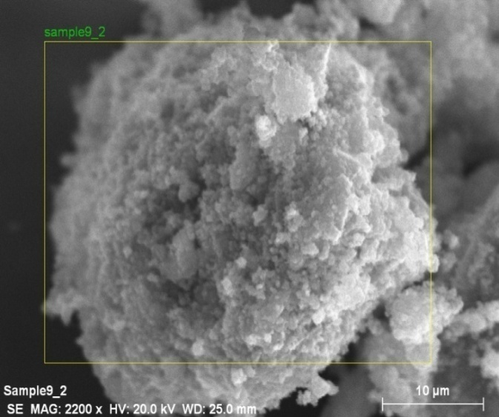
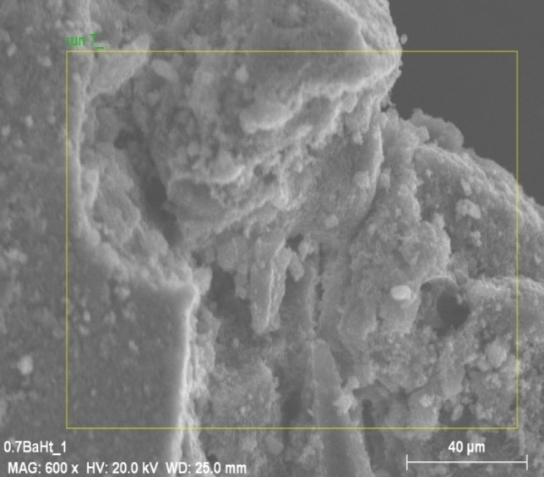
b
a
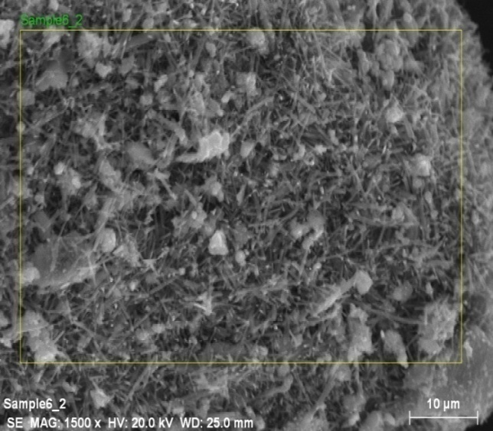
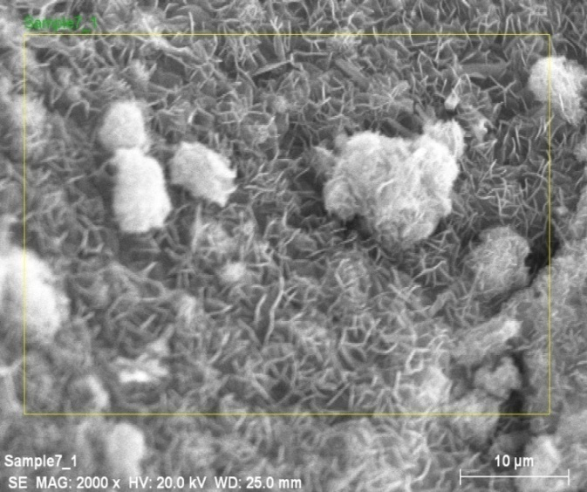
d
c
Figure 4.23: SEM images of a) 0.2% BaMg-V-HTlc b) 0.7% BaMg-V-HTlc c) 1.4% BaMg-V-HTlc d) 6% BaMg-V-HTlc

Figure 4.24: TG and DTG curves for 0.25 BaMg-V-HTlc

Figure 4.25:TG and DTG curves for 0.7% BaMg-V-HTlc

Figure 4.26: TG and DTG curves for 1.4% BaMg-V-HTlc

Figure 4.27: TG and DTG curves for 6% BaMg-V-HTlc

4.3. Characterisation of cesium promoted catalysts

Cesium promoted catalysts were synthesized and ICP analysis used to determine the cesium loading. The results show that Cs loadings of 0.4%, 0.9% and 1.9% were achieved. The Mg/V ratio was found to be 1.8 for each of the promoted catalysts. The catalysts will be named (as was done for the barium promoted samples) according to the weight percent of cesium loaded e.g. the 0.4% Cs-containing Mg-V-HTlc will be referred to as 0.4% CsMg-V-HTlc etc.

XRD studies on the Cs promoted catalysts (Figure 4.28 – Figure 4.30) showed no observable changes in the diffractorgram when compared to the Mg-V-HTlc. This is likely due to the low loading of the metal which did not result in phase changes identifiable by XRD. The lattice parameters that were calculated, presented in Table 4.11, show that all the catalysts have the same cation-cation distance, while the a parameter was found to be similar for each. The increase in the a parameter relative to that calculated for the Mg-V-HTlc (Table 4.1) is possibly due to the presence of cesium, which has an ionic radius of 1.67 Å [15].

Figure 4.28: Diffractorgram of 0.4% CsMg-V-HTlc

Figure 4.29: Diffractogram of 0.9 % CsMg-V-HTlc

Figure 4.30: Diffractogram of 1.9 % CsMg-V-HTlc

Table 4.11: Lattice parameters for Cs promoted catalysts
CATALYST | c (Å) | a (Å)
0.4% CsMg-V-HTlc | 23.3 | 3.1
0.9% CsMg-V-HTlc | 23.2 | 3.1
1.9% CsMg-V-HTlc | 23.2 | 3.1

The surface area measurements of the different Cs loaded catalysts (Table 4.12) suggests that the presence of Cs in different concentrations does not affect the surface area of the catalyst to a great extent, as there are negligible increases in surface area with increasing cesium loading. All three catalysts are, however, slightly higher in area than the Mg-V-HTlc.

Table 4.12: Effect of Cs loading on surface area
CATALYST | SURFACE AREA (m²/g)
0.4% CsMg-V-HTlc | 100.1
0.9% CsMg-V-HTlc | 100.4
1.9% CsMg-V-HTlc | 101.3

The IR spectra of each of the promoted catalysts presented in Figure 4.31, clearly show a broad band around ~ 3400 cm⁻¹ due to OH⁻ stretching vibrations, while those due to water bending vibrations are observed around 1630 cm⁻¹. These peaks are common to the Mg-V-HTlc and Ba promoted catalysts as well. The splitting of the CO₃ bands results in two sharp peaks between 1420 cm⁻¹ and 1485 cm⁻¹ in each promoted catalyst. Additional bands associated with the presence of CO₃ and due to a change in symmetry of the molecule appear around 880 cm ⁻¹. All the bands associated with carbonate ions discussed here were also present in the IR spectrum of the unpromoted catalyst (Figure 4.5).

Figure 4.31: IR spectra of Cs promoted catalysts

TPR studies on the Cs promoted catalysts (Figure 4.32) showed a single deep reduction peak in each case, attributed to the reduction of the vanadium ions in the sample. The peak maxima were found to increase marginally with increasing Cs loading: 734 °C for 0.4% Cs loading, 745 °C for 0.9% Cs loading and 766 °C for 1.9% Cs loading, likely due to the interaction between Cs and V, which makes it difficult to reduce vanadium. The oxidation state of the vanadium in the reduced catalyst was calculated based on the amount (μmol) of hydrogen consumed (Table 4.13) during the experiment. The data suggests that the vanadium was not completely reduced to the +3 oxidation state; some vanadium species are likely to exist in the +4 oxidation state as well.

Table 4.13: TPR results for the Cs containing Mg-V-HTlc’s
CATALYST | H₂ CONSUMED (μmol) | V OXIDATION STATE IN REDUCED CATALYST | % REDUCIBILITY
0.4% CsMg-V-HTlc | 0.076 | 3.2 | 90.1
0.9% CsMg-V-HTlc | 0.064 | 3.3 | 86.3
1.9% CsMg-V-HTlc | 0.065 | 3.4 | 85.1

Figure 4.32: TPR curves for Cs promoted catalysts

The Cs promoted catalysts showed weak (100 °C – 200 °C) and medium acid sites (350 °C – 500 °C) and the total acidity of the catalysts was found to decrease with increasing Cs loading (Table 4.14), with all catalysts having a lower acidity than the unpromoted Mg-V-HTlc. The observed behaviour may be attributed to the basic properties of cesium.

Figure 4.33: TPD curves for the Cs promoted catalysts
Table 4.14: Total acidity of the Cs promoted catalysts
CATALYST | TOTAL ACIDITY (μmol NH₃ / g catalyst)
0.4% CsMg-V-HTlc | 571.9
0.9% CsMg-V-HTlc | 561.7
1.9% CsMg-V-HTlc | 446.2

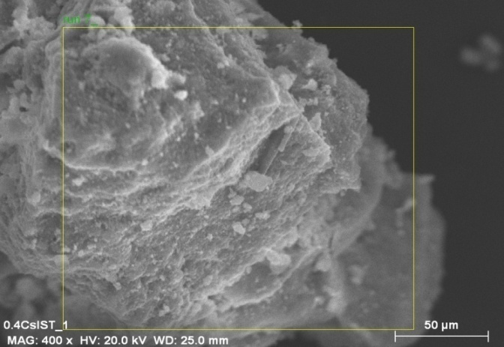
The surface morphology of the promoted catalysts was found to be quite similar to that of the Mg-V-HTlc, such that it was found to have an irregular structure (Figure 4.34). Increased metal loadings did not significantly change the morphology. Elemental mapping results for each of the selected areas shown in Figure 4.34 (Refer to Appendix B, Figure B9 – Figure B11) suggest that cesium, magnesium and vanadium are evenly distributed along the surface of the catalyst.
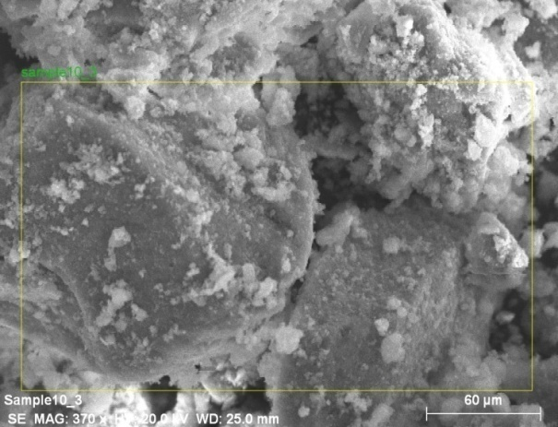
a
b
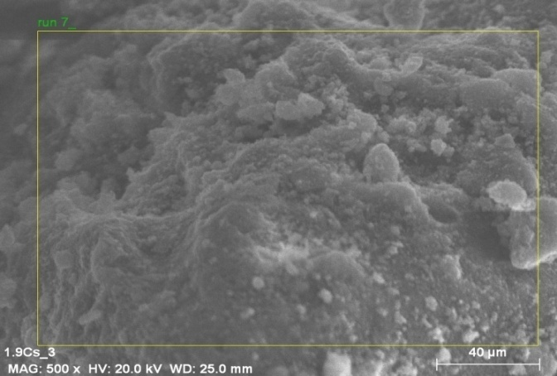
c

Figure 4.34: SEM images of a) 0.4% CsMg-V-HTlc b) 0.9% CsMg-V-HTlc and c) 1.9% CsMg-V-HTlc
The TG and DTG results show that each catalyst undergoes a loss of physisorbed water at ~ 113 °C. The second weight loss step observed for the Mg-V-HTlc is not present in the 0.9% CsMg-V-HTlc and is observed at a lower temperature in the 0.4% CsMg-V-HTlc and 1.9% CsMg-V-HTlc’s. In hydrotalcite-like catalysts, this peak is usually due to the loss of interlayer water [6]. XRD analyses on the Cs promoted catalysts shows that the HT-like structure is maintained, irrespective of the loading – interlayer water is therefore still present. It is therefore likely that cesium could possibly interact with interlayer water, therefore making it much more difficult to remove under the experimental conditions. The final weight loss step (due to decarboxylation and dehydroxylation) is present in all the promoted samples and occurs at approximately 400 °C. The total weight loss observed for the 0.4%, 0.9% and 1.9% Cs promoted catalysts was determined to be 28.5%, 27.2% and 26.4% respectively.

Figure 4.35: TG and DTG curves for the 0.4% CsMg-V-HTlc

Figure 4.36: TG and DTG curves for the 0.9% CsMg-V-HTlc

Figure 4.37: TG and DTG curves for the 1.9% CsMg-V-HTlc

4.4. Characterisation of the boron promoted catalysts

Three boron loaded catalysts were synthesized and ICP analysis confirmed the loading of boron on the catalyst (Table 4.15). The Mg/V ratios were found to be lower than that for the Mg-V-HTlc; specifically, the amount of vanadium present was found to decrease as the boron loading increased. Boron loadings higher than 0.6% were difficult to obtain, although multiple syntheses was attempted. Boron promoted catalysts will henceforth be named as was done for both the cesium and barium promoted samples e.g. the 0.1% boron promoted Mg-V-HTlc will be referred to as 0.1% BMg-V-HTlc etc.

Table 4.15: ICP results for the boron promoted catalysts
CATALYST | % B LOADING | Mg/V | V CONTENT (mg / g)
Catalyst 1 | 0.1 | 1.7 | 175.5
Catalyst 2 | 0.3 | 1.6 | 165.8
Catalyst 3 | 0.6 | 1.6 | 152.0

XRD analyses on the catalysts (Figure 4.39 – Figure 4.41) showed the presence of peaks that were attributed to the formation of the HT-like structure (at ~ 17 °2θ, 27 °2θ, ~ 42 °2θ and ~ 70 °2θ) and these were used to calculate the lattice parameters presented in Table 4.16. No additional phases could be identified. For the 0.6% BMg-V-HTlc, the sharp peak at ~ 30 °2θ, was due to the XRD sample holder, due to the small quantity of sample analysed – the diffractogram of which can be found in Appendix B, Figure B12). This sharp peak was not noticed for the 0.1% and 0.3% boron promoted catalysts since larger sample sizes were used during XRD analyses. The c parameter was found to increase marginally with increasing boron loading and was higher than that of the Mg-V-HTlc. Boron (+3) has an ionic radius of 0.23 Å and the increased c parameter suggests that some of the boron could possibly be located in the interlayer space. The average cation-cation distance was consistently 3.1 Å - higher than the 2.9 Å determined for Mg-V-HTlc, likely due to the presence of the additional cation in the structure as compared to the Mg-V-HTlc. The increased concentration of +3 cations increases the formal positive charge of the brucite-like layer and thus the value of the a parameter. The unity in the a parameter amongst the boron promoted catalyst was likely due to the low loadings used i.e. the different metal loadings used were not sufficient to cause substantial differences of the a value. This calculated a value may be compared to literature, which reports a value of 3.1 Å for a Mg-V-HTlc [8].
Table 4.16: Calculated lattice parameters for boron promoted catalysts
CATALYST | c (Å) | a (Å)
0.1% BMg-V-HTlc | 23.8 | 3.1
0.3% BMg-V-HTlc | 24.2 | 3.1
0.6% BMg-V-HTlc | 24.4 | 3.1

Figure 4.38: X-Ray diffractogram for the 0.1% BMg-V-HTlc

Figure 4.39: Diffractogram of the 0.3% BMg-V-HTlc

Figure 4.40: Diffractogram of 0.6% BMg-V-HTlc

The IR spectra of the boron promoted catalysts (Figure 4.41) shows the presence of bands associated with OH⁻ groups (~ 3380 cm⁻¹). Water bending vibrations are observed at ~ 1640 cm⁻¹. The carbonate bands were observed as sharp peaks at ~ 1420 cm⁻¹ and 1480 cm⁻¹ respectively and were also present in the IR spectrum of the Mg-V-HTlc. A further band attributed to CO₃²⁻, but due to a lowering of symmetry of the anion, occurs at ~ 875 cm⁻¹ in each of the boron containing samples. It is therefore evident that the presence of boron in varying quantities in the catalyst does not cause substantial changes in the IR spectra.

The surface areas of all three boron promoted catalysts were found to be essentially similar to each other (Table 4.17) (within experimental error). It is likely that the difference in boron loading is too small to adversely affect the surface area. All boron promoted catalysts showed an increase in surface area when compared to the unpromoted catalyst.

1635.90

1630.29
1425.95

Figure 4.41: IR spectra of boron promoted catalysts

Table 4.17: Surface areas of the boron promoted catalysts
CATALYST | SURFACE AREA (m²/g)
0.1% BMg-V-HTlc | 85.4
0.3% BMg-V-HTlc | 88.4
0.6% BMg-V-HTlc | 87.7

The TPR profiles show single reduction peaks for each of the boron promoted catalysts (Figure 4.42) and these were due to the reduction of the vanadium ions in the sample. A reduction peak associated with boron was not observed under these experimental conditions. The peaks themselves were found to be slightly asymmetric, suggesting that peaks are possibly overlapping and therefore a two-step reduction could be taking place [13]. This is confirmed by the calculated oxidation state of vanadium in the reduced sample, which was found to be 3.1 for the 0.1% BMg-V-HTlc and 3.3 for the remaining two catalysts (Table 4.18), suggesting that vanadium was reduced to the +4 and further to the +3 oxidation state.

Figure 4.42: TPR curves for the boron promoted catalysts

Table 4.18: TPR results for the boron promoted catalysts
CATALYST | PEAK MAXIMA (°C) | V OXIDATION STATE IN REDCUED CATALYST | REDUCIBILITY (%) | mmol H₂ CONSUMED
0.1% BMg-V-HTlc | 735 | 3.1 | 84.4 | 0.229
0.3% BMg-V-HTlc | 720 | 3.3 | 93.3 | 0.225
0.6% BMg-V-HTlc | 744 | 3.3 | 83.0 | 0.165

The TPD curves for the boron promoted catalysts were found to be different to the curve obtained for the Mg-V-HTlc, as well as those of the cesium and barium promoted catalysts in that there are three types of acid sites present, inferred from the 3 peaks (albeit noisy) identified in Figure 4.43. The results suggest that the presence of boron on the catalyst increases the weak acid sites and creates a degree of strong acid sites. Boron is amphoteric in nature and the observed changes in the acidity of the catalyst are indicative of this. The total acidity was, however, lower than that obtained for the Mg-V-HTlc (Table 4.19).

Figure 4.43: TPD curves for the various B-HTlc’s

Table 4.19: Total acidity of the boron promoted catalysts
CATALYST | TOTAL ACIDITY (μmol NH₃ / g catalyst)
0.1% BMg-V-HTlc | 285
0.3% BMg-V-HTlc | 481
0.6% BMg-V-HTlc | 691

The thermal analyses results for these catalysts showed only 2 weight loss steps in each case – the first occurring at ~ 110 °C and the second at ~ 415 °C, with the total weight loss of 26.6%, 29.2% and 28.8% for the 0.1%BMg-V-HTlc, 0.34% BMg-V-HTlc and 0.6% BMg-V-HTlc respectively. The peak attributed to the removal of interlayer water, usually around 230 °C, is not present in any of the boron promoted catalysts, thus implying that the boron species could possibly be interacting with the interlayer water, making it difficult to remove. However, it is reported that HTlc’s usually undergo a two-step weight loss although in some cases these steps may be further divided [6, 16]. Such an inference correlates with the increased c parameter determined by XRD i.e. the boron species could possibly be located in the interlayer thus increasing the spacing observed in these catalysts as compared to that found for the Mg-V-HTlc.

Figure 4.44: TG and DTG curve for 0.1% BMg-V-HTlc

Figure 4.45: TG and DTG curves for the 0.3% BMg-V-HTlc

Figure 4.46: TG and DTG curves for the 0.6% BMg-V-HTlc

References

- F.M. Labajos, M.D. Sastre, R. Trujillano and V. Rives, J. Mater. Chem., 9, 1999, 1033
- H.B. Friedrich and A.S. Mahomed, Appl. Catal. A. Gen., 347, 2008, 11
- R.D. Shannon, Acta Crystallog. A, 32, 1976, 751
- R. Burch and E.M. Crabb, Appl. Catal. A Gen., 100. 1993, 111
- F. Cavani, F. Trifiró and A. Vaccari, Catal. Today, 11, 1991, 173
- V. Rives, Layered Double Hydroxides: Present and Future, Nova Science Publishers Inc., 2001
- F.M.Labajos, V. Rives, P. Malet, M.A. Centeno and M.A. Ulibarri, Inorg. Chem., 35, 1996, 1154
- V. Rives and F.M. Labajos, Inorg. Chem., 32, 1993, 5000
- S. Miyata, Clays Clay Miner., 28, 1980, 50
- S. Miyata and A. Okada, Clays Clay Miner., 25, 1977, 14
- T.S. Stanimirova, I. Vergilov and G. Kirov, J. Mater. Sci., 34, 1999, 4153
- V. Rives, Appl. Clay Sci., 10, 1995, 83
- E.A. Elkhalifa and H.B. Friedrich, Appl. Catal. A Gen., doi; 10.1016
- W.S. Chang, Y.Z. Chen, B.L. Yang, Appl. Catal. A Gen., 124, 1995, 221
- D.W. Oxtoby, N.H. Nachtrieb, Principles of Modern Chemistry, Saunders College Publishing, United Stated of America, 1986
- P. Ber, M. Rajmathi, M.S. Hegde and P.V. Kamath, Bull. Mater. Sci., 23 2000, 141

5. CHAPTER FIVE – RESULTS AND DISCUSSION

5.1. Non-catalytic experiments

Alkanes are associated with a chemical inertness that often requires high temperatures to overcome. However, under such conditions, the contributions of homogeneous gas phase reactions can be quite significant. It was therefore necessary to carry out non-catalytic experiments to evaluate the extent of these homogeneous reactions.

To this end, the reactor tube was packed with carborundum (refer to section 3.4) and the ODH of n-octane was tested using 14.9% octane in air between 300 °C and 550 °C. The conversion data, presented in Figure 5.1, shows that carborundum effectively suppresses conversion up to 450 °C. Conversion then increases with an increase in temperature reaching ca. 5% at 550 °C. These results can be compared to literature, where a study under similar conditions showed conversion from 350 °C, albeit minimal, reaching ca. 6% at 550 °C [1]. The reactor block used in the work described in the literature is longer than that used in this study, thus it can be concluded that the shorter reactor further reduces non-catalytic conversion of the feedstock.

Figure 5.1: Conversion of n-octane as a function of temperature for the blank reactor experiment
The products that were obtained at the higher temperatures were mainly CO and CO₂ and to a smaller extent, 1-octene, 2-octene, 3-octene and 4-octene which, for the purpose of this reaction, were grouped as C8 olefins. Cracked products (C1 – C3 alkanes and alkenes) were also noted in small selectivities (< 1%), as was the formation of ethylbenzene (Figure 5.2). Those products that could not be identified, albeit minimal, were grouped together as “others” (Figure 5.2) The selectivity to the C8 olefins and total cracked products was found to increase from 500 °C to 550 °C, while the CO_{x} selectivity remained relatively consistent (Figure 5.3).

It was therefore shown that there is no contribution to the conversion of n-octane from homogeneous gas phase reactions up to and including 450 °C.

Figure 5.2: Selectivity to organic products obtained

Figure 5.3: Selectivity to CO and CO₂ for the blank reactor experiment

5.2 Effect of treatment conditions on the Mg-V-HTlc

The Mg-V-HTlc was tested in its uncalcined form, calcined form and after in-situ treatment (Section 3.6 for treatment conditions). Reaction parameters include a contact time of 0.5 s and a fuel-air ratio of 15% octane in air. The HC/O₂ ratio was 0.7 and the total flow was 192 ml/min.

A comparison of the conversion data, presented in Figure 5.4., shows that at the higher temperatures, the in-situ treated catalysts gave the highest conversion reaching 35% at 550 °C. The in-situ treated sample shows a gradual increase from 300 – 400 °C and a more rapid increase from 400 – 500 °C, after which conversion begins to stabilize. The uncalcined catalyst shows a greater increase in conversion from 300 – 400 °C, when compared to the in-situ treated sample, and this stabilizes until 450 °C. Conversion then increases until 550 °C. The calcined catalyst was found to have a very different conversion profile, such that the highest conversion of ~ 10% was obtained at 400 °C, following which a decline in conversion was observed with an increase in temperature. This decrease in conversion can be attributed to coking of the catalyst and is confirmed by surface area measurements on the used catalyst which show a decrease in surface area [2].

The C8 aromatic products observed included ethylbenzene, xylene and styrene. The total selectivity to these compounds for each of the reactions is presented in Figure 5.5 and the corresponding yield data in Table 5.1.

Figure 5.4.: Comparison of conversions of n-octane for the Mg-V-HTlc under different treatment conditions

Figure 5.5: Total selectivity to C8 aromatics
Table 5.1: Yield to the total C8 aromatic products
TEMPERATURE | CALCINED Mg-V-HTlc | UNCALCINED Mg-V-HTlc | IN-SITU TREATED Mg-V-HTlc
300 | 0 | 0 | 0
350 | 0 | 0 | 0
400 | 0 | 0.2 | 0
450 | 0.1 | 1.8 | 1.7
500 | 0.2 | 3.8 | 5.2
550 | 0.1 | 3.9 | 6.5

The uncalcined and calcined catalysts showed a similar trend, viz. the selectivity to the aromatics increased gradually from 400 °C to 500 °C and thereafter stabilized. The in-situ treated catalyst, however, showed a sharp increase in selectivity from 400 °C – 500 °C reaching the highest selectivity of ~ 19% at 550 °C (yield of 6.5%). A comparison of both the yield and selectivity suggests that the in-situ treated sample would be most suitable for further reaction studies.
The C8 olefins that were produced were 1-octene through to 4-octene and the total yield and selectivity to these is presented in Figure 5.6. The uncalcined sample showed the lowest selectivity at all temperatures while the calcined and in-situ treated sample showed a similar selectivity trend. The in-situ treated catalyst was found to produce a marginally higher total selectivity of 30.1 % and 28.2% at 500 °C and 550 °C respectively vs. 27.8% and 25.2% for the calcined catalyst. The yields, however, were significantly different for each of the catalytic systems, with the in-situ treated catalyst producing the highest yields of ~ 10% at 550 °C to the total C8 olefins.

Figure 5.6: Total yield and selectivity to C8 olefins

A significant amount of the total product selectivity was attributed to the carbon oxides, both CO and CO₂. The selectivity data presented in Figure 5.7 shows that each of the catalytic systems displays a similar selectivity trend with increasing temperature i.e. the selectivity is initially high at 350 °C and decreases with increasing temperature owing to the formation of other products such as the C8 olefins and C8 aromatics. The in-situ treated sample showed the lowest selectivity to carbon oxides over all temperatures studied, while the uncalcined sample displayed the highest selectivity (Figure 5.7).

Figure 5.7: Total Selectivity to carbon oxides
Other products that were observed were the cracked products i.e. products with carbon number < 8, as well as a small contribution from unidentified products.

The results from this set of reactions shows that the catalyst is most active and selective to C8 olefins and C8 aromatics when treated in-situ prior to commencing catalytic runs. Consequently, in-situ treatment of the catalyst in question preceded all further catalytic testing.

5.3. Effect of contact time

To determine the effect of contact time on the conversion of n-octane and selectivity and yield to various products, different contact time experiments were carried out viz. 0.2 s, 0.5 s, 0.75 s, 1.0 s and 1.5 s. The fuel-air ratio was maintained at 7.6% octane in air for each of the contact time experiments as this was not previously presented in the literature, as mentioned in section 1.6.3.

The general trend observed from the comparative conversion results, presented in Figure 5.8, is that conversion increases with an increase in temperature for each of the contact times tested. Further, at 550 °C it is evident that as the contact time increases, conversion increases. This is as a result of the time the feed spends on the surface of the catalyst i.e. a longer contact time implies a greater interaction between the feed and the surface of the catalyst, thus promoting higher conversions as compared to those observed for lower contact times [1]. Thermogravimetric analysis on the in-situ treated Mg-V-HTlc (Section 4.1, Figure 4.12) suggests that decarboxylation and dehydroxylation occurs between 300 – 450 °C and this change in structure from HT-like to mixed metal oxide, corresponds with a sharp increase in conversion generally observed [3 - 6].

Figure 5.8: Effect of contact time on conversion of n-octane as a function of temperature

The total selectivity to the C8 olefins (1-octene through to 4-octene) is presented in Figure 5.9. Initial octene formation (2-octene) was observed at 350 °C for the 0.75 s, 1.0 s and 1.5 s contact times, while the lower two contact times initially produced both 1-octene and 2-octene at 400 °C. The formation of 2-octene at the lower temperature is initially favoured as it is easier to abstract the hydrogen from the secondary carbon compared to the primary carbon. It is likely, that at the higher temperature, there is sufficient energy available to result in both primary and secondary functionalisation. The formation of 3-octene and 4-octene is initially inhibited possibly due to steric constraints while at the higher temperatures, the energy required for their formation is likely to be met. A comparison of the data at 500 °C shows that the 0.5 s contact time has the highest total C8 olefin selectivity of 21.7 % (yield of 7.9%), 7.1% of which is due to 1-octene. Contact times higher than 0.5 s are therefore likely to be sufficient to promote further oxidation of the C8 olefins. The contribution of 1-octene only to the total octene selectivity (Figure 5.10) shows that at 400 °C, the 0.2 s C.T. experiment produces the highest selectivity to 1-octene, which decreases with an increase in temperature. A short residence time (i.e. 0.2 s) of the feed on the catalyst is likely to result in faster desorption of the primary products, as compared to the longer contact times [7].

Figure 5.9: Selectivity to total C8 olefins for various contact time experiments

Figure 5.10: 1-octene selectivity for various contact times

The yields to the total octenes for the different contact times (Figure 5.11) shows that the 0.2 s C.T. experiment produces the lowest yields at all temperatures, while the 0.5 s C.T. gives the highest yields.

Figure 5.11: Effect of contact time on yield to total C8 olefins

The C8 aromatic compounds produced in all reactions included ethylbenzene, styrene and xylene and for each of the contact time experiments, these were only observed in meaningful quantities from 400 °C – 550 °C (Figure 5.12). Of these three products, styrene was found to be dominant in terms of selectivity and yield, followed by ethylbenzene and then xylene. As a general trend, the total selectivity to the C8 aromatics was found to increase with increasing temperature until 500 °C, following which it either decreased (0.2 s and 0.5 s contact times) or remained relatively consistent (0.75 s, 1.0 s and 1.5 s contact time experiments). The higher selectivities observed for the 1.0 s and 1.5s contact time experiments can be linked to the lower total C8 olefin selectivities. It is likely the longer contact times promote further oxidation of the C8 olefins to other compounds, including the aromatics, thus lowering the selectivity of olefins but increasing the selectivity to, for example, the C8 aromatic compounds. The highest total C8 aromatic selectivity of 21.4% was achieved for the 1.0 s contact time experiment at 500 °C, 14.6% of which was due to styrene (yield = 6.4%).

Figure 5.12: Effect of contact time on total C8 aromatic selectivity

The carbon oxides, grouped as CO_{x}, were significantly affected by the variation in contact time (Figure 5.13). Only CO₂ was produced at 350 °C for all contact times, except 0.2 s (due to no conversion at this temperature). At 400 °C, both CO and CO₂ were observed for experiments with a contact time > 0.2 s. The combined selectivities of these oxidation products were relatively stable from 400 °C to 550 °C, apart from the 0.5 s C.T. result, which showed a decrease in selectivity at 500 °C followed by a slight increase with increasing temperature. The catalysts did, however, appear grey to slightly black once removed from the reactor, suggesting possible coke formation, which is confirmed by the decrease in surface area of the used catalysts (Table 5.2) as compared to the surface area of the catalyst before usage (Table 4.3) [2].

Figure 5.13: Selectivity to carbon oxides for different contact times
CONTACT TIME (s) | SURFACE AREA (m²/g)
0.2 | 28.1
0.5 | 20.8
0.75 | 29.1
1.0 | 27.3
1.5 | 28.8

Table 5.2: Surface area of the used catalysts for various contact time experiments

Those products with a carbon number < 8 (both saturated and unsaturated compounds) were grouped together as ‘cracked” products for the purpose of this discussion and the total selectivity to these compounds for each of the contact time experiments is presented in Figure 5.14. The 1.0 s and 1.5 s contact time experiments showed cracking products at 350 °C, whereas all other contact time experiments only produced these products from 400 °C onwards. The production of cracked products at 350 °C is as a result of the longer residence times of the feed on the surface of the catalyst, thus allowing for the formation of primary products and their subsequent oxidation to other products, inclusive of the cracked products. The conversion at the 1.0 s and 1.5 s contact times was also higher at 350 °C as compared to the conversion at lower contact times, thereby supporting the production of cracked products from secondary oxidation reactions.
Other products that were formed include 1,3-octadiene and 2,5-octadiene, which were grouped as “dienes” (Figure 5.15) as well as a small percentage of products that could not be identified (< 3%). No apparent trend could be determined for the total diene selectivity, however, the 0.5 s C.T. experiment was found to produce the highest diene selectivity at both 500 °C and 550 °C.

Figure 5.14: Selectivity to the total cracked products for various contact times

Figure 5.15: Total diene selectivity for different CT experiments

The yields for each group of compounds are presented in Figure 5.16. One of the conclusions that can be drawn is that the yield to the total aromatic products is similar for the 0.5 s, 1.0 s and 1.5 s contact time experiments and lower for the 0.2 s and 0.75 s experiments. The highest yield to the total C8 olefins is achieved using a contact time of 0.5 s, and under these conditions the yield to carbon oxides and cracked products is reduced, as compared to those obtained for contact times > 0.5 s. Apart from the 0.2 s CT experiments, the yield to the total dienes is relatively unaffected by changing contact times. The results from this series of experiments suggests that the 0.5 s contact time is optimum for the production of desirable products viz. the C8 olefins and aromatics, while minimizing the production of carbon oxides. A contact time of 0.5 s was therefore chosen as the optimum and was maintained for all reactions that followed.

Figure 5.16: Comparison of yields to various groups of products at 500 °C

5.4. Effect of fuel-air ratio

The fuel-air ratios tested include: 7.6%, 11%, 15%, 19.9% and 30% octane in air. The motivation for this was to try and optimize the selectivity to C8 aromatics and olefins, specifically, styrene and 1-octene respectively which are high-demand products [7]. For all of these experiments, the contact time was maintained at 0.5 s based on conclusions drawn previously (Section 5.2).

For all fuel-air ratios, the results show (Figure 5.17) that conversion increases with increasing temperature until 500 °C, following which it either stabilizes (7.6%, 11% and 15% octane in air), or decreases marginally (19.9% and 30% octane in air) when the temperature is increased to 550 °C (Figure 5.17). The conversion trend is comparable to those reported by Friedrich and Mahomed [1]. It was also observed that as the fuel-air ratio increases, conversion generally decreases due to the progressively lower amounts of oxidant i.e. oxygen, available in the system. The conversions at 500 °C and 550 °C were comparable for the 11% and 15% octane in air experiments.

Figure 5.17: Effect of fuel-air ratio on conversion of n-octane

The effect of fuel-air ratio on the total selectivity to the C8 aromatics (ethylbenzene, styrene and xylene) shown in Figure 5.18 suggests that these compounds are not produced at 350 °C, irrespective of the HC:O₂ ratio, but are seen at 400 °C – 550 °C. Apart from the 15% octane in air experiments, all fuel-air ratios show a decline in the total selectivity from 500 °C – 550 °C ; matched with a small increase in selectivity to the carbon oxides (Figure 5.19). Catalyst deactivation due to coking, as confirmed by decreased surface area measurements (Table 5.3) of the used catalysts, accounted for the marginal decrease in conversion and the selectivity to the desirable products [2].

The production of C8 olefins (1-octene through to 4-octene) occurs from 350 °C up to 550 °C (Figure 5.20) for each of the fuel-air ratios tested. Fuel-air ratios of 20% and 30% showed a similar trend with increasing temperature, reaching the highest selectivity at 400 °C of 50.4% (yield of 3.4%) and 46.9% (yield of 2.6%) respectively. The total C8 olefin selectivity was found to decrease as the fuel-air ratio decreases, a trend that is attributed to the increased amount of oxygen available in the system. Under fuel lean conditions, the C8 olefins are easily converted further, possibly to C8 aromatics and CO_{x}, due to sufficient oxygen in the system. This observation is confirmed by the high selectivities to the C8 aromatics (Figure 5.18) and CO_{x} (Figure 5.19), such that the selectivity increases with a progressive increase in the oxygen concentration.

Figure 5.18: Total selectivity to C8 aromatic compounds for different fuel-air ratios

Figure 5.19: Effect of fuel-air ratios on total selectivity to CO_{x}

Figure 5.20: Effect of fuel-air ratio on total selectivity to C8 olefins

Table 5.3: Surface areas of the used unpromoted catalysts
FUEL-AIR RATIO (%) | SURFACE AREA (m²/g)
7.6 | 20.8
11 | 19.3
15 | 24.2
20 | 19.5
30 | 34.4

A comparison of the yields obtained at 500 °C shows that a fuel-air ratio of 15% octane in air is optimum for the production of C8 olefins (Figure 5.21). The styrene yield was significantly affected by the choice of fuel-air ratios; 7.6% proving to give > twice the yields of the higher fuel-air ratios. The CO_{x} yield was found to be higher for the lower fuel-air ratios. It was therefore concluded that 15% octane in air would be chosen as the optimum fuel-air ratio as the production of CO_{x} is reduced (compared to the fuel-air ratios < 15% octane in air), while the yields to C8 aromatics and olefins are still substantial.

Figure 5.21: Effect of fuel-air ratios on yields at 500 °C for n-octane conversion

The optimum conditions for the Mg-V-HTlc were chosen to be 15% octane in air using a contact time of 0.5s. Under these conditions, reasonably good selectivities and yields to both the total C8 olefins and total C8 aromatic compounds are obtained. Further, the production of CO_{x} is not as high as for other reaction conditions tested.

5.5. Catalytic results for barium promoted catalysts

All catalytic testing for the barium promoted samples were carried out using a fuel-air ratio of 15% octane in air and a contact time of 0.5 s for reasons discussed earlier (Section 5.3).

The conversion of n-octane with increasing temperature was found to follow a similar trend for all barium promoted catalysts; conversion increased to 500 °C and then decreased marginally or stabilized at 550 °C (Figure 5.22). It was also observed that the conversions obtained were similar for the lower Ba loadings, while the n-octane conversion in the 6% BaMg-V-HTlc was consistently lower at all temperatures. The behaviour of the 6% Ba promoted catalyst can be related to its surface area, which was found to be much lower than those of its counterparts (Section 4.2). Furthermore, XRD shows a mixture of phases present in the sample while SEM showed a change in the surface morphology with increasing barium loading (Figure 4.23) which is possibly affecting the conversion of n-octane. Comparing the conversion obtained for all barium promoted catalysts to the unpromoted catalyst, it was observed that the Mg-V-HTlc displays higher conversions from 450 °C to 550 °C.

Figure 5.22: Conversion of n-octane as a function of temperature for Ba promoted catalysts
The C8 olefins were initially produced at 350 °C, specifically 2-octene due to the ease with which hydrogen abstraction from the secondary carbon, as compared to the primary carbon, can occur. The 6% BaMg-V-HTlc, however, did not produce any C8 olefins at this temperature, possibly due to the catalyst composition as determined from XRD. In fact, the 6% BaMg-V-HTlc produces the lowest total C8 olefin selectivity at all temperatures (Figure 5.23). The highest total selectivity (27%) was obtained with the 1.4% BaMg-V-HTlc at 500 °C, 9.1% of which was due to the production of 1-octene. It was thought that the addition of a basic promoter would decrease the acidity of the catalyst, therefore possibly increasing the desorption of the primary products i.e. C8 olefins, thereby increasing their selectivity. The 0.2% BaMg-V-HTlc was the only catalyst that showed this at 400 °C – the selectivity to total C8 olefins was marginally higher than that of the unpromoted catalyst; 26.6% for 0.2% BaMg-V-HTlc vs. 23.4% for Mg-V-HTlc. It is therefore possible that the lack of improved selectivity to C8 olefins could be due to the change in the structure of the catalyst with increasing barium loading (Section 4.2, Figure 4.16 – Figure 4.19).

Figure 5.23: Selectivity to total C8 olefins for Ba promoted catalysts

The total selectivity to the C8 aromatics, which comprised of ethylbenzene, styrene and xylene, is presented in Figure 5.24. The three lower Ba promoted catalysts showed a similar trend with increasing temperature, while the 6% BaMg-V-HTlc was found to produce the lowest selectivity at all temperatures. It was observed that as the barium loading increased, the selectivity to the aromatics decreased. Literature reports, for MgVO catalysts in the ODH of n-butane, suggest that the ability of the catalyst to produce one product vs. another is related to the presence of acid and base sites on the surface of the catalyst [8, 9]. Basic sites favour a fast desorption of olefinic species, while acid sites adsorb oxygen-containing species which may then be transformed further, finally to CO₂ [8, 9]. The TPD studies on the barium promoted catalysts showed a decrease in acidity as the barium loading increased. It follows therefore, that the selectivity to aromatics is low since these are the secondary products. We also expect then, a high selectivity to CO_{x} for the 6% BaMg-V-HTlc and this is indeed observed (Figure 5.25). The total CO_{x} selectivity is, in fact, found to decrease with decreasing Ba loading and hence increasing acidity. As observed for the Mg-V-HTlc, all barium promoted catalysts produced styrene as the dominant aromatic product, as shown for the 1.4% BaMg-V-HTlc in Figure 5.26. However, the best selectivities were obtained with the unpromoted catalyst at 500 °C and 550 °C.

Figure 5.24: Total selectivity to C8 aromatic compounds for Ba promoted catalysts

Figure 5.25: Total CO_{x} selectivity for barium promoted catalysts

Figure 5.26: Selectivity to the aromatic products for the 1.4% BaMg-V-HTlc

Products with a carbon number < 8, both alkanes and alkenes, were grouped as “cracked” products and their total selectivity for the different barium promoted catalysts is presented in Figure 5.27. At temperatures lower than 450 °C, no clear trend could be observed. However, from 450 °C to 550 °C, there was an increase in the selectivity to cracked products. Further, in this temperature range, it was evident that the selectivity increased with increasing barium loading. Surface area studies on the used catalysts showed a decrease in surface area (Table 5.4). This, together with the grey colour of the used catalyst, suggests that coking mechanisms occurred [2]. As such, the selectivity to the cracked products is likely to increase as the C8 olefins and C8 aromatics are further converted ultimately to smaller chain compounds and CO_{x}.

Figure 5.27: Selectivity to total “cracked” products for barium promoted catalysts

Table 5.4: Surface areas of the used Ba promoted catalysts
CATALYST | SURFACE AREA (m²/g)
0.2% BaMg-V-HTlc | 30.2
0.7% BaMg-V-HTlc | 29.8
1.4% BaMg-V-HTlc | 28.4
6% BaMg-V-HTlc | 27.2

The catalytic results for the barium containing catalysts were compared at constant conversion of ~ 16% at 450 °C (Figure 5.28). The 0.2% and 0.7% BaMg-V-HTlc was found to give marginally higher selectivities to the total octane isomers than the Mg-V-HTlc, but these decreased with an increase in barium loading. The 1.4% barium promoted catalyst gave the highest total selectivity to the C8 aromatics, however, all barium promoted catalysts were found to less selective to total aromatics than the Mg-V-HTlc. The total selectivity to CO_{x} was found to be significantly affected by the barium loading, with the lowest selectivity obtained over the unpromoted Mg-V-HTlc and the highest over the 6% BaMg-V-HTlc. This may be tentatively related to the acidity of the catalyst, which was found to decrease with increasing barium loading. The total yield to the cracked products was found to increase with increasing barium loading, while the reverse trend was observed for the total diene selectivity – dienes being mainly 1.3-octadiene and a smaller contribution from cyclooctadiene.

Figure 5.28: Comparison of results at ~ 16% conversion and 450 °C

5.6. Catalytic results for the cesium promoted catalysts

The cesium promoted catalysts was also tested using a fuel-air ratio of 15% octane in air and a contact time of 0.5 s.

The conversion for all catalysts was found to increase from 300 °C to 500 °C, following which a slight decrease was observed at 550 °C (Figure 5.29). In general, as the cesium loading was increased from 0.4% to 0.9%, conversion increased at all temperatures. However, a further increase in loading to 1.9% resulted in a decrease in conversion, such that the 1.9% CsMg-V-HTlc was found to have the lowest conversions between 300 °C – 550 °C. Comparing the data to the Mg-V-HTlc shows that all the promoted catalysts have a similar conversion to the unpromoted catalyst at temperatures up to 400 °C. The Mg-V-HTlc was found to have higher conversions than all promoted samples from 450 °C to 550 °C.

Figure 5.29: Comparison of conversion of n-octane for the cesium promoted catalysts

The highest total selectivity to the C8 olefins (1-octene, 2-octene, 3-octene and 4-octene) was found to be the same for all catalysts at 450 °C, following which a decrease was observed with increasing temperature (Figure 5.30). The 0.4% and 1.9% cesium loadings improved the selectivity to C8 olefins up to 450 °C, when compared to the umpromoted catalyst. This is likely due to the reduced acidity of these samples which promote fast desorption of the olefins. The decrease in selectivity from 500 °C to 550 °C may be associated with the observed decrease in conversion which suggests catalyst deactivation could be occurring. This was confirmed by the lower surface areas of the used catalysts (Table 5.5); indicative of catalyst coking.

The decrease in olefin selectivity from 450 °C is concomitant with the increase in the CO_{x} selectivity (Figure 5.31). It is likely that the olefins are being converted further to secondary products and carbon oxides. In general, the 0.9% and 1.9% cesium loadings have similar CO_{x} selectivity, whereas the 0.4% CsMg-V-HTlc has lower CO_{x} selectivities at temperatures < 450 °C. All cesium promoted catalysts were, however, found to have higher selectivities to carbon oxides than the Mg-V-HTlc discussed earlier.

Figure 5.30: Total C8 olefin selectivity for Cs promoted catalysts

Table 5.5: Surface areas of the used Cs promoted catalysts
CATALYST | SURFACE AREA (m²/g)
0.4% CsMg-V-HTlc | 48.1
0.9% CsMg-V-HTlc | 46.2
1.9% CsMg-V-HTlc | 44.8

Figure 5.31: Total CO_{x} selectivity for cesium promoted catalysts

The 0.4% and 0.9% cesium loaded catalysts showed the formation of the ethylbenzene and styrene at 400 °C, whereas no aromatics were observed with the Mg-V-HTlc (Figure 5.18) and 1.9% CsMg-V-HTlc (Figure 5.32) at the same temperature (400 °C). The selectivities of the former two catalysts remained higher than the latter up to 450 °C, following which a decline was observed. This is coincident with the increase in CO_{x} formation presented in Figure 5.30. The aromatics are possibly undergoing further oxidation reactions to yield the total oxidation products. The 1.9% CsMg-V-HTlc gave the lowest selectivity to total aromatic compounds when compared to the unpromoted and the lower Cs loaded catalysts. For the promoted catalysts, the highest selectivity of 7.9% (yield of 1.5%) to styrene (the dominant aromatic compound) was achieved with the 0.9% CsMg-V-HTlc at 450 °C. The trends observed towards the total aromatic selectivity for the promoted catalysts can be related to the acid-base character of the promoted catalysts; the total acidity was found to decrease with increasing cesium loading (Table 4.13). It is therefore expected that the 0.9% CsMg-V-HTlc (with the highest total acidity of the Cs promoted catalysts) would show a higher selectivity to total C8 aromatic compounds as compared to the 1.9% CsMg-V-HTlc (which has the lowest total acidity of the Cs promoted catalysts) – as is indeed observed (Figure 5.32) [7].

Figure 5.32: Total selectivity to C8 aromatic compounds for cesium promoted catalysts

The higher the cesium loading, the higher the selectivity to total cracked products (alkanes and alkenes with carbon number < 8) and this data is presented in Figure 5.33.

The results were then compared using an approximately constant conversion of 16% and a temperature of 450 °C (Figure 5.34). As regards the total C8 olefin selectivity, marginal increases in selectivity are observed with increasing cesium loading – each promoted catalyst being higher in selectivity than the unpromoted catalyst. This may be tentatively attributed to the decreased acidity of the catalysts with increasing loading. The faster desorption of olefinic species from the catalyst surface implies a higher yield and selectivity to the C8 olefins as compared to the unpromoted catalyst; a trend that is indeed observed. Further, if it is argued that the primary products (C8 olefins) undergo further catalytic oxidation to eventually produce the C8 aromatics, it follows that the selectivity to aromatics should decrease with increasing cesium loading; again a trend presented in Figure 5.34. The unpromoted catalyst, however, is still the best in that it produces the lowest selectivity to carbon oxides under these comparative conditions. The CO_{x} selectivity is found to increase with increasing Cs loading. Minimal cracked products were observed for the 0.4% CsMg-V-HTlc, while the selectivity to dienes and those products grouped as “others”, was relatively unaffected by the concentration of cesium on the catalyst.

Figure 5.33: Selectivity to the total cracked products for Cs promoted catalysts

Figure 5.34: Comparison of selectivity at 450 °C and ~ 16% conversion

5.7. Catalytic results for the boron promoted catalysts

The activity and selectivity to different products of the boron promoted catalysts at 15% octane in air and a contact time of 0.5 s will be presented in the sections that follow.

The boron promoted catalysts showed an increase in conversion up to 450 °C, following which a decrease was observed with increasing temperature (Figure 5.35). As the boron loading was increased to 0.3%, conversion was found to increase. However, a further increase in the boron loading to 0.6% gave conversions that were lower than that observed for both the 0.1% and 0.3% boron promoted catalysts. At 400 °C, all boron promoted catalysts gave higher conversion than the unpromoted catalyst. It appears therefore, that the presence of this dopant lowers the activation energy for the formation of the primary products. At 450 °C, each promoted catalyst produces its highest conversion but catalyst deactivation occurs with an increase in temperature.

Figure 5.35: Effect of boron loading on conversion of n-octane

The C8 olefins observed were again 1-octene through to 4-octene, as seen for all other catalytic data presented thus far. The 0.1% and 0.3% BMg-V-HTlc gave higher selectivities than the unpromoted catalyst, while the 0.58% BMg-V-HTlc was found to be similar to Mg-V-HTlc in this temperature range (Figure 5.36). The selectivity of each promoted catalyst then decreases with increasing temperature, whereas that for the Mg-V-HTlc, increases.

Figure 5.36: Selectivity to total C8 olefinic species for boron promoted catalysts

The addition of boron to the Mg-V-HTlc, succeeded in producing catalysts that gave ethylbenzene and styrene at 350 °C, as opposed to 450 °C for the unpromoted catalyst (Figure 5.37). This alone is desirable, as a reduction in operating temperatures for a catalytic system is more cost efficient. The selectivities in question then decrease with a further increase in temperature and this corresponds to an increase in the CO_{x} selectivity in the same temperature range (Figure 5.38). The observations in terms of selectivity, together with the conversion trends presented earlier (Figure 5.35) suggest that the catalysts activities are decreasing. This may be due to the formation of carbon deposits on the surface of the catalyst which block the active sites needed for conversion to occur. Surface area measurements of the used catalysts (Table 5.6) show a decrease in area of the used catalysts, as compared to the precursor loaded in the reactor, and is likely the reason for the decrease in conversion. The highest total aromatic selectivity (15.9%) is achieved at 450 °C with the 0.34% BMg-V-HTlc; 8.5% of which is due to the production of styrene.

Figure 5.37: Total selectivity to C8 aromatic compounds for n-octane conversion

Table 5.6: Surface areas of the used boron promoted catalysts
CATALYST | SURFACE AREA (m²/g)
0.1% BMg-V-HTlc | 45.4
0.3% BMg-V-HTlc | 35.8
0.6% BMg-V-HTlc | 37.9

Figure 5.38: Total carbon oxide selectivity for n-octane conversion

The boron promoted catalysts were compared at constant conversion of ~ 19% at 450 °C (Figure 5.39). The selectivity to the C8 olefinic species was found to be marginally higher than over the unpromoted catalyst while the aromatic selectivity decreased. It seems therefore that boron, being amphoteric in nature, is adding basicity to the catalyst, creating a greater selectivity to olefins than aromatics. The CO_{x} selectivity was found to be higher than over the Mg-V-HTlc and decreased slightly with increasing boron loading. The observed decrease in CO_{x} selectivity may be associated with the trends observed for the octenes, which are seen to increase marginally with increasing boron loading as well as to the aromatics which shows the reverse trend for selectivity. Carbon oxides can be produced from both the olefins and the aromatic compounds - the decrease in aromatic selectivity infers that there are less of these products to undergo further oxidation (to CO_{x}) while the increased octene selectivity suggests that the octenes possibly desorb before undergoing further catalytic oxidation (which could result in increased CO_{x} selectivity).

Figure 5.39: Comparison of data at 450 °C and ~ 19% conversion of n-octane

References

- H.B. Friedrich and A.S. Mahomed, Appl. Catal. A Gen., 347, 2008, 11
- C.H. Bartholomew, Appl. Catal. A Gen., 212, 2001, 17
- V. Rives, Layered Double Hydroxides: Present and Future, Nova Science Publishers Inc., 2001
- F.M. Labajos, M.D. Sastre, R. Trujillano and V. Rives, J. Mater. Chem., 9, 1999, 1033
- M.J. Holgado, F.M. Labajos, M.J.S. Montero and V. Rives, Mater. Res. Bull., 38, 2003, 1879
- V. Rives, Mater. Chem. Phys., 75, 2002, 19
- E.A. Elkhalifa and H.B. Friedrich, Appl. Catal. A Gen., doi; 10.1016
- T. Blasco, J.M. López-Nieto, A. Dejoz and M.I. Vazquez, J. Catal., 157, 1995, 271
- J.M. López-Nieto, P. Concepción, A. Dejoz, H. Knözinger, F. Melo and M.I. Vazquez, J. Catal., 189, 2000, 147

6. CHAPTER SIX - CONCLUSION

Non-catalytic experiments carried out in this work have shown minimal contribution from homogenous gas phase reactions for the ODH of n-octane – no conversion was observed at temperatures up to 450°C, while a conversion of ca. 5% was obtained at 550 °C. The products obtained at the higher temperatures were mainly carbon oxides and, to a smaller extent, the octene isomers.

The Mg-V-HTlc, with carbonate anions in the interlayer, was synthesized and characterisation of the material showed that the hydrotalcite-like structure was obtained with good incorporation of the metals. The catalyst was composed of crystallites described as having a hexagonal platelet shape and an irregular surface morphology. A series of experiments to determine the effect of various contact times on the conversion of the feed and selectivity to products suggests that a contact time of 0.5s produces good selectivities and yields to desirable products while minimizing the formation of carbon oxides. At a temperature of 500°C, a contact time of 0.5s was found to produce a total aromatic selectivity (with styrene as the dominant product) of ca. 19%, while the total olefin selectivity was found to be 21.7%, of which 7.1% was due to 1-octene. The selectivity to the combustion products under these conditions was found to be the lowest of all the contact times tested. This contact time was used to study the effect of fuel-air ratios on the catalytic results. It was found that a fuel-air ratio of 15% octane in air produced acceptable selectivities to the C8 olefinic species (ca. 30% at 500 °C) and C8 aromatic compounds (15% at 500 °C), without extensive production of the total oxidation products (ca. 28% at 500 °C). The results from testing of the Mg-V-HTlc suggest that the optimum conditions for this system is 15% octane in air and a contact time of 0.5 s. Consequently, these optimum conditions were used in the testing of promoted catalysts.

A series of barium promoted catalysts were synthesized and ICP results confirmed the different weight % of barium in the sample. Catalysts with a loading of 1.4% and 6% barium were found to result in the formation of phases other than the HT-like phase. The reducibility of the catalyst was found to decrease as the barium loading increased. Using optimum conditions, the conversion of n-octane was found to decrease with increasing barium loading. A comparative study of data under iso-conversion and temperature suggested that the 0.2% and 0.7% barium promoted samples improve the selectivity to the C8 olefins – a total selectivity of ca. 28% and ca. 27% was achieved for the 0.2% and 0.7% barium promoted catalysts, respectively, compared to a selectivity of ca. 26% for the unpromoted catalyst. All barium promoted catalysts was found to reduce the total selectivity to the aromatic compounds.

Three cesium promoted catalysts were synthesized and were found to retain the HT-like structure irrespective of the cesium loading. Within the cesium series of catalysts, the selectivity to the olefins was found to increase marginally with increasing cesium loading, while the selectivity to the total aromatics decreased when compared under constant conversion and temperature. A comparison of the cesium promoted catalysts to the unpromoted Mg-V-HTlc, suggests that the 1.9% CsMg-V-HTlc is optimum in terms of total octene selectivity (ca. 26% for the Mg-V-HTlc vs. ca. 29% for the 1.9% CsMg-V-HTlc), however, the unpromoted catalyst produced the highest selectivity to the total aromatic compounds. The CO_{x} selectivity increases with increasing cesium loading. The CO_{x} data shows that all of the promoted samples resulted in a higher total carbon oxide selectivity when compared to the unpromoted catalyst under iso-conversion. From this series of experiments, it was shown that the 1.9% CsMg-V-HTlc is optimum for the production of olefins and was attributed to its acid-base character.

Boron promoted catalysts were synthesized and found to maintain the HT-like structure. Boron was found to form a small amount of strong acid sites in the catalyst, although the total acidity was still lower than for the unpromoted sample. Within the series of boron promoted catalysts, a comparison of catalytic data under iso-conversion and temperature shows that the highest selectivity of 30% is obtained to the C8 olefins with the 0.6% BMg-V-HTlc. In addition, all of the boron promoted catalysts were found to give higher selectivities to the total C8 olefins i.e. > ca. 26% achieved for the Mg-V-HTlc. All of the boron promoted catalysts were found to produce similar selectivities to the total aromatic compounds i.e. ~ 13%. The unpromoted catalysts thus produced the highest selectivity to the aromatic compounds when compared under similar conditions. A comparison of the total selectivity to the combustion products under similar conditions shows that the selectivity decreases with an increase in boron loading. Under the same conditions, the unpromoted catalyst was found to have the lowest total CO_{x} selectivity when compared to this series of catalysts.

The research carried out in this study has shown that barium, boron and cesium can be incorporated into the hydrotalcite-like structure of a Mg-V-HTlc. The use of low loadings of barium was shown to improve the selectivities to the C8 olefins, while the selectivity to the aromatics was found to be reduced, irrespective of the barium loading. Both cesium and boron were found to improve the selectivity to the total C8 olefins when compared to the unpromoted catalyst under similar conditions. It may therefore be concluded that the incorporation of these promoters does positively impact the selectivity to the C8 olefins under the conditions discussed, while the unpromoted Mg-V-HTlc appears to be optimum in terms of obtaining the highest selectivity to the C8 aromatic compounds.

APPENDIX A
Contents

Figure A1: Mini regulators for the control of gas flows into the reactor 142
Figure A2: Rotameters used for adjusting the flow of nitrogen and air 143
Figure A3: Cylindrical heating elements within the copper block 144
Figure A4.1: FID Method 146
Figure A4.2: TCD Method 148
Figure A5.1: Data sheet for a reaction 149
Figure A5.2: Quantification of CO_{x} data for a reaction 150
Figure A5.3: Response Factors and Calibration Equations Obtained 151
Figure A5.4: Simplified sheet showing quantification of liquid organic products 152
Figure A5.5: Simplified sheet showing quantification of gaseous products 153
Figure A5.6: Simplified spreadsheet showing quantification of unidentified products 154
Figure A 5.7: Simplified spreadsheet for the determination of yield and selectivity to products 155

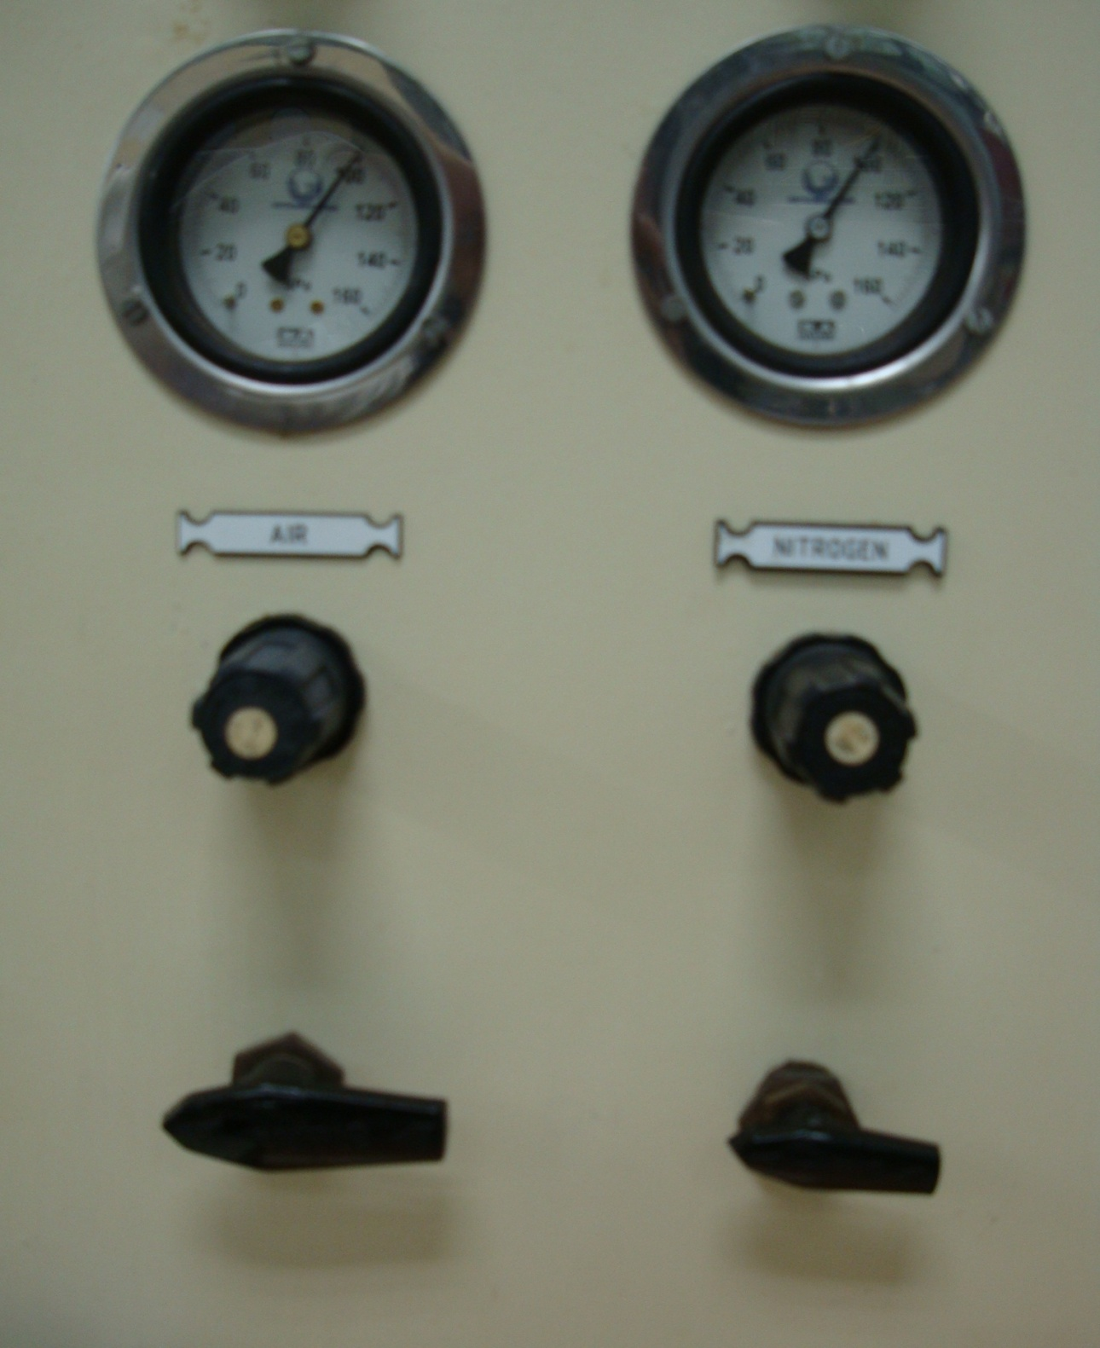

Figure A1: Mini regulators for the control of gas flows into the reactor

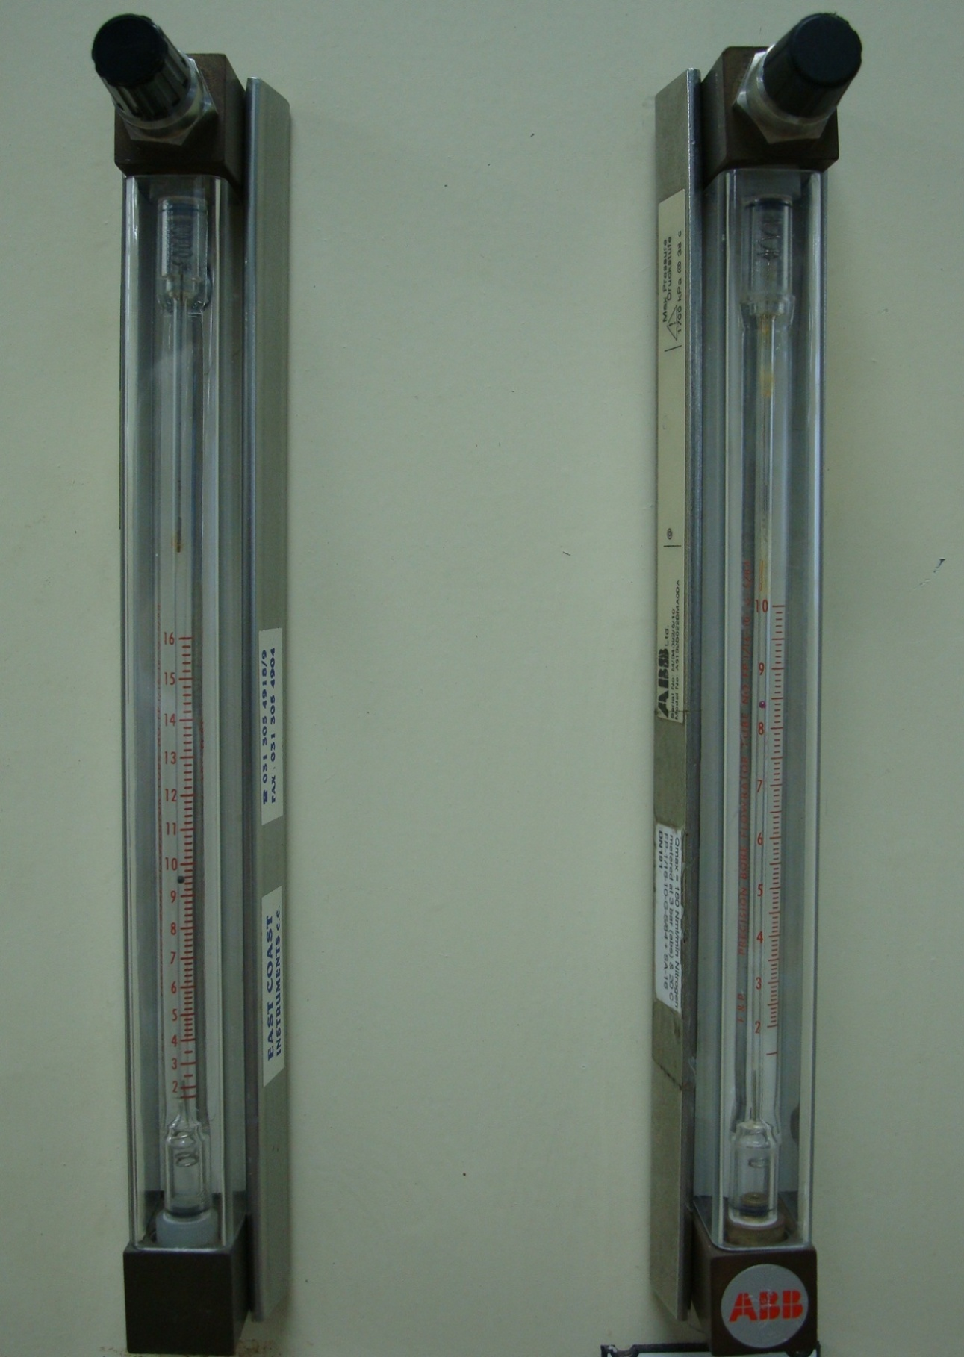
Figure A2: Rotameters used for adjusting the flow of nitrogen and air

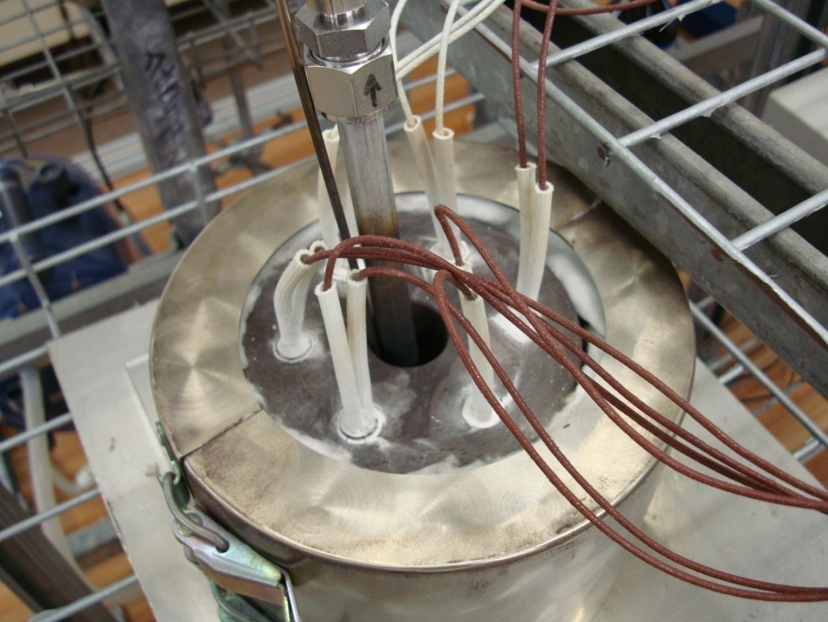

Figure A3: Cylindrical heating elements within the copper block

FID Method

Channel Parameters:
Run Time : 30.00 min
Sampling Rate: 3.1250 pts/s

Carrier Parameters:
Carrier A Control: PFlow – H₂ Carrier B Control; PFlow - He
Column A length: 50.00 m Column B length: 30.00 m
Vacuum Compensation: Off Vacuum Compensation: Off
Diameter: 200 μm Diameter: 530 μm
Split Ratio: 150:1 Split Flow: 500.0 ml/min
Initial Setpoint: 2.0 ml/min Initial Setpoint: 6.0 ml/min

Valve Configuration and Setting:
Valve 1: SPLIT On Valve 2: SPLIT On
Valve 3: NONE Valve 4: NONE
Valve 5: NONE Valve 6: NONE

Detector Parameters:
Detector A Detector B
Detector FID TCD + R + M
Range 1 3
Time Constant 200 200
Autozero ON ON
Polarity - POS
Detector A Gas Flows Detector B Gas Flows
Air: 450.0 ml/min Helium: 30.0 ml/min
Hydrogen: 45.0 ml/min Helium: 30.0 ml/min

Heated Zones:
Injector A: CAP Injector B: CAP
Setpoint: 220 °C Setpoint: 220 °C
Detector A: 250 °C Detector B: 250 °C

Oven Program:
Cryogenics: Off Total Run Time: 30.0 min
Initial Temp: 40°C Max. Temp: 300°C
Initial Hold: 15.0 min Equilibration Time: 0.2 min
Ramp 1: 20.0 °C/min to 100 °C, hold for 5.0 min
Ramp 2: 20.0 °C/min to 200 °C, hold for 2.0 min

Processing Parameters:
Bunch Factor: 2 points
Noise threshold: 50 μV
Area Threshold: 100.0 μV

Peak Separation Criteria:
Width Ratio: 0.2

Figure A4.1: FID Method

TCD Method

Channel Parameters:
Run Time: 7.0 min
Sampling Rate: 6.25 pts/s

Carrier Parameters:
Carrier A Control: PFlow – H₂ Carrier B Control; PFlow - He
Column A length: 50.00 m Column B length: 30.00 m
Vacuum Compensation: Off Vacuum Compensation: Off
Diameter: 200 μm Diameter: 530 μm
Split Ratio: 150:1 Split Flow: 500.0 ml/min
Initial Setpoint: 2.0 ml/min Initial Setpoint:6.0 ml/min

Valve Configuration and Setting:
Valve 1: SPLIT On Valve 2: SPLIT On
Valve 3: NONE Valve 4: NONE
Valve 5: NONE Valve 6: NONE

Detector Parameters:
Detector A Detector B
Detector FID TCD + R + M
Range 1 3
Time Constant 200 200
Autozero ON ON
Polarity - POS
Detector A Gas Flows Detector B Gas Flows
Air: 450.0 ml/min Helium: 30.0 ml/min
Hydrogen: 45.0 ml/min Helium: 30.0 ml/min

Heated Zones:
Injector A: CAP Injector B: CAP
Setpoint: 220 °C Setpoint: 220 °C
Detector A: 250 °C Detector B: 250 °C

Oven Program:
Cryogenics: Off total Run Time: 7.0 min
Initial temp: 40 °C Max. Temp: 250 °c
Initial Hold: 2.50 min Equilibration Temp: 0.2 min
Ramp 1: 20.0 °C/min to 80 °C, hold for 2.5 min

Processing Parameters:
Bunch Factor: 2 points
Noise threshold: 1 μV
Area Threshold: 100.0 μV

Peak Separation Criteria:
Width Ratio: 0.2
Valley-to-peak Ratio: 0.01

Figure A4.2: TCD Method

Figure A5.1: Data sheet for a reaction

Figure A5.2: Quantification of CO_{x} data for a reaction

Component | R.F | Equation (y= mx + c) |  | Component | R.F | Equation (y= mx + c)
methane | 1 | 3.77E+11 |  | trans-2-octene | 1 | 1.79E+12
ethane/ethene | 1 | 5.11E+11 |  | 1,3-octadiene | 0.9 | 1.54E+12
propane / propene | 1 | 1.08E+12 |  | ethylcyclohexane | 1 | 1.87E+12
methanol | 0.3 | 1.78E+11 |  | propylcyclopentane | 1 | 1.75E+12
butane | 1 | 1.19E+12 |  | ethylbenzene | 1.1 | 1.93E+12
ethanol | 0.5 | 3.53E+11 |  | styrene | 1.1 | 1.75E+12
acetone | 0.5 | 4.57E+11 |  | xylene | 1.1 | 1.92E+12
2-propanol | 0.5 | 4.37E+11 |  | cis-cyclooctene | 1 | 1.78E+12
1-pentene | 0.9 | 1.01E+12 |  | cyclooctane | 1.1 | 1.90E+12
2-methyl-2-propanol | 0.7 | 8.13E+11 |  | cis.cis-1,5-cyclooctadiene | 1.1 | 1.84E+12
pentane | 0.7 | 8.81E+11 |  | 4-octanone | 0.7 | 1.32E+12
butanone | 0.6 | 6.82E+11 |  | 3-octanone | 0.9 | 1.87E+12
1-hexene | 1 | 1.36E+12 |  | 2-octanone | 0.8 | 1.80E+12
hexane | 1 | 1.32E+12 |  | 3-octanol | 0.7 | 1.51E+12
methylcyclopentane | 0.9 | 1.24E+12 |  | octanal | 0.7 | 1.40E+12
heptane | 1 | 1.63E+12 |  | 2-octanol | 0.7 | 1.46E+12
2,4-dimethylhexane | 1 | 1.79E+12 |  | octene oxide | 0.8 | 1.61E+12
toluene | 1.1 | 1.57E+12 |  | benzyl alcohol | 0.8 | 1.28E+12
4-methylheptane | 1.1 | 1.83E+12 |  | 1-octanol | 0.8 | 1.86E+12
1,7-octadiene | 1 | 1.85E+12 |  | octanoic acid | 0.6 | 1.23E+12
1-octene | 1 | 1.90E+12 |  | cracked | 1 | -
3-octene | 1 | 1.75E+12 |  | others (dienes, cyclics, aromatics) | 1 | -
trans-4-octene | 1 | 1.83E+12 |  | oxygenates | 0.9 | -
octane | 1 | 1.82E+12 |  | heavy's | 0.8 | -
 |  |  |  | impurities | 1 | -

Figure A5.3: Response Factors and Calibration Equations Obtained

Figure A5.4: Simplified sheet showing quantification of liquid organic products

Figure A5.5: Simplified sheet showing quantification of gaseous products

Figure A5.6: Simplified spreadsheet showing quantification of unidentified products

Figure A 5.7: Simplified spreadsheet for the determination of yield and selectivity to products

APPENDIX B
Contents

Figure B1: SEM image of the in-situ treated Mg-V-HTlc 157
Figure B2: a) Composite map of V and Mg b) Mg distribution c) V distribution 158
Figure B3: SEM image of the calcined Mg-V-HTlc 159
Figure B4: a) Composite scan of Mg and V for calcined Mg-V-HTlc b) Mg distribution c) V distribution 160
Figure B5: a) SEM image of 0.2% BaMg-V-HTlc b) Composite scan of Mg, V and Ba c) Mg distribution d) V distribution e) Ba distribution 161
Figure B6: a) SEM image of 0.7% BaMg-V-HTlc b) Mg distribution c) V distribution d) Ba distribution 162
Figure B7: a) SEM image of 1.4% BaMg-V-HTlc b) V distribution c) Mg distribution d) Ba distribution 163
Figure B8: a) SEM image of 6% BaMg-V-HTlc b) Mg distribution c) V distribution d) Ba distribution 164
Figure B9: a) 0.4% CsMg-V-HTlc b) Cs distribution c) Mg distribution d) V distibution 165
Figure B10: a) SEM image of 0.9% CsMg-V-HTlc b) Mg distribution c) V distribution d) Cs distribution 166
Figure B11: a) SEM image of 1.9% CsMg-V-HTlc b) Cs distribution c) Mg distribution d) V distribution 167
Figure B12: Diffractogram for the XRD sample holder 168

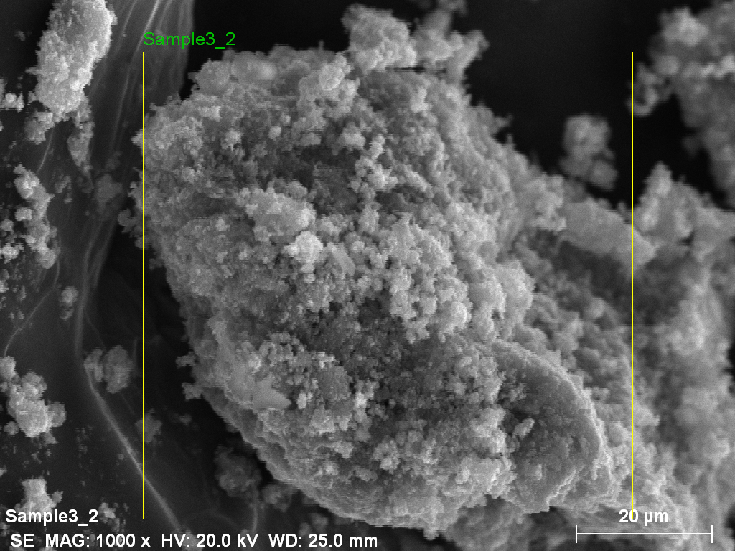

Figure B1: SEM image of the in-situ treated Mg-V-HTlc

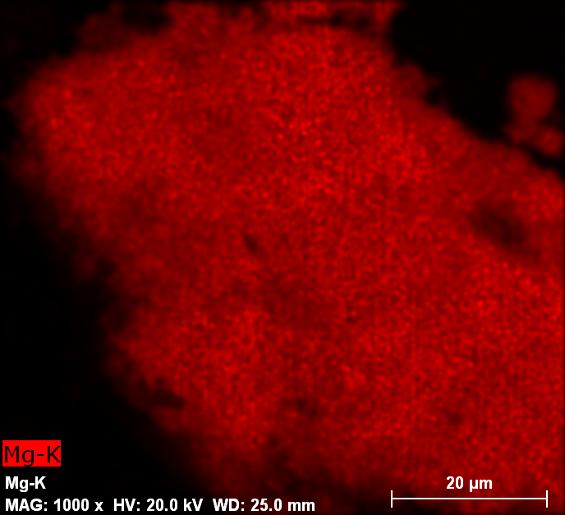
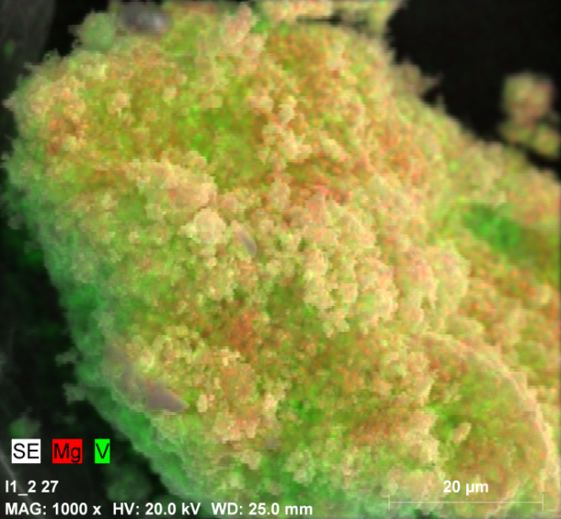
a
b
b

b
a

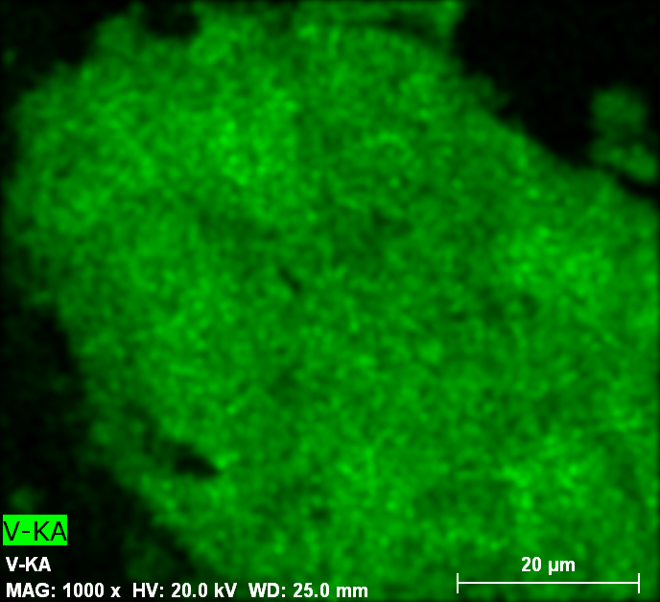
c

Figure B2: a) Composite map of V and Mg b) Mg distribution c) V distribution

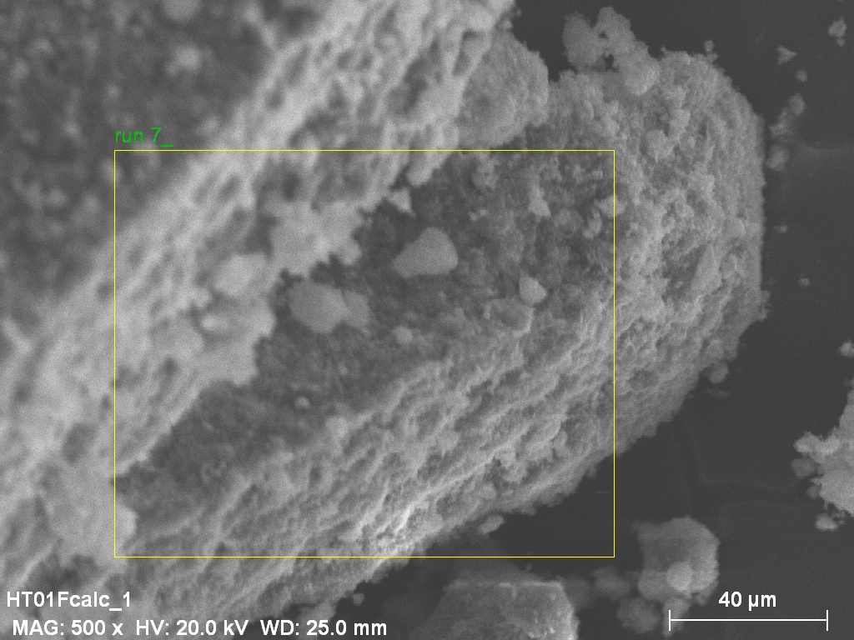

Figure B3: SEM image of the calcined Mg-V-HTlc

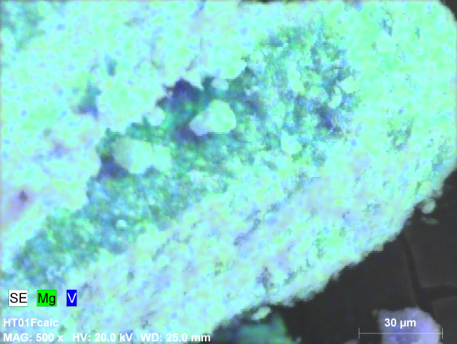
a
b
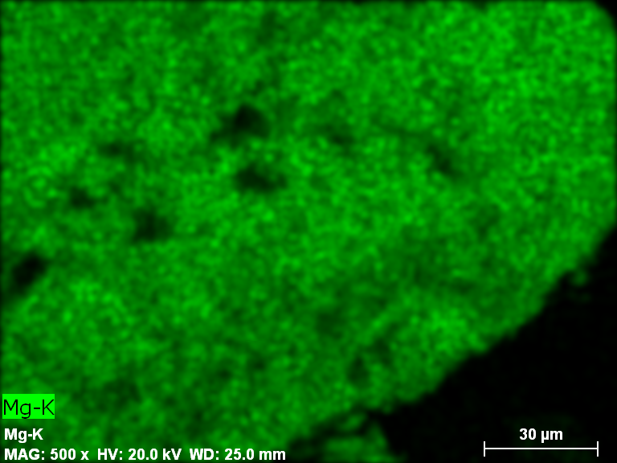
b
a

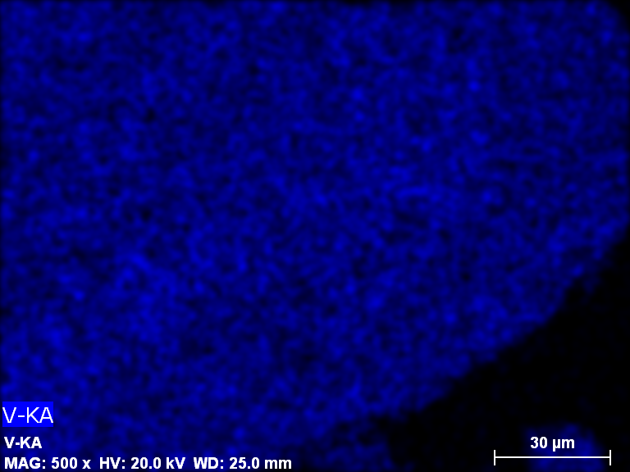
c

Figure B4: a) Composite scan of Mg and V for calcined Mg-V-HTlc b) Mg distribution c) V distribution

b
a
e
d
c
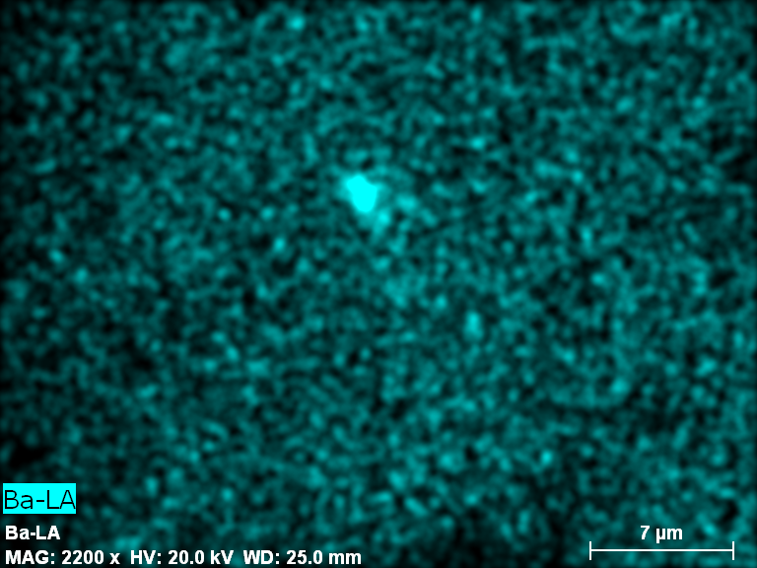
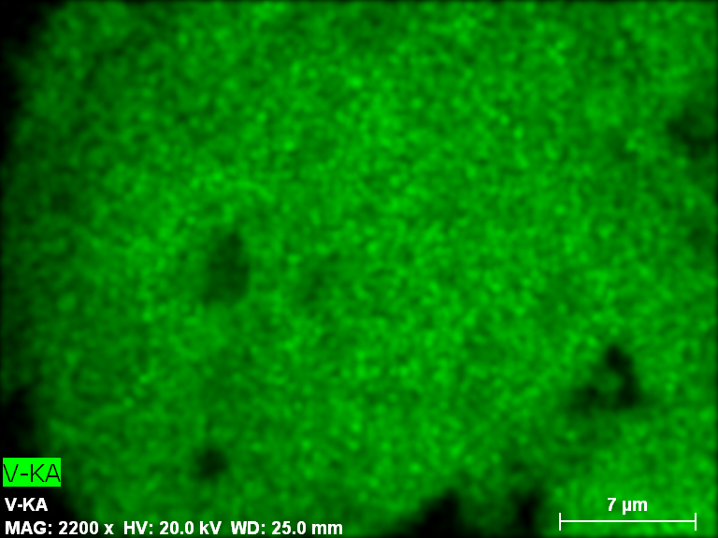
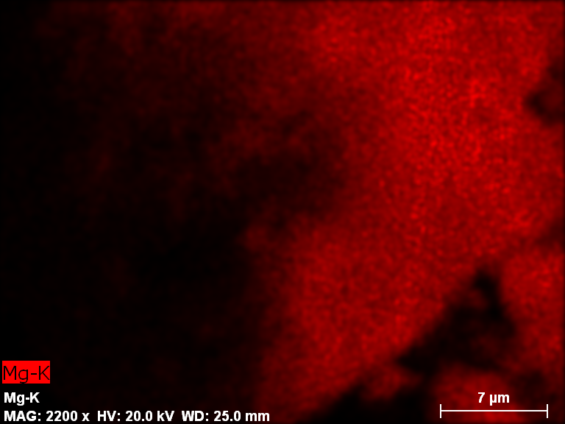
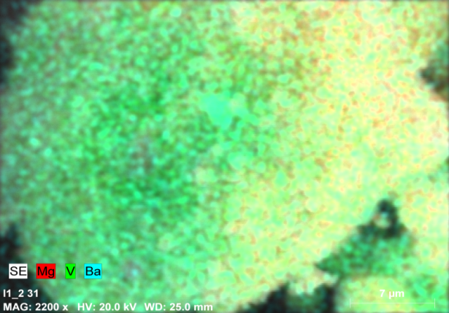
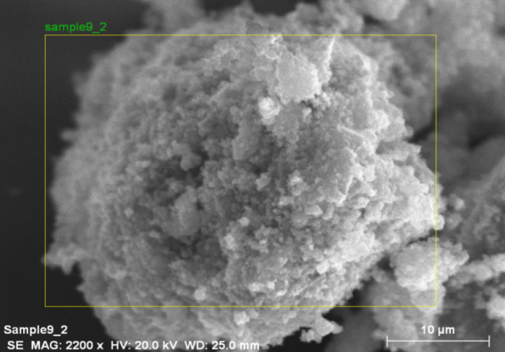

Figure B5: a) SEM image of 0.2% BaMg-V-HTlc b) Composite scan of Mg, V and Ba c) Mg distribution d) V distribution e) Ba distribution

b
a
c
d
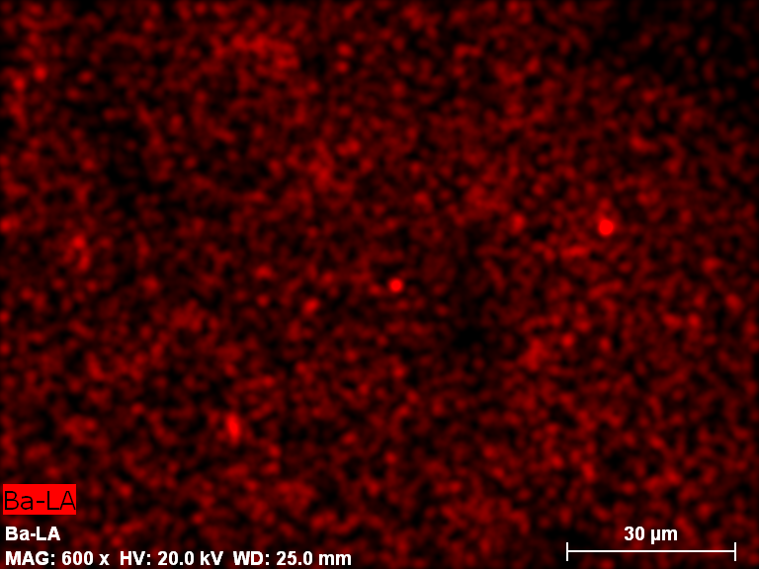
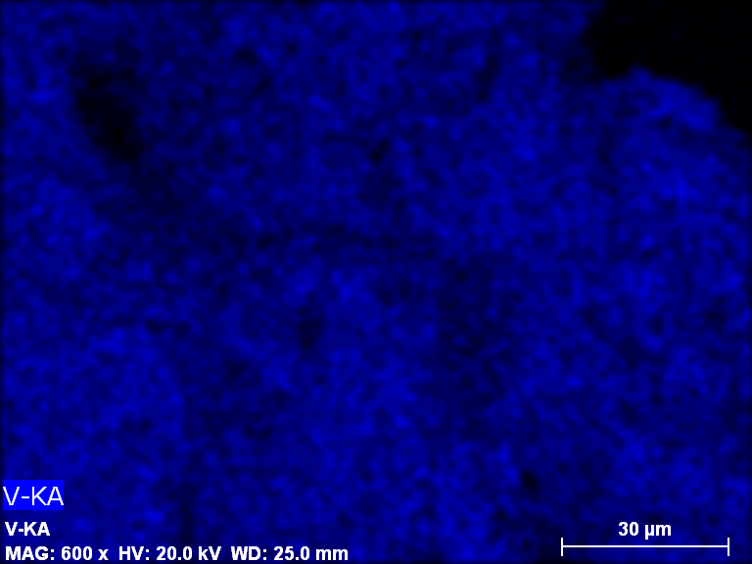
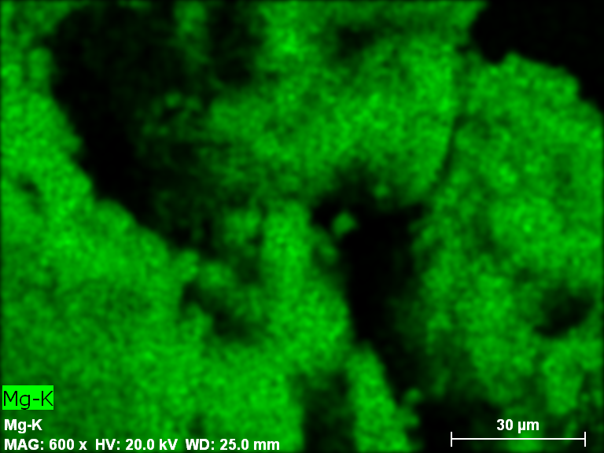
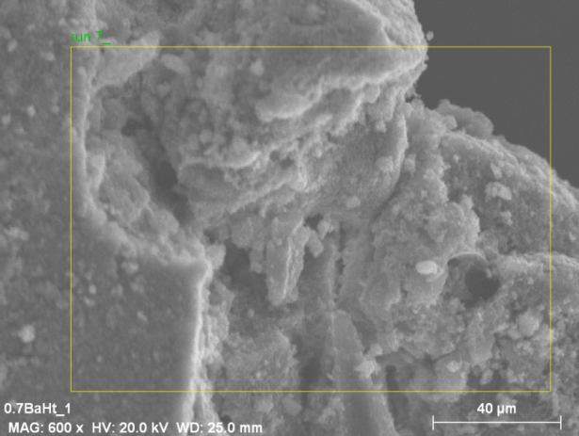
Figure B6: a) SEM image of 0.7% BaMg-V-HTlc b) Mg distribution c) V distribution d) Ba distribution

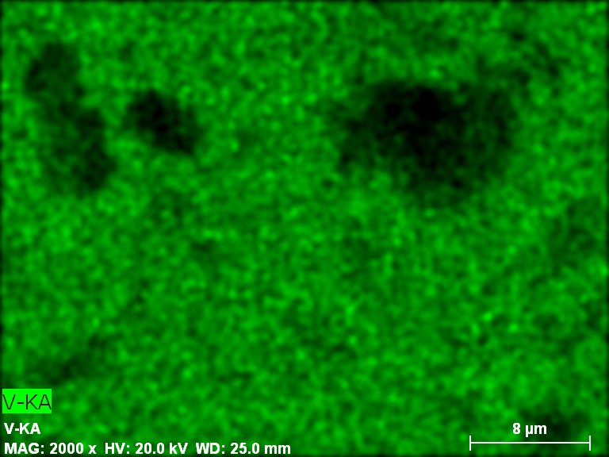
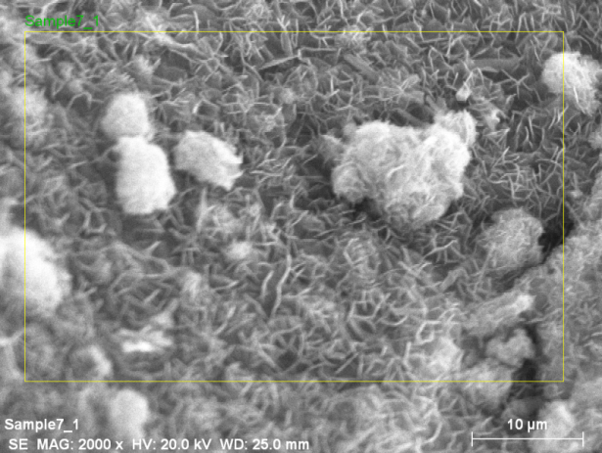
b
a

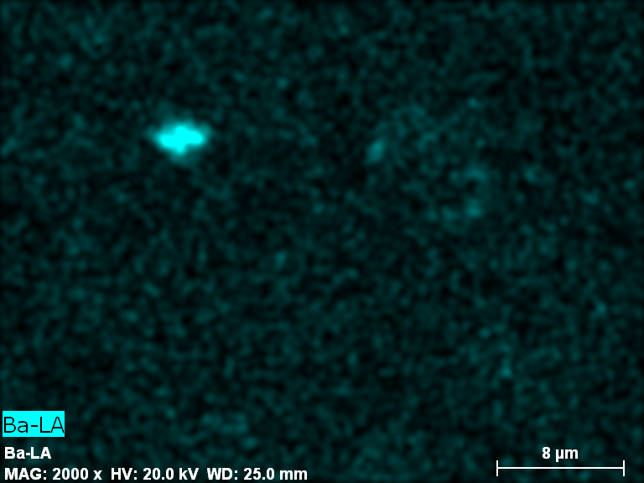
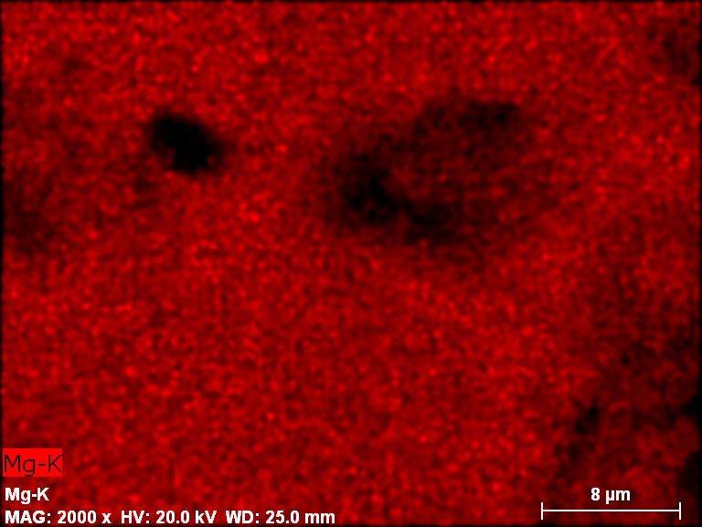
d
c

Figure B7: a) SEM image of 1.4% BaMg-V-HTlc b) V distribution c) Mg distribution d) Ba distribution

d
c
b
a
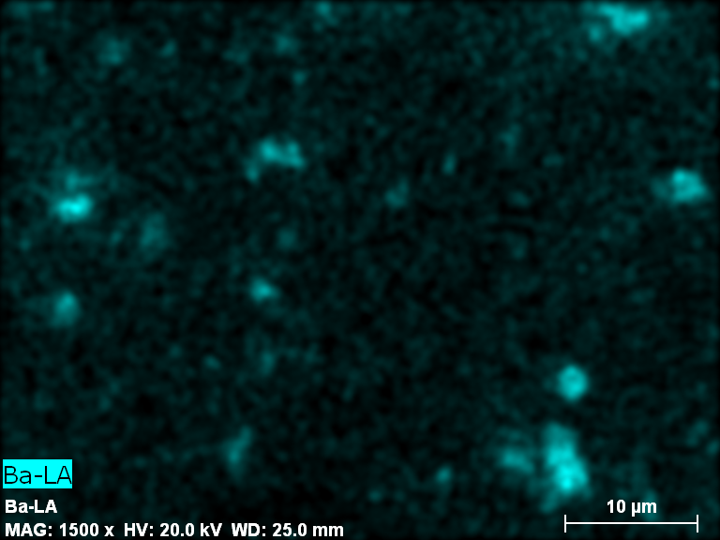
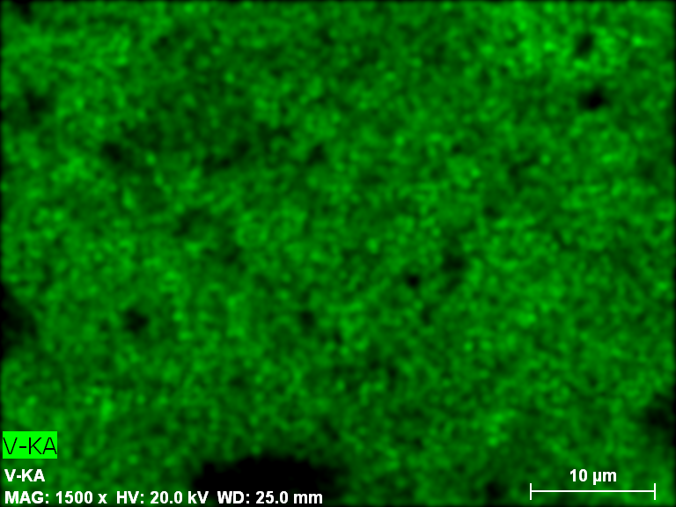
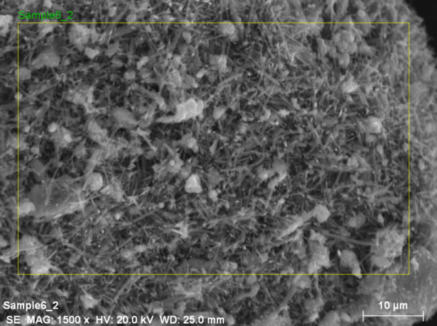
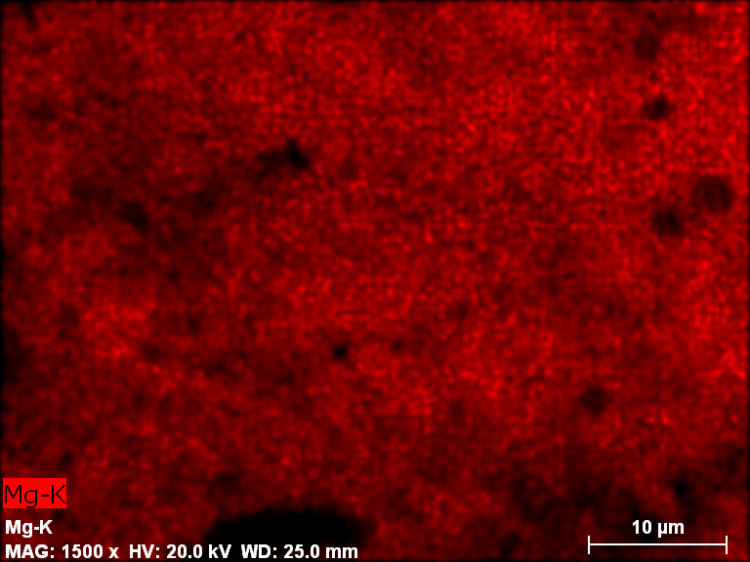

Figure B8: a) SEM image of 6% BaMg-V-HTlc b) Mg distribution c) V distribution d) Ba distribution

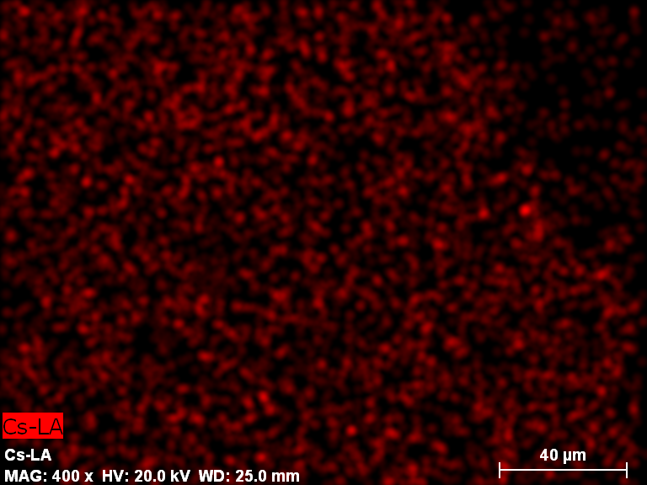
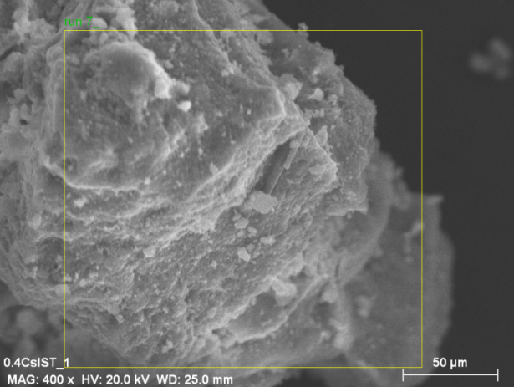
b
a

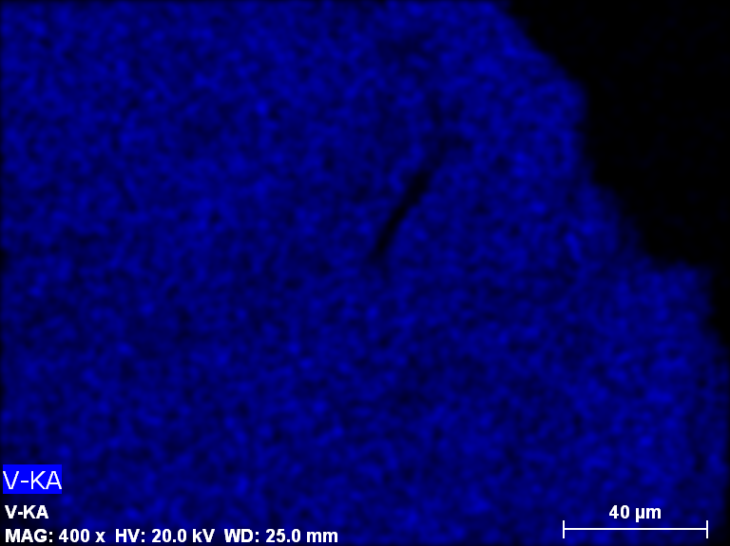
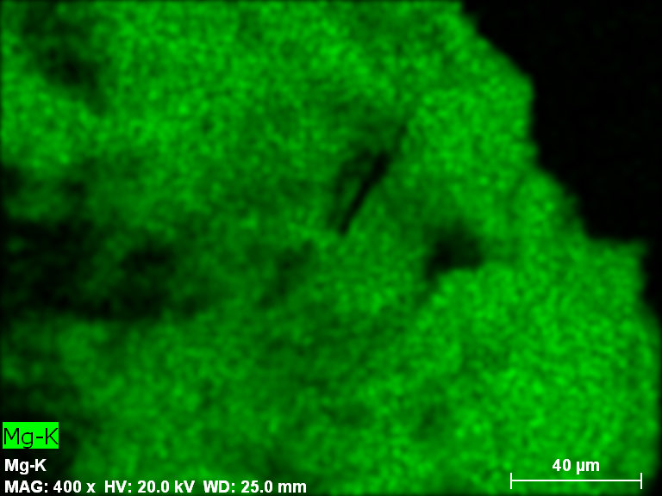
d
c

Figure B9: a) 0.4% CsMg-V-HTlc b) Cs distribution c) Mg distribution d) V distibution

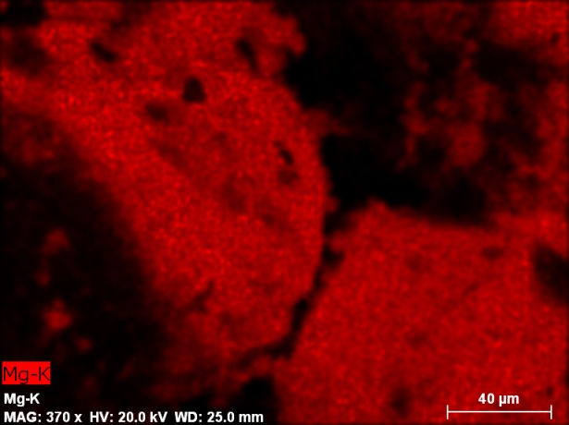
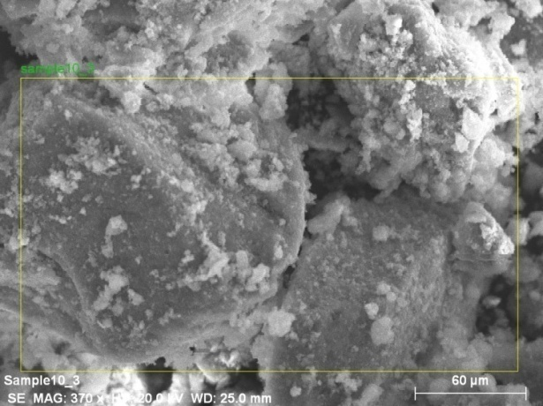
b
a
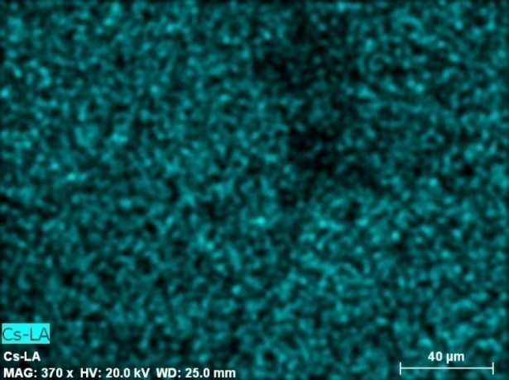
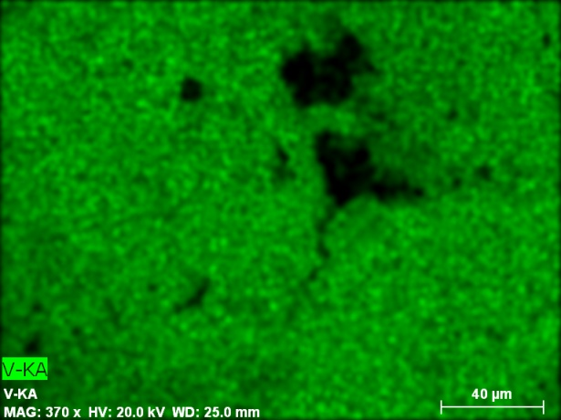
d
c

Figure B10: a) SEM image of 0.9% CsMg-V-HTlc b) Mg distribution c) V distribution d) Cs distribution

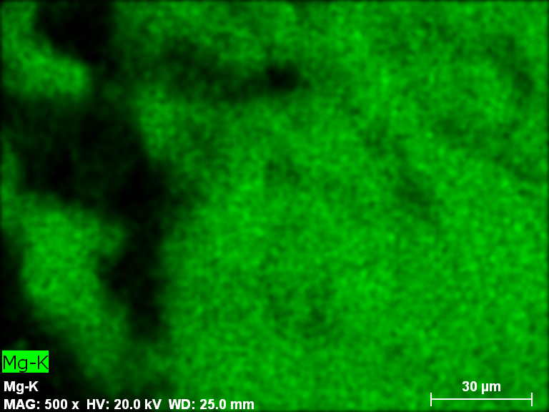
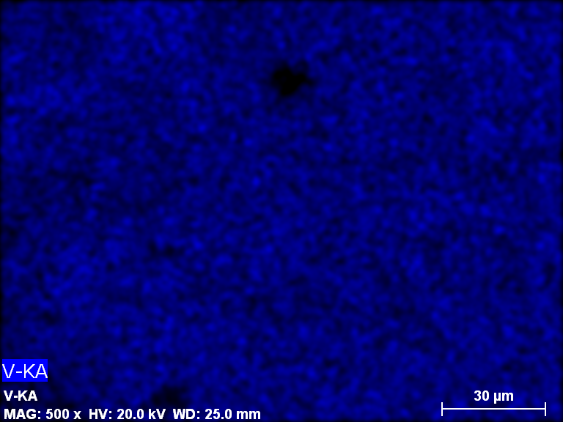
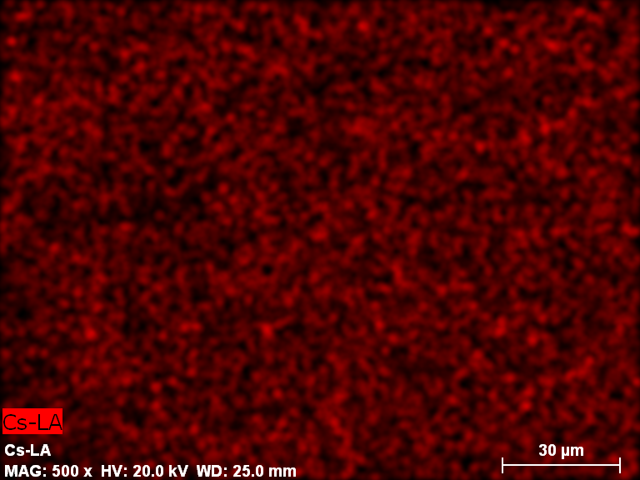
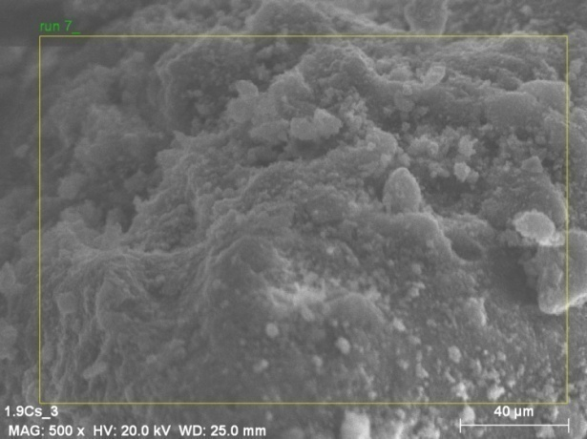
b
a
d
c
b
a

Figure B11: a) SEM image of 1.9% CsMg-V-HTlc b) Cs distribution c) Mg distribution d) V distribution

Figure B12: Diffractogram for the XRD sample holder

