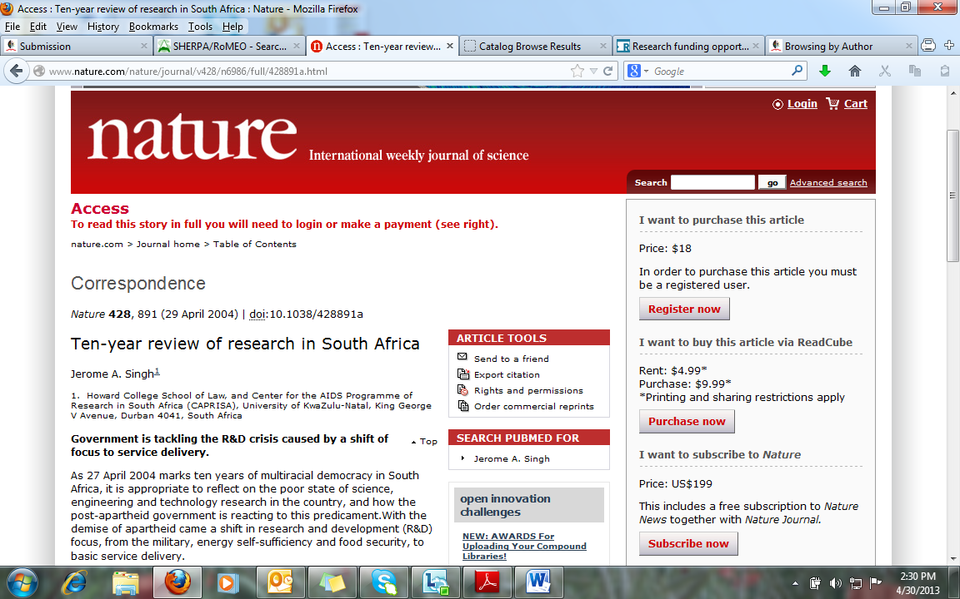
To download the full text of this article use the URL below:
http://search.ebscohost.com/login.aspx?direct=true&db=a9h&AN=13009285&site=ehost-live

