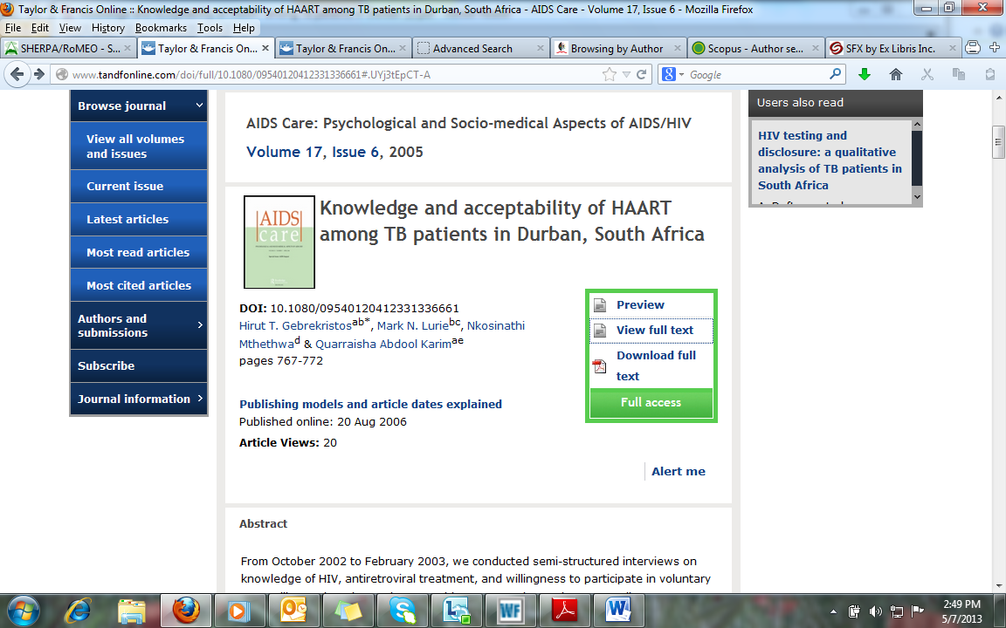

http://www.tandfonline.com/doi/full/10.1080/09540120412331336661#.UYj3tEpCT-A

